Name: _____________________________

Things Move with a **Push** or a **Pull**

|  |  |  |
| --- | --- | --- |
| pull |  |  |
| Black and White Kids on a Sled |  | Black and White Black and White Girl Riding a Scooter |
|  | Clipart Auto Racing Free Clip  on Firetruck Clipart Image   Black And White Fire Truck Racing To A Fire |  |

~~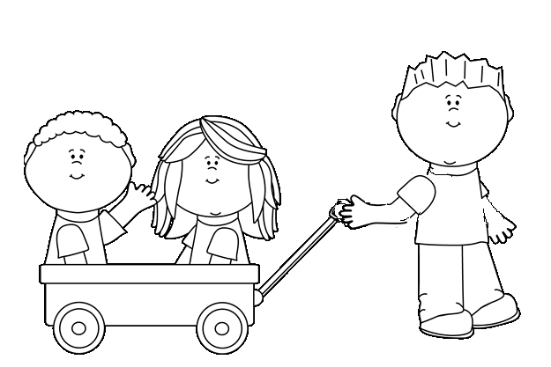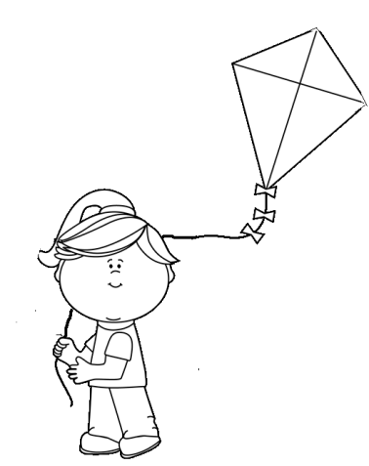~~Label each diagram to describe how the object is moved. Add the word **push or a pull** and and an **arrow** to show which direction the object will move when pushed or pulled.