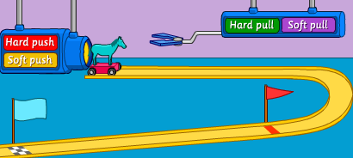Testing Different Size Pushes and Pulls
Type of Force | What is your Prediction? |  | Right?
Hard Push | Red Flag | Blue Flag | Yes or No
Soft Push | Red Flag | Blue Flag | Yes or No
Hard Pull | Red Flag | Blue Flag | Yes or No
Soft Pull | Red Flag | Blue Flag | Yes or No

