|  |  |
| --- | --- |
|  |  |
|  |  |
|  |  |

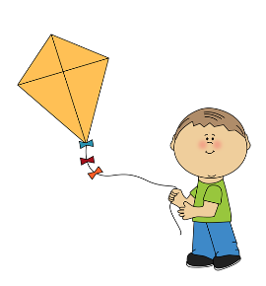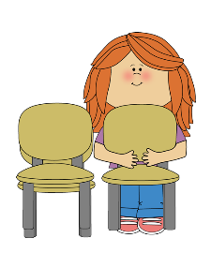

|  |  |
| --- | --- |
|  |  |
| A **pull** brings something closer to you.  A **push** moves something away from you.  A force is a **push** or **pull** on an object. |  |
|  |  |
|  |  |
|  | Zipper |

