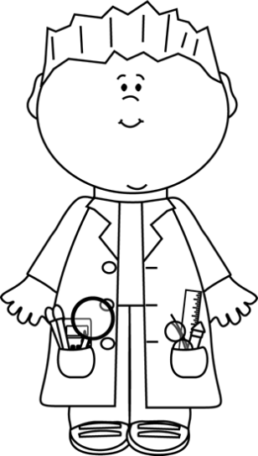
Name:______________________________
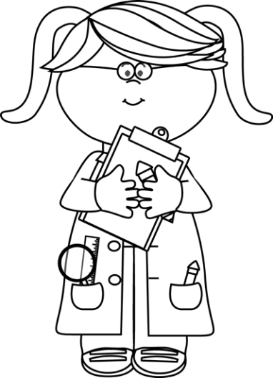
Push and Pull Inc.
Push and Pull Inc. needs your help to design a new toy. You will need to design,
construct, and name a toy that will show an can be moved using a push or a pull.

What will your toy look like?

