**Physical and Chemical Changes and Properties of Matter Worksheet**

**Classify the following as chemical change (cc), chemical property (cp), physical change (pc), or physical property (pp).**

1. _____ Heat conductivity 8. _____ Combustible

2. _____ Silver tarnishing 9. _____ Water freezing

3. _____ sublimation 10. _____ Wood burning

4. _____ magnetizing steel 11. _____ Acid resistance

5. _____ length of metal object 12. _____ Brittleness

6. _____ shortening melting 13. _____ Milk souring

7. _____ exploding dynamite 14. _____ baking bread

**Identify the following as being true or false to the left of the sentence.**

_____ 15. A change in size or shape is a physical change.

_____ 16. A chemical change means a new substance with new properties was formed.

_____ 17. An example of a chemical change is when water freezes.

_____ 18. When platinum is heated, then cooled to its original state, we say this is a physical change.

_____ 19. When milk turns sour, this is a physical change because a change in odor does not indicate a chemical change.

_____ 20. When citric acid and baking soda mix, carbon dioxide is produced and the temperature decreases. This must be a chemical change.

**Identify each of the following as a physical or chemical change.**

21. _____ You leave your bicycle out in the rain and it rusts.

22. _____ A sugar cube dissolves.

23. _____ Scientist break-up water into oxygen and hydrogen gas.

24. _____ Burning coal for a barbecue.

25. ______ Trimming a bush because it has grown too tall.

**Classifying Matter Worksheet**

**Classify each of the following substances as an element, a compound, a solution (homogenous mixture, or a heterogeneous mixture.**

1. Sand 2. Salt 3. Pure Water

4. Soil 5. Soda just opened 6. Pure air

7. Carbon Dioxide 8. Gold 9. Brass

10. Oxygen 11. Italian Salad Dressing 12. Salt Water

13. Raisin Bran 14. Silver 15. Lithium Iodide

16. Apple Pie 17. Kool Aid 18. Sugar Water

19. Chocolatechip Cookie 20. Gatorade 21. Gold

22. tacos 23.Lead 24. Ceasar Salad

25. Calcium 26. Whole Milk 27. Skim Milk

28. hydrogen peroxide 29. Potassium 30. Sugar

31. Raisin Bran Cereal with Milk 32. Raisin Bran Cereal without Milk

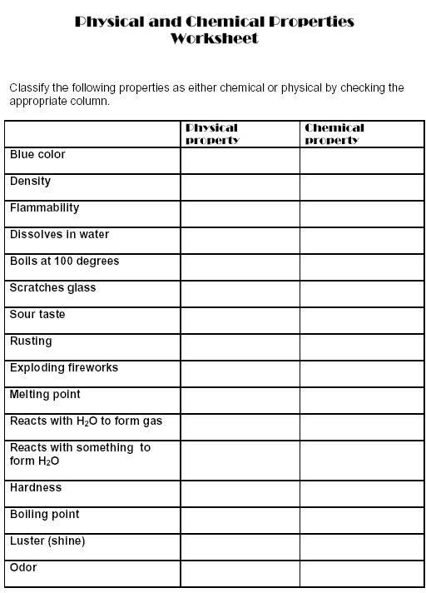

**Vocabulary Cards**

Use the example below, make vocabulary cards for the following words on the bottom and back of this paper:

Compound

Mixture

Pure Substance

Element

Matter



**Write the definition in this square**

**Use the word in a sentence in this square**

**Draw an illustration (picture) for the word in this square**

Identify each of the following as an example of a physical property or a chemical property.

1. Silver tarnishes when it comes in contact with hydrogen sulfide in the air.
2. A banana is yellow.
3. A sheet of copper can be pounded into a bowl.
4. Barium melts at 725 C.
5. Gasoline is flammable.
6. A diamond is the hardest natural substance.
7. Helium does not react with any other element.
8. A bar of lead is more easily bent than is a bar of aluminum of the same size.
9. Potassium metal is kept submerged in oil to prevent contact with oxygen or water.
10. An apple will turn brown is left in oxygen.
11. Diamond dust can be used to cut or grind most other materials.
12. Acid in tomato sauce can corrode aluminum foil.
13. Rocks containing carbonates can be identified because they fizz when hydrochloric acid is applied.
14. A piece of charcoal, which is mostly the substance carbon, glows red, gives off heat, and becomes a gray ash.