Force

& Motion

Read by:__________________________________

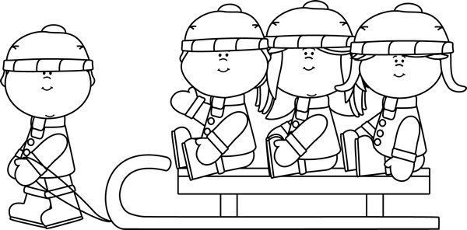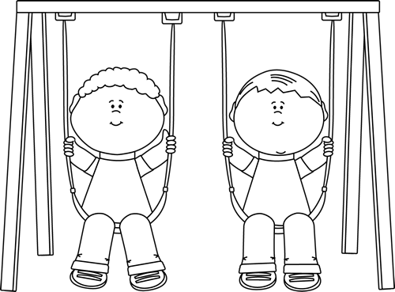

I can _________ the sled.

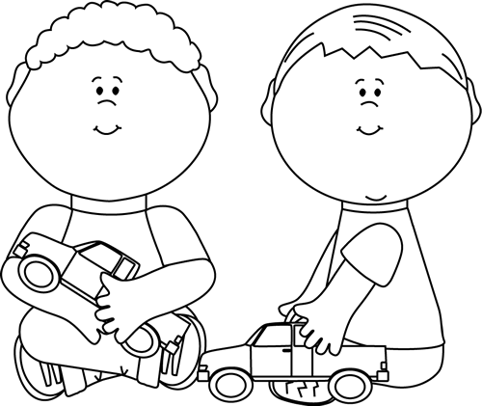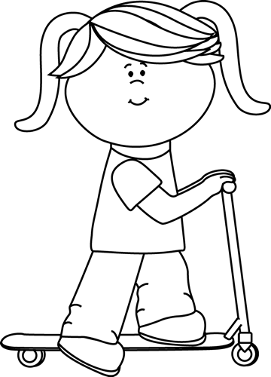

I can _________ the scooter.

I can _________ the truck.

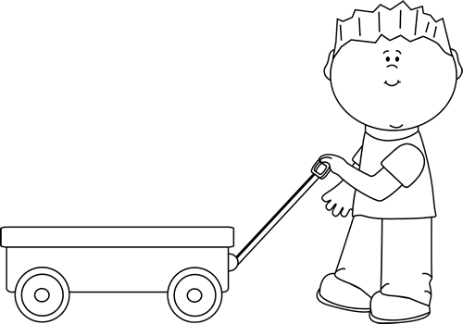

I can _________ the wagon.

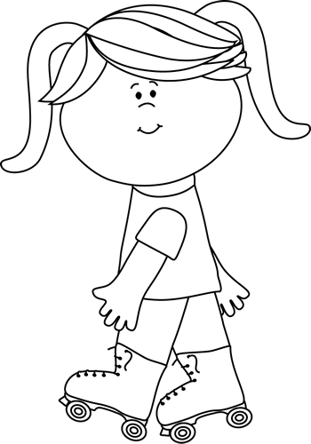

I can _______ the rollerskates.

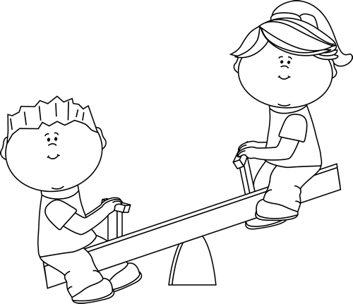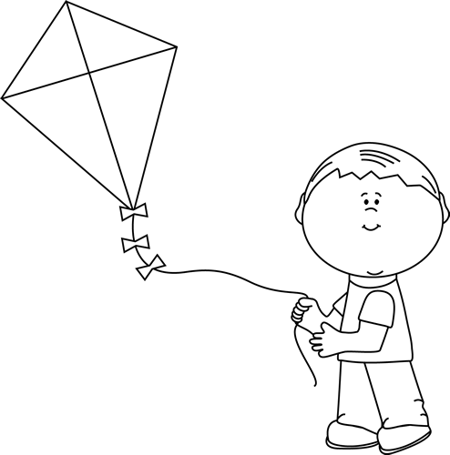

I can _________ the seesaw.

I can _________ the kite.