|  |  |
| --- | --- |
| [Eye Clip Art](javascript:edit(30030))See | http://year3french.wikispaces.com/file/view/ear-9527.jpg/189966660/ear-9527.jpgHear |
| http://www.clipartoday.com/_thumbs/034/T/Tongue_1_tns.pngTaste  Five Senses Labels Activity 12Activity 12 | http://bp2.blogger.com/_YKp4YVTvPLw/SFAkX_cJA2I/AAAAAAAAAEo/SI5DYJEUp18/s320/Nose+clipart.jpgSmell  Kindergarten Unit 1  Activity 12 |

Touch

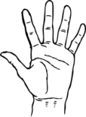

Kindergarten Unit 1

Activity 12

|  |  |  |  |  |
| --- | --- | --- | --- | --- |
| [Eye Clip Art](javascript:edit(30030))See | http://year3french.wikispaces.com/file/view/ear-9527.jpg/189966660/ear-9527.jpgHear | http://bp2.blogger.com/_YKp4YVTvPLw/SFAkX_cJA2I/AAAAAAAAAEo/SI5DYJEUp18/s320/Nose+clipart.jpgSmell | Description: http://danielleschechter.com/visualpoem/img/hand.pngTouch | http://www.clipartoday.com/_thumbs/034/T/Tongue_1_tns.pngTaste |

Name:____________________________________ (Activity 12)

Sight Smell Sound Taste Touch

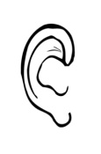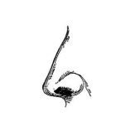[](javascript:edit(30030))

I can see a… I can smell a… I can hear a … I can taste… I can touch a…

|  |  |  |  |  |
| --- | --- | --- | --- | --- |
|  |  |  |  |  |

Kindergarten Unit 1

Activity 10

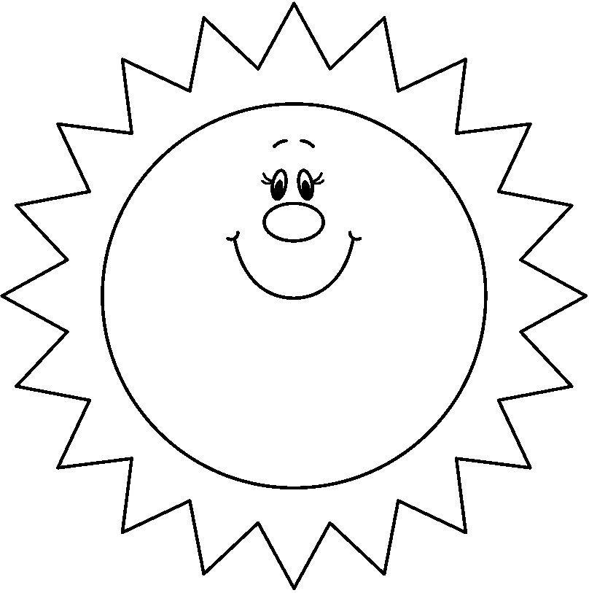

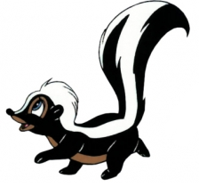

Kindergarten Unit 1

Activity 10