**Unit 3: Sound Energy**

**Teacher Background**

Sound is a form of mechanical energy that results in the vibration of matter. To make a sound, matter must vibrate—move back and forth—so sound can only travel through matter. There is no sound in outer space or in a vacuum. Sound travels better through solids and liquids than through gases.

Sound is described in three ways: amplitude (volume), pitch (the frequency or speed of the vibration), and quality (the regularity of the vibration). This unit covers volume and pitch in a formal way, but there will be many opportunities to discuss the quality of sound as children make their own music.

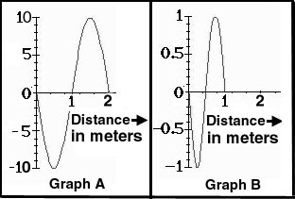

Amplitude is how much force is used to make the vibrations.

#### A graph of sound often looks like this: It can be understood by thinking about how many particles of air are in a certain space. When an object vibrates, it squeezes a lot of particles in a small space (a compression), and then the next space has very few particles, then more particles again. (Think of an accordion pleat.) These periodic compressions constitute a vibration. The closer the compressions, the higher the frequency or pitch of the sound. (Something that vibrates faster makes a higher pitch of the sound.)

#### The volume of the sound is shown by the height of the graph. It reflects how much the air is compressed—what difference there is between the number of particles in a space when the air is compressed and when it is spread out. If your instrument vibrates with more energy (you hit or pluck it harder) you produce a louder sound.

#### The quality of sound is how regular (even) it is. A good instrument vibrates at the same frequency every time you hit it the same way. A good singer can keep vocal cords vibrating at the same speed for some time—hold a pitch. Bad music is irregular; the pitch moves up and down in an irregular manner. Our ear can’t predict what it will hear, so that is less pleasing.

#### A very good instrument produces several kinds of vibrations at the same time. When they are compatible (when the mathematic ratio between the different vibrations is just right) we say that there is harmony.

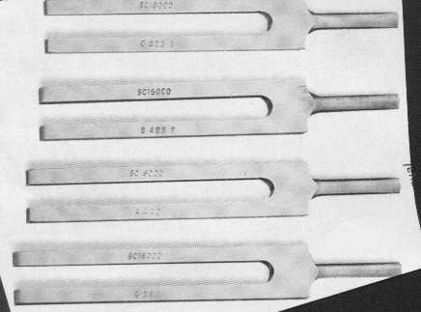

#### In science, we often demonstrate sound with tuning forks. These instruments are all designed to vibrate at very specific frequencies. If you look carefully at the tuning fork, the frequency at which it will vibrate is etched on the side. Hit the fork on a soft surface (like the heel of your hand), not on something hard that could nick it. (The metal is somewhat soft and a nick will change the frequency.)

#### **Transparency**

#### **Sound and Ear Damage**

|  |  |  |
| --- | --- | --- |
| **Type Of Sound** | Decibel Level | **Level Of Harm** |
| Missile | 180 | DANGEROUS |
| Machine gun | 160-170 | (Sounds of 140 or |
| Jet in air | 140-150 | Higher may cause |
| Jet on ground | 130 | Pain) |
|  |  |  |
| Rock band | 120 | SERIOUS |
| Motorcycle | 110 |  |
| Traffic | 100 |  |
| Large truck | 90 |  |
|  |  |  |
| Vacuum cleaner | 80 | MINOR |
| Ringing phone | 70 |  |
| Loud yell | 60 |  |
| Quiet restaurant | 50 |  |
|  |  |  |
| Quiet talking | 40 | NONE |
| Empty school | 30 |  |
| Whispering | 20 |  |
| Normal breathing | 10 |  |

**Parent Directions for Making Instruments**

Dear Parents:

We are studying sound in science class. One way in which children can demonstrate their understanding of sound is to make a musical instrument.

There are many ways to make instruments. In this exercise, children can be creative. The simplest kinds of instruments are percussion. Drums and cymbals are percussion instruments. If you have empty milk cartons, pails, or other containers, your child can make a percussion instrument. It can be decorated with permanent markers or other media.



Stringed instruments use rubber, string, or fabric to vibrate the air. Your child can make a stringed instrument with rubber bands, wires, or string. You can use a firm box (a shoe box or pencil box) as the base for a stringed instrument. Make some strings tight (to make high sounds) and some strings a little looser (to make low sounds.)

Wind instruments use long tubes to vibrate the air. Children can make music by blowing in something simple (like a paper towel tube) or can create a more complicated instrument using a PVC pipe. (An adult should drill the holes in PVC pipe.)

A good instrument makes a regular sound. Help your child test and improve the instrument design. Then give your child the opportunity to test and improve the design. As you help your child make these instruments, the most important rule is to have fun. Music is not only science—it’s an important way for children to express themselves creatively.



Thanks for your help.

**Rubric for listening to children’s explanations of sound**

|  |  |  |
| --- | --- | --- |
| **Criterion** |  | **Level** |
| **Basic Science** | Child clearly explains that sound is a vibration in matter. | 4 |
| Child explains that sound is a vibration in a fragmented way. | 3 |
| Child implies understanding that sound is a vibration, but does not explain in words. | 2 |
| No evidence that child understands that sound is a vibration. | 1 |
| **Pitch** | Child clearly explains that pitch is the frequency of vibration. | 4 |
| Child explains that pitch is the frequency of vibration in a fragmented way. | 3 |
| Child implies understanding that pitch is the frequency of vibration, but does not explain in words. | 2 |
| No evidence that child understands that pitch is the frequency of vibration. | 1 |
| **Volume** | Child clearly explains that volume is the result of the amount of force (amplitude of vibration) in matter. | 4 |
| Child explains that volume is the result of the amount of force (amplitude of vibration) in a fragmented way. | 3 |
| Child implies understanding that volume is the result of the amount of force (amplitude of vibration), but does not explain in words. | 2 |
| No evidence that child understands that volume is the result of the amount of force (amplitude of vibration). | 1 |

**Word Cards for Unit 3**

|  |  |
| --- | --- |
| **1**  **vibration**  Fast back and  forth movement.  ***Example*:** The tuning fork made a vibration. | **2** **pitch** How high or  low a sound  is.  ***Example*:** The xylophone has a high pitch and a low pitch. |
| **3**  **volume**  How loud or quiet  a sound is.  ***Example:*** The volume in the headphones is too loud. | **4** **percussion instrument** An instrument  that makes a  sound when it  is hit by another  object.  ***Example*:** The drums are percussion instruments. |
| **5**  **wind instrument**  An instrument  that makes a  sound when air  is blown into it.  ***Example:*** The horn is a wind instrument. | **6**  **stringed instrument**  An instrument  that makes a  sound when a  string is plucked.  ***Example*:** The guitar is a stringed instrument. |

**Questions Chart for Unit 3**

|  |  |
| --- | --- |
| **Question** | **Answer** |
| **What causes sound?** | Movements cause sound. |
| **What is a vibration?** | A vibration is a fast back and forth movement. |
| **What is pitch?** | Pitch is how high or low a sound is*.* |
| **Which bars have a higher pitch on a xylophone?** | The shorter bars have a higher pitch on a xylophone. |
| **What is volume?** | Volume is how loud or quiet a sound is. |
| **What things can sound travel through?** | Sound can travel through air, water, and solids. |
| **Why should you be careful with loud sounds?** | Loud sounds can cause hearing loss. |
| **How can you group instruments?** | You can group instruments by the way they make their sounds. |
| **How can you change the volume of an instrument?** | You can change the volume of an instrument by using more force. |
| **How can you change the pitch of an instrument?** | You can change the pitch by adjusting the length or the tightness of a part of the instrument. |

**Graphic Organizer for Unit 3**

**Graphic Organizer for Lesson 1**

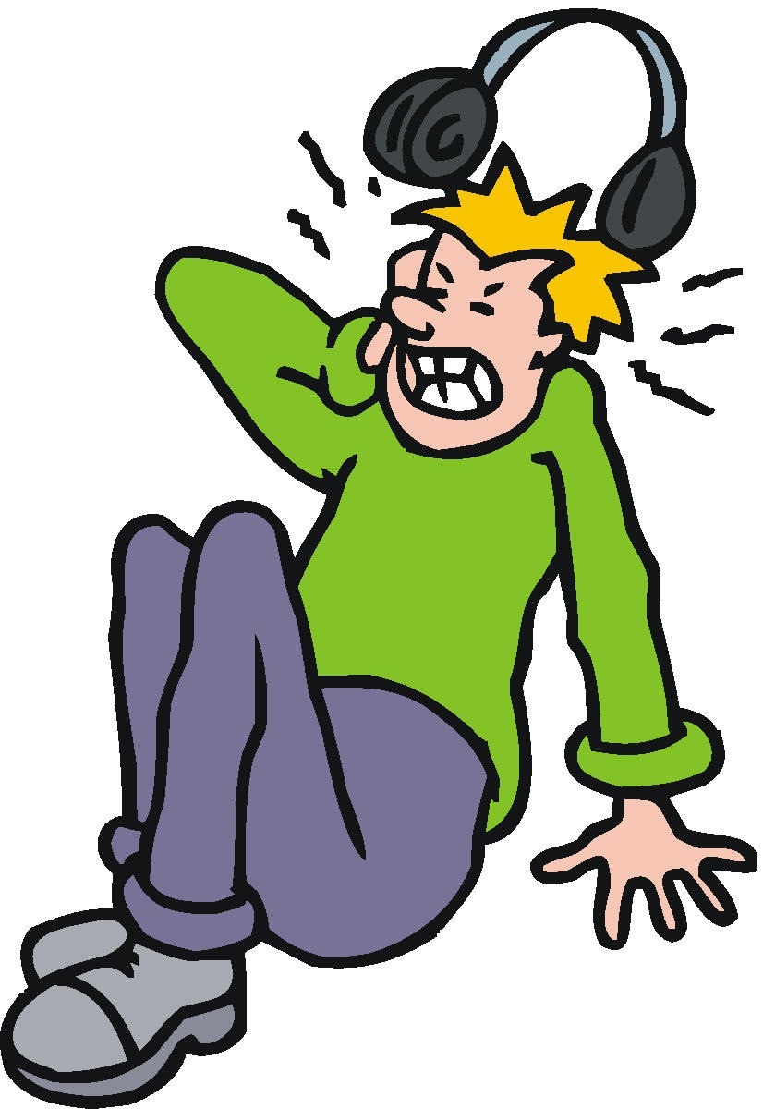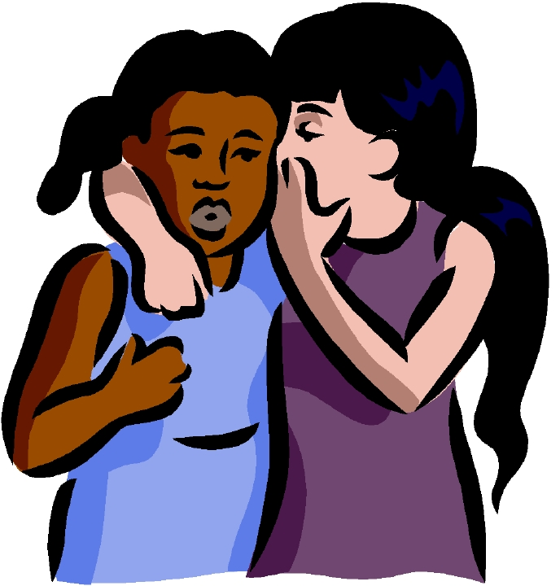

Stringed Instruments

Pluck the strings

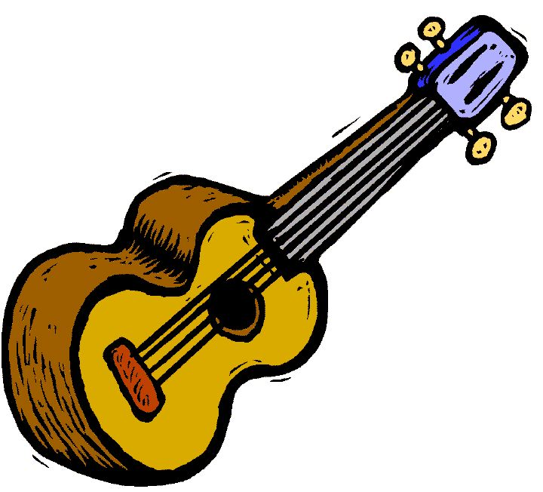

Percussion Instruments

Hit them

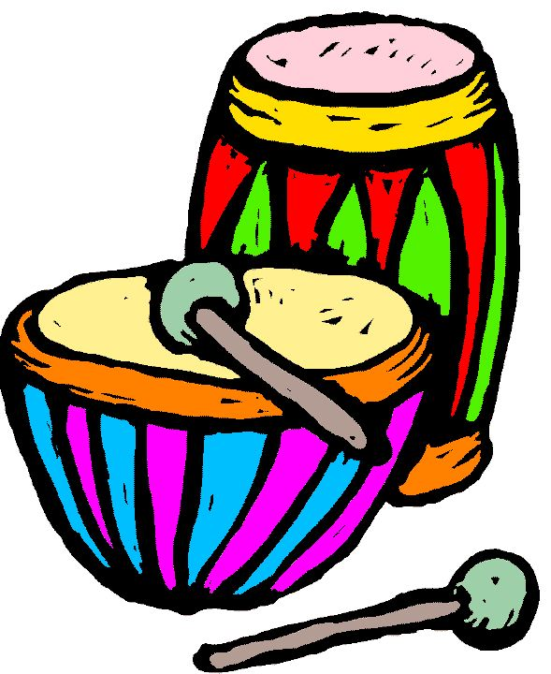

Wind Instruments

Blow into them



# Volume

Loud or Quiet

Vibration

Movement

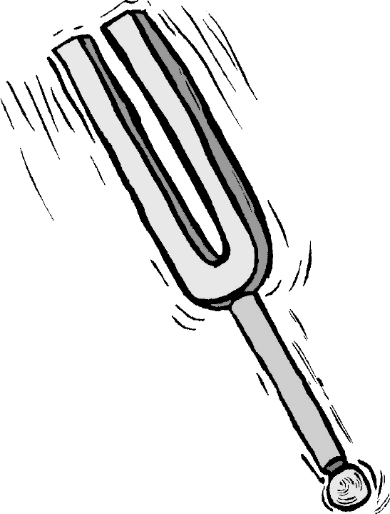

Pitch

High or Low

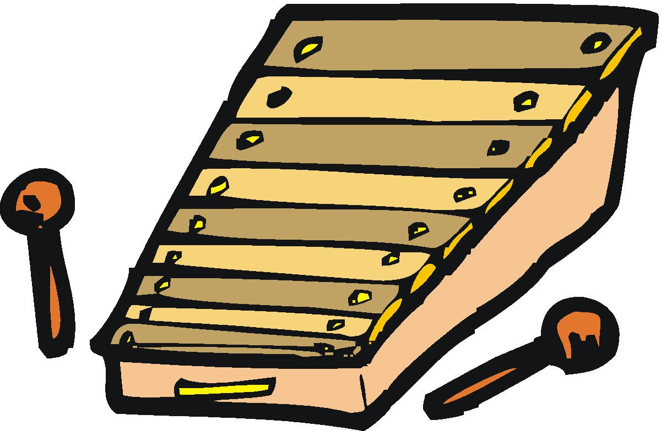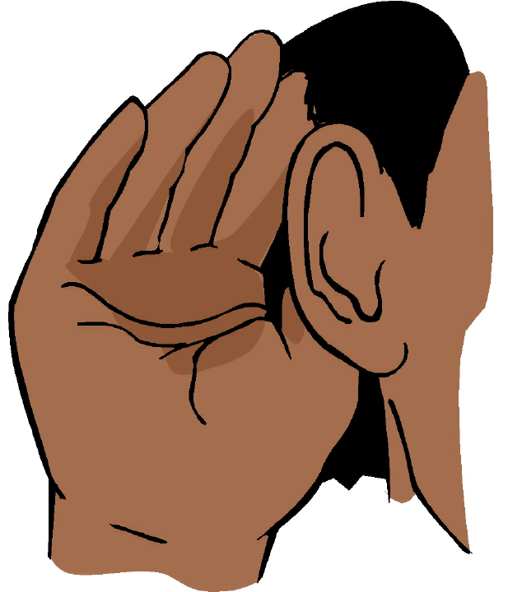

|  |  |  |
| --- | --- | --- |
| **Object That Made Sound** | **Description Of Sound** | **What Was Moving?** |
|  |  |  |

**Graphic Organizer for Lesson 6**

**Graphic Organizer for Lesson 8**

Through Water

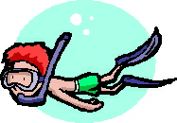

Through

Air

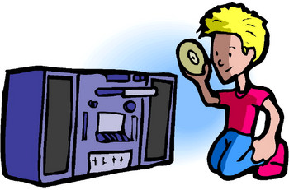

Through Solids

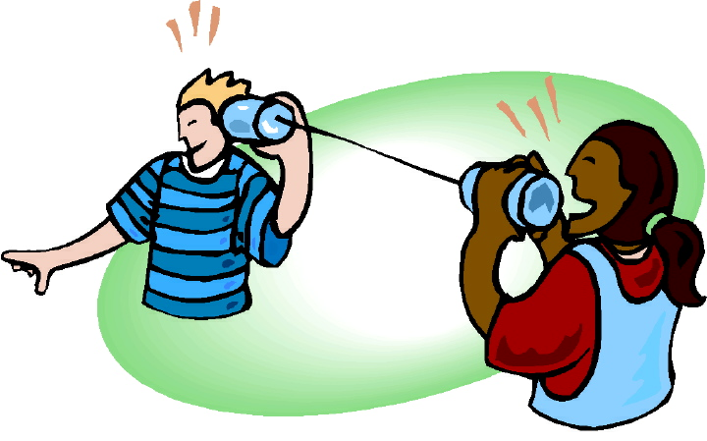

# Sound Travels

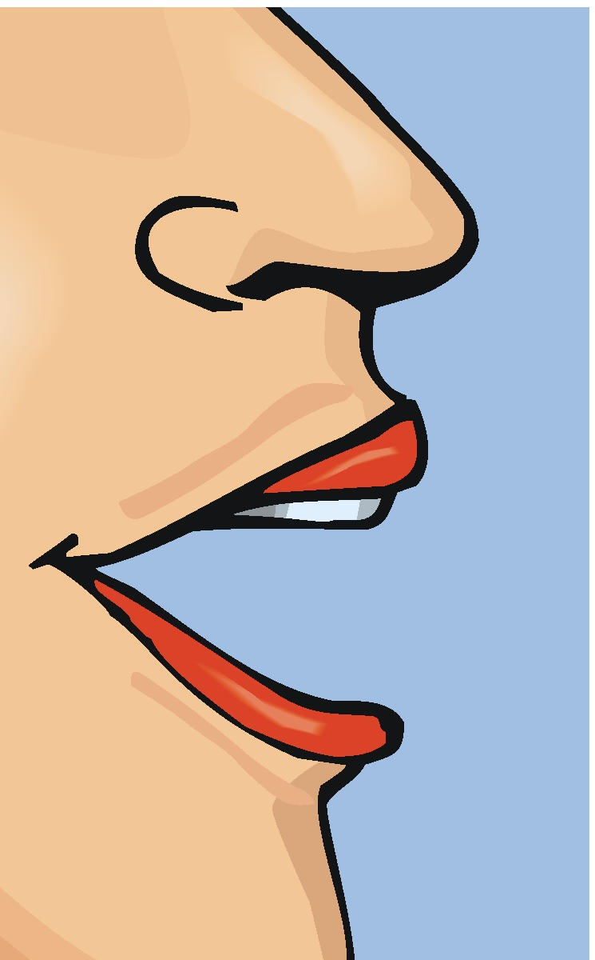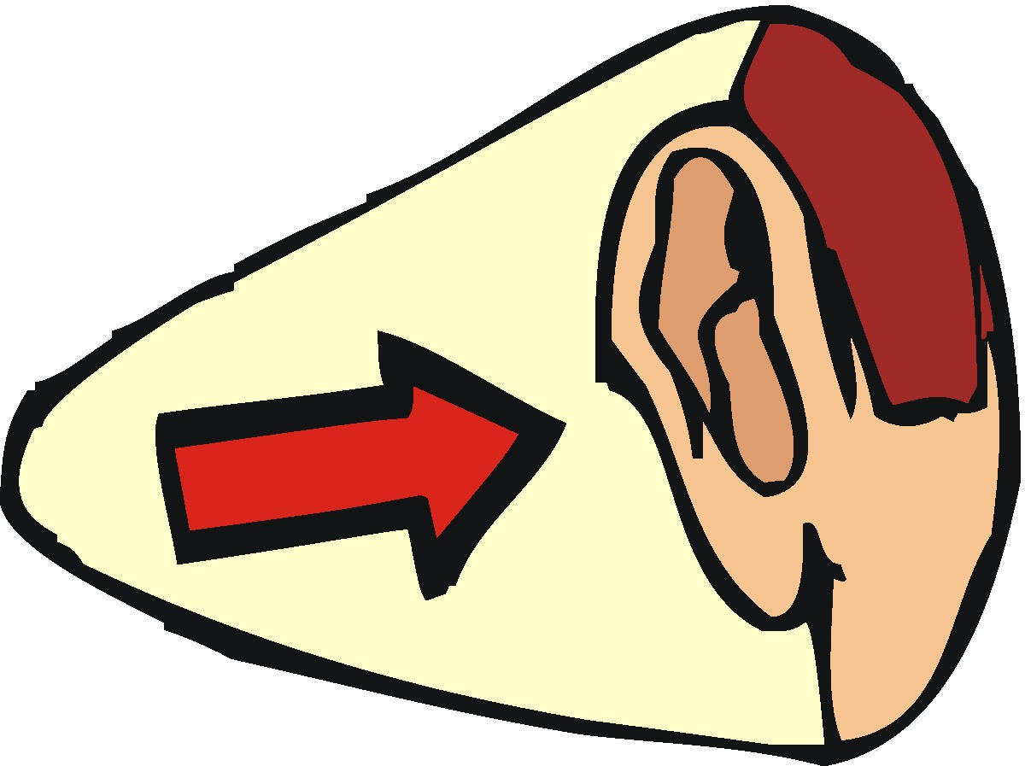

Stringed Instruments

Pluck the strings



Percussion Instruments

Hit them



Wind Instruments

Blow into them



#### Instruments

# Unit Abstract

In this physical science unit students investigate the properties of light. They identify various light sources such as light bulbs, the sun, flashlights, and candles. Students learn that light usually travels in a straight line and cannot pass through opaque objects. They explore how some materials are heated more than others by light that shines one them. Students perform several experiments to find out how shadows are created and how they can be manipulated. They also examine how light can be bent as it passes from one material to another, and reflected by materials such as mirrors.

# Grade Level Content Expectations

Students will:

* identify light as a form of energy (P.EN.03.11).
* demonstrate that light travels in a straight path and that shadows are made by placing an object in a path of light (P.EN.03.21).
* observe what happens to light when it travels from air to water (a straw half in the water and half in air looks bent) (P.EN.03.22).
* explain how we need light to see objects: light from a source reflects off objects and enters our eyes (P.PM.03.52).
* demonstrate how some materials are heated more than others by light that shines on them (P.PM.03.51).
* describe how people have contributed to science throughout history and across cultures (S.RS.03.19).

**Key Concepts**

light source

opaque

reflection

shadow

translucent

transparent

**Duration:** 4 – 6 weeks

**Supplemental Materials**

SCoPE Lesson 1 – Sources of Light

SCoPE Lesson 2 – Let’s Get It Straight

SCoPE Lesson 3 – Me and My Shadow

SCoPE Lesson 4 – What’s The Angle?

SCoPE Lesson 5 – Can You Believe Your Eyes?

SCoPE Lesson 6 – Scattering Light

SCoPE Lesson 7 – Mirror, Mirror

SCoPE Lesson 8 – Using Light As Art

**Recommended (not required) Instructional Resources**

Student Resource

Bailey, Gerry. *Light and Color: Discover Science Through Facts and Fun.* Strongsville, OH: Gareth Stevens Publishing, 2008.

Broekel, Ray. *Experiments with Light.* New York: Children’s Press, 1986.

Cooper, Jason. *Science Secrets: LIGHT.* Vero Beach, FL: Rourke Corporation, 1992.

Davies, Kay, and Wendy Oldfield. *Light.* Austin, TX: Steck-Vaughn Library, 1992.

Gardner, Robert. *Experiments with Light and Mirrors.* Berkeley, NJ: Enslow Publishers, 2006.

Hewitt, Sally. *Amazing Light*. New York: Crabtree Publishing, 2008.

Johnstone, Leslie, and Shar Levine. *The Optics Book of Fun Experiments with Light, Vision, and Color.* New York: Sterling Publishing Company, 1998.

Lauw, Darlene. *Light*. New York: Crabtree Publishing, 2002.

Lynette, Rachel. *Experiments with Light.* Portsmouth, NH: Heinemann, 2008.

Rosinsky. *Light: Shadows, Mirrors, and Rainbows.* Mankato, MN: Picture Window Books, 2004.

Taylor, Barbara.  *Light, Color, and Art Activities.* New York: Crabtree Publishing, 2002.

Teacher Resource

Fiarotta, Noel and Phyllis. *Great Experiments with Light.* New York: Sterling Publishing Company, 1999.

*Stage One Science: Light and Color.* United Learning. 1994. Discovery Education. 15 July 2009 <<http://streaming.discoveryeducation.com/>>.

Zubrowski, Bernie. *Shadow Play*. New York: Morrow Junior Books, 1995.

**Sample Performance Assessments**

1. While standing outside in a sunny place, record the position and length of your shadow at different times during the day. Based upon the findings, explain how the shadows were created and how the angle of the light rays affected the shadow (P.EN.03.21).
2. Using pencils, baggies, and water, describe what happens to light as it travels from air to water (P.EN.03.22).
3. Working in pairs, research the discovery of the light bulb and its affects on society. Write a paper describing what was learned and present to the class (P.EN.03.11, S.RS.03.19).
4. List five sources of light and explain in writing why we need light to see (P.EN.03.51).
5. Using a list of light sources, demonstrate how certain light sources increase temperature. Present outcomes to the class (P.EN.03.52).

**Connections**

English Language Arts

When learning about light and shadows students can use informational text to further their knowledge.

Mathematics

When learning about light students can consider angles of reflection.

Social Studies

When learning about light students can begin to explore how the invention of modern light sources influenced the course of history.

When learning about light students could consider human living conditions before the invention of modern light sources.

Teacher Resource List

Unit 3 Sound Energy

Lesson 2 –

United Streaming videos on Sound

<http://app.discoveryeducation.com/search?Ntt=vibrations&N=18341>

Interactive sound lesson

<http://www.bbc.co.uk/schools/scienceclips/ages/9_10/science_9_10.shtml>

Lesson 3-

United Streaming *Magic School Bus*

<http://app.discoveryeducation.com/search?Ntt=magic+school+bus+sound>

Promethean Planet – Sound review flipchart

<http://www.prometheanplanet.com/en-us/Resources/Item/145441/sound#.U8aa-5RdUdV>

Video- *Understanding Vibrations and Sound* <http://www.pbslearningmedia.org/resource/phy03.sci.phys.howmove.collage/understanding-vibration-and-pitch/>

Lesson 4-

United Streaming – *Change in Pitch*

<http://app.discoveryeducation.com/search?Ntt=changing+pitch>

Lesson 5-

United Streaming – video *Exploring Sounds*

<http://app.discoveryeducation.com/search?Ntt=loud+and+soft+sounds>

Lesson 6-

United Streaming – Video *How Sound Travels*

<http://app.discoveryeducation.com/search?Ntt=how+sound+travels>

Lesson 7-

You tube – Video *String Sound Travel*

<https://www.youtube.com/results?search_query=how+sound+travels+for+children%2F+string+experiment>+

Lesson 8,9, & 10- no videos added

Unit 3 Equipment/Manipulatives

**Lesson 1 Toys That Make Noise**

**Equipment/Manipulatives**

Books (several per group)

Cups (paper or plastic, one per group)

Digital camera (optional, to record ideas throughout unit on bulletin board)

Rubberbands (large, one per group)

Toys that make noise (musical instruments such as kazoos, drums, horns, castanets, flutes,

toy guitars, bells, toys such as wind up toys, rattles, pair of blocks, etc.)

**Lesson 2    Sound Match**

**Equipment/Manipulatives**

Drum

Glass baking pan or pie pan

Overhead projector

Small opaque containers (i.e., Flim canisters or paper bags, 16 per group)

Tuning fork

Variety of small objects for containers (rice, beans, bells, buttons, erasers, marbles, paper clips,

   beads, coins, screws, nuts, washers, centimeter cubes, etc., at least 4 per group)

**Lesson 3 Pitch**

**Equipment/Manipulatives**

Rulers (or paint stirring sticks, one per student)

Scissors

Sound tape

Straws (3 per student)

Xylophone (or Orph instrument)

**Lesson 4   Our Rubber Band**

**Equipment/Manipulatives**

Geoboards (2 per group)

Rubber bands (a variety for each group)

Straw horns (from Lesson 2)

Xylophone (or Orph Instrument)

**Lesson 5  Loud or Quiet?**

**Equipment/Manipulatives**

Straw horns, geoboards, paint stirrers

Tape of music (CD)

Tape recorder (CD player)

**Lesson 6   Sound Travels**

**Equipment/Manipulatives**

Class chart

Earplugs (for demonstration only, several disposable pairs)

Metal spoons or washers (several for each group)

“Sound Damage” transparency from Teacher Background

String (about 1m per group)

**Lesson 7   String Telephone**

**Equipment/Manipulatives**

Paper cups (2 per group)

Sound Transmission Transparency (from Teacher Background)

String (3 meters per group)

Toothpicks (2 per group)

**Lesson 8  Making Music**

**Equipment/Manipulatives**

Balloons

Cereal box

Dowels

Glass jars

Juice cans

Margarine tubs

Nails

Oatmeal box

Paper tubes

Plastic bottles

Rubber bands

Sandpaper

Seeds

Spoons

Tape

Wood

Wooden spoons

**Lesson 9  Playing in the Band**

**Equipment/Manipulatives**

Music for playing along

Student instruments from Lesson 8

**Lesson 10  Changing Pitch**

**Equipment/Manipulatives**

Instruments from Lessons 8 and 9

Optional:  Real instruments that can be used to demonstrate pitch and volume

**Lesson 1: Toys That Make Noise**

**Big Ideas of the Lesson**

* Sounds can be made in different ways.
* Sound is the result of a movement.

**Abstract**

In this lesson students observe sounds that are made by toys and experiment to make their own sounds with familiar equipment.

**Grade Level Context Expectation(s)**

Students will:

* identify sound as a form of mechanical energy (P.EN.03.11).
* relate sounds to their sources of vibrations (e.g., a musical note produced by a vibrating guitar string, the sounds of a drum made by the vibrating drum head) (P.EN.03.31).
* construct simple charts and graphs from data and observations (S.IP.03.16).

**Key Concept(s)**

sound

vibration

**Instructional Resources**

## Equipment/Manipulative

Books (several per group)

Cups (paper or plastic, one per group)

Digital camera (optional, to record ideas throughout unit on bulletin board)

Rubber bands (large, one per group)

Toys that make noise (musical instruments such as kazoos, drums, horns castanets, cymbals, flutes, toy guitars, bells; toys such as wind up toys, rattles, pair of blocks, etc.)

## Student Resource

Hewitt, Sally. *Amazing Sound*. New York: Crabtree Publishing, 2008.

Kahan, Janet, and Juliana Texley. *Supplemental Materials (SC03030101.doc).* Teacher-made material. Waterford, MI: Oakland Schools, 2009.

##### Teacher Resource

Dispezio, Michael. *Awesome Experiments in Light and Sound.* New York: Sterling, 2000.

Kahan, Janet, and Juliana Texley. *Grade 3 Unit 3 Teacher Background (SC030300TB.doc).* Teacher-made material. Waterford, MI: Oakland Schools, 2009.

Nankwell-Aston, Dorothy Jackson. *Sound.* New York: Franklin-Watts, 2000.

National Science Resource Center. *Sound*. Burlington, NC: Carolina Biological Supply Co., 1997.

Pfeffer, Wendy. *Sounds All Around.* New York: Harper Collins, 1999.

Royston, Angela. *My World of Science: Sound and Hearing.* Chicago: Heinemann, 2002.

# Sequence of Activities

Advance Preparation: Collect toys from friends, garage sales, or ask parents for donations. (Children may be reluctant to bring in toys from younger brothers or sisters but will enjoy them when they arrive.)

Make a class chart as shown below:

|  |  |  |
| --- | --- | --- |
| Object that made sound | Description of sound | What was moving? |
|  |  |  |

Create a word bank of sound words (see Step 3 below) on the board or near the chart to help the students describe sounds. Gather cups, rubber bands that fit around the cups, and a book as shown below.

1. Use one of the toys to make a sound. Ask students: “ What did that?” “What made that sound?” Repeat the sound.
2. Show the first section of the Student Pages, “My First Ideas About Sound.” Ask students to use this page to put down some of their ideas about sound.
3. Gather the students near the chart you have prepared. Explain that you are beginning a study of sound and that you have some toys that you would like to investigate. Use one to make a sound and then fill in the chart with the name of the object and description of the sound. Helpful sound words might include “ blat, blare, honk, squeak, tootle, snap, clap, beep, click, clack, cluck, ring, clang, cling, ding, bing, bong, bang, twang, ting, hoot, rustle, whistle, whirr, roar, and growl.”
4. Then ask the students to tell you how the toy made the sound. Ask: “What was moving to make the sound?” Fill in the chart.

Repeat for several different types of toys including percussion, wind, and string instruments, and several other types of toys. Fill in the chart with their answers. Students should fill in the answers to the questions on the first Student Page: Question #2: “How do you describe the sound the object makes?” Question #3: “How does your object make a sound?” [Moves, wiggles, vibrates.] Question #4: “How do you hear the sound?” [Through your ears; vibration goes through air to ears.]

1. Explain that you would like children to work in pairs to investigate another way to make sound. Show them the book, cup, and rubber band. Explain that you would like them to find ways to use these objects to make sound. Show the section of the Student Pages, “How I Made Sound.” Explain that after they have tried several ways to make sound, you would like them to draw and label at least one of the ways that worked. Students should be able to answer the questions with responses parallel to those described in Step 4 above.
2. Lead a brief discussion to help students summarize the concept that sound is the result of movement/vibrations in matter.
3. Create a class bulletin board with sound generating objects. Begin with some photos from magazines or a digital camera photograph of something used in class. This bulletin board should be continued throughout the unit with the participation of the students. They can contribute pictures from magazines.

# Assessment

The Student Pages are authentic assessments. Look for evidence that students understand that vibrations are necessary in the second activity.

# Application Beyond School

At home or on the way home, students can find examples of objects that move or vibrate to make sounds. Have the students observe the dismissal bell, a fire or police siren, and an alarm clock.

# Connections

Arts

Students can explore rhythm and sound generation by various instruments in music classes.

**Lesson 2: Sound Match**

**Big Ideas of the Lesson**

* Vibration is a fast back and forth movement.
* Tuning forks vibrate when they make a sound.

**Abstract**

In this lesson students see demonstrations of a tuning fork in water causing the water to ripple, sand bouncing on a drum, and rice vibrating on a speaker. They define “vibration.” Students match sounds from bags or film canisters with common objects inside. They choose one canister to describe what vibrated to make the sound.

**Grade Level Context Expectation(s)**

Students will:

* identify sound as a form of mechanical energy (P.EN.03.11).
* relate sounds to their sources of vibrations (e.g., a musical note produced by a vibrating guitar string, the sounds of a drum made by the vibrating drum head) (P.EN.03.31).
* construct simple charts and graphs from data and observations (S.IP.03.16).

**Key Concept(s)**

sound

vibration

**Instructional Resources**

## Equipment/Manipulative

Drum

Glass baking pan or pie pan

Overhead projector

Small opaque containers (i.e., Film canisters or paper bags, 16 per group)

Tuning fork

Variety of small objects for containers (rice, beans, bells, buttons, erasers, marbles, paper clips, beads, coins, screws, nuts, washers, centimeter cubes, etc., at least 4 per group)

## Student Resource

Hewitt, Sally. *Amazing Sound.* New York: Crabtree Publishing, 2008.

Kahan, Janet, and Juliana Texley. *Supplemental Materials (SC03030201.doc).* Teacher-made material. Waterford, MI: Oakland Schools, 2009.

##### Teacher Resource

Dispezio, Michael. *Awesome Experiments in Light and Sound.* New York: Sterling, 2000.

Kahan, Janet, and Juliana Texley. *Grade 3 Unit 3 Teacher Background (SC030300TB.doc).* Teacher-made material. Waterford, MI: Oakland Schools, 2009.

Nankwell-Aston, Dorothy Jackson. *Sound.* New York: Franklin-Watts, 2000.

National Science Resource Center. *Sound.* Burlington, NC: Carolina Biological Supply Co., 1997.

Pfeiffer, Wendy. *Sounds All Around Us.* New York: Harper Collins, 1999.

Royston, Angela. *My World of Science: Sound and Hearing.* Chicago: Heinemann, 2002.

United Streaming videos on Sound

<http://app.discoveryeducation.com/search?Ntt=vibrations&N=18341>

Interactive sound lesson

<http://www.bbc.co.uk/schools/scienceclips/ages/9_10/science_9_10.shtml>

# Sequence of Activities

Advance Preparation: Practice using the tuning fork to make vibrations in the water. Strike the tuning fork on your shoe. (Caution: Do not strike it against a hard object such as a table, to avoid damaging the tuning fork.) Then carefully lower the tuning fork into the water in the baking pan or aquarium. You should see a small splash.

You may be able to collect film canisters from your school photographer or a parent with photography as a hobby. Make sets of 16 containers for each group (in film canisters or bags), with pairs of each object. Label eight of each set A, B, C, etc. Label the other eight of the set 1, 2, 3, etc. Record your pairs of objects (For example A, 8 = buttons).

1. Ask students to recall the objects they know of at home that moved to make sound. Add some ideas and a picture to the bulletin board.
2. Explain that a word scientists use for a fast back and forth movement is “vibration.” (If you have an old fashioned alarm clock or if students can feel the dismissal bell, they may wish to describe the feel of a vibration. A pocket pager also can be set to vibrate to help students learn this concept.) Move your hand back and forth quickly to illustrate this idea. Remind them of how they made the rubber band make sound by plucking it. The rubber band moved back and forth. Then strike the tuning fork and place the end on a table. “Can you hear the sound?” Repeat until all have heard it.
3. Ask the students if the tuning fork is vibrating? Explain that you will put the tuning fork into water. Ask for predictions: “Is the tuning fork vibrating when it makes sound?”
4. Again strike the tuning fork. Put the tuning fork into the water in the pan. Ask: “Is the tuning fork vibrating when it makes sound?” Alternate sounding the tuning fork on the table and showing the splash. Add the tuning fork to the class sound chart (bulletin board).
5. Explain to students that you would like them to work in groups to investigate another way to make vibrations. Show them one of the containers. Shake it. Ask: “Is something vibrating or moving back and forth? What might be making this sound?” Explain that you would like them to find matches between the two sets without opening the containers. They should match each lettered container with one numbered container by the sound it makes while shaken. Show the Student Page “Sound Match”. Explain that after they have made their matches they should fill in their record sheet and answer the question.

# Assessment

In the final question, students should be able to explain sound as the result of a movement or a vibration.

# Application Beyond School

Sound helps us recognize many problems; for example, a rattle in a car means something is loose, a jingle in our pocket may mean that’s where our change is.

# Connections

## English Language Arts

In many stories a sound is a clue to a mystery or a lost item. Integrate fiction reading and discuss the importance of sound in the story.

**Lesson 3: Pitch**

**Big Ideas of the Lesson**

* Pitch means how high or low a sound is.
* The pitch of the straw horn depends on the length of the straw. Shorter straws have a higher pitch. Longer ones have a lower pitch.

**Abstract**

In this lesson students listen to a xylophone or file of music with high and low sounds. They define pitch. Students explore pitch using straw horns and develop a rule about pitch. They test their rule using rulers or objects on the edge of their desks.

**Grade Level Context Expectation(s)**

Students will:

* identify sound as a form of mechanical energy (P.EN.03.11).
* relate sounds to their sources of vibrations (e.g., a musical note produced by a vibrating guitar string, the sounds of a drum made by the vibrating drum head) (P.EN.03.31).
* distinguish the effect of fast or slow vibrations as pitch (P.EN.03.32).
* construct simple charts and graphs from data and observations (S.IP.03.16).

**Key Concept(s)**

pitch

sound

vibration

volume

**Instructional Resources**

## Equipment/Manipulative

Rulers (or paint stirring sticks, one per student)

Scissors

Sound tape

Straws (3 per student)

Xylophone (or Orph instrument)

## Student Resource

Hewitt, Sally. *Amazing Sound.* New York: Crabtree Publishing, 2008.

Kahn, Janet, and Juliana Texley. *Supplemental Materials (SC03030301.doc).* Teacher-made material. Waterford, MI: Oakland Schools, 2009.

##### Teacher Resource

Dispezio, Michael. *Awesome Experiments in Light and Sound.* New York: Sterling, 2000.

Kahn, Janet, and Juliana Texley. *Grade 3 Unit 3 Teacher Background (SC030300TB.doc).* Teacher-made material. Waterford, MI: Oakland Schools, 2009.

Nankwell-Aston, Dorothy Jackson. *Sound.* New York: Franklin-Watts, 2000.

National Science Resource Center. *Sound*. Burlington, NC: Carolina Biological Supply Co., 1997.

Pfiffer, Wendy. *Sounds All Around Us.* New York: Harper Collins, 1999.

Royston, Angela. *My World of Science: Sound and Hearing.* Chicago: Heinemann, 2002.

United Streaming *Magic School Bus*

<http://app.discoveryeducation.com/search?Ntt=magic+school+bus+sound>

Promethean Planet – Sound review flipchart

<http://www.prometheanplanet.com/en-us/Resources/Item/145441/sound#.U8aa-5RdUdV>

Video- *Understanding Vibrations and Sound* <http://www.pbslearningmedia.org/resource/phy03.sci.phys.howmove.collage/understanding-vibration-and-pitch/>

Advance Preparation: Practice making and playing three straw horns of different length. Cut a straw to be about 30 cm long. Snip one end of the straw so that it is triangular or pointed. Put the pointed end in your mouth. Use your teeth to flatten the pointed end. Blow through the straw, until it makes a honking noise. Make a second horn a little shorter, and a third a little longer.

1. Ask students to think about their home. “What were some of the objects that found moving to make sounds?” [Bells, whistles, pagers, fans.] “What is the science word we use for the idea that something is moving back and forth?” [Vibration.]
2. Play a note on the xylophone. Ask: “What is vibrating here?” [The bar is vibrating.] Ask students to listen to the sounds you make with the xylophone. Ask them to describe what they have heard. “What was the same about the sounds? What was different?”
3. If students have not used the words *high* and *low* to describe the sounds, play a high note and a low note on the xylophone. Ask: “Which sound is higher? Lower?” Explain that the idea we are using when we say high or low is called “pitch.” Perhaps they have heard a pitch pipe used in music class to give everyone the note.
4. Explain that you would like them to investigate another way change pitch. Show them a straw horn. Honk (or play) the horn. Explain that you would like them to make a straw horn. Explain and model how to make the horn. Remind them to be careful with these pointed objects.
5. After students have made horns, quiet them and ask them to listen carefully as several students play their horns one at a time. Ask them to describe the differences in pitch between the horns. [One is higher; one is lower.] Then ask each student to make another horn that is different in pitch than their first horn. Once they have made a different pitched horn, have students use the Student Page “Straw Horns” to describe the rule they used or found in making the pitches different.
6. Have students make their own horns. Then ask them to test their rule by the sounds they make. Ask students to write how to make horn pitches different on their Student Pages. [Look for *vibration* and *pitch* in their responses.]
7. Take time to discuss the methods that the students used. Allow them to explain to you and to one another how they changed the pitch of their horns.
8. Discuss with students the correlation between their straw horns and wind instruments. Then add a picture of a wind instrument to your bulletin board.

# Assessment

Ask students to twang rulers or paint stirrers on desk edges. Ask them to show how they would vary the pitch of the sound. They should explain how changing the pitch of the paint stirrer is like changing the pitch of the straws. [Look for the terms *high* and *low* in their explanations.]

# Application Beyond School

Some sounds are so high that humans cannot hear them but dogs and cats can. Students may be familiar with a dog whistle or the whine as a camera or other electronic instrument cycles up.

# Connections

## Social Studies

Students can investigate the simple instruments made in other cultures such as an Irish penny whistle, an Australian didgeridoo, or an early European pan harp.

**Lesson 4: Our Rubber Band**

**Big Ideas of the Lesson**

* The pitch of the xylophone depends on the length of the bar. Shorter bars have a higher pitch. Longer ones have a lower pitch.
* The pitch of the rubber band depends on how tight the band is stretched. Tighter bands have a higher pitch. Looser bands have a lower pitch.

**Abstract**

In this lesson students use geoboards with rubbers bands or jars with different depths of water to vary pitch. They write a sentence or two explaining how they arranged the rubber bands and how they changed the pitches.

**Grade Level Context Expectation(s)**

Students will:

* identify sound as a form of mechanical energy (P.EN.03.11).
* relate sounds to their sources of vibrations (e.g., a musical note produced by a vibrating guitar string, the sounds of a drum made by the vibrating drum head) (P.EN.03.31).
* distinguish the effect of fast or slow vibrations as pitch (P.EN.03.32).
* construct simple charts and graphs from data and observations (S.IP.03.16).

**Key Concept(s)**

pitch

sound

vibration

volume

**Instructional Resources**

## Equipment/Manipulative

Geoboards (1 per group)

Rubber bands (a variety for each group)

Straw horns (from Lesson 2)

Xylophone (or Orph Instrument)

## Student Resource

Hewitt, Sally. *Amazing Sound.* New York: Crabtree Publishing, 2008.

Kahan, Janet, and Juliana Texley. *Supplemental Materials (SC03030401.doc).* Teacher-made material. Waterford, MI: Oakland Schools, 2009.

##### Teacher Resource

Dispezio, Michael. *Awesome Experiments in Light and Sound.* New York: Sterling, 2000.

Kahan, Janet, and Juliana Texley. *Grade 3 Unit 3 Teacher Background (SC030300TB.doc).* Teacher-made material. Waterford, MI: Oakland Schools, 2009.

Nankwell-Aston, Dorothy Jackson. *Sound.* New York: Franklin-Watts, 2000.

National Science Research Council. *Sound.* Burlington, NC: Carolina Biological Supply Co., 1997.

Pfiffer, Wendy. *Sounds All Around Us.* New York: Harper Collins, 1999.

Royston, Angela. *My World of Science: Sound and Hearing.* Chicago: Heinemann, 2002.

United Streaming – *Change in Pitch*

<http://app.discoveryeducation.com/search?Ntt=changing+pitch>

# Sequence of Activities

Advance Preparation: Collect geoboards (a common math manipulative) and rubber bands. You may need to contact your mathematics resource person for the manipulative, and your music teacher for an Orph instrument or xylophone.

Safety Precautions: To prevent eye injury, good discipline is necessary when students play with rubber bands.

1. Begin with a motivating sound activity. You might play a sound effects tape, a bell, a gong, or any instrument. Ask: “How do we make sounds?” [Vibrations, moving back and forth.]
2. Review the previous lesson by playing a little on a straw flute. Ask students to think about the rule they made to explain how the pitch changed on their straw horns. Have them share with a partner what their rules were and what their evidence was. Put a rule on the board.
3. Show students the xylophone (or Orph instrument) and ask if their rules for horns can be used to predict the pitches on the xylophone. (The shorter the bar, the higher the tone.) Try out several bars to check.
4. Explain to students that they are going to investigate another way to change pitch. Show them a geoboard. Put a rubber band on it and pluck it. Ask: “Could I change the pitch of this sound?” Try out one or two of their ideas. Explain to students that you would like them to investigate how to change pitch using the geoboards with rubber bands. Show them the Student Page “Our Rubber Band” and demonstrate how you would like them to record how the rubber band was arranged for 2 high pitches and 2 low pitches. Then remind of them class rules about using rubber bands. (They are only to be used on the geoboards, no shooting them, etc.)
5. After students have tried and recorded various arrangements, ask them to stop working and discuss their findings. “Is there a rule like the one that they discovered with the straw horns which tells how pitch will change?” [Yes. The tighter the band is stretched, the higher the pitch.]

Ask students to write a sentence or two explaining what they did with the rubber bands, and what they found out about how to change the pitch.

1. Discuss with students how the geoboard with rubber bands is like a stringed instrument. Then add a picture of a stringed instrument to your class bulletin board.

# Assessment

This is an embedded assessment. Listen to the class discussion of the rules for changing pitch with horns, paint stirrers, xylophones, and rubber bands. Read children’s sentences. Look for consistency of rules and application of rules.

# Application Beyond School

Whales use variation in pitch to communicate over long distances in the oceans. Dolphins and bats use echolocation to navigate.

# Connections

Health and Physical Education

While studying the concept of sound, students can investigate how the human ear works.

**Lesson 5: Loud or Quiet?**

**Big Ideas of the Lesson**

* Volume is how loud or quiet a sound is.
* Increasing the volume requires more force.
* Loud sounds can be dangerous.
* It is important to protect your ears from loud sounds.

**Abstract**

In this lesson students listen for sounds they can hear. They classify them as high or low pitched. Then the students listen for loud and quiet sounds. They classify them as loud or quiet. Students define volume, They tap pencils on their desks, varying the volume. Students use one of their instruments (straw horns, geoboards, paint stirrers) to vary volume. They write a sentence or two explaining how to vary volume.

**Grade Level Context Expectation(s)**

Students will:

* identify sound as a form of mechanical energy (P.EN.03.11).
* relate sounds to their sources of vibrations (e.g., a musical note produced by a vibrating guitar string, the sounds of a drum made by the vibrating drum head) (P.EN.03.31).
* distinguish the effect of fast or slow vibrations as pitch (P.EN.03.32).
* construct simple charts and graphs from data and observations (S.IP.03.16).

**Key Concept(s)**

pitch

sound

vibration

volume

**Instructional Resources**

## Equipment/Manipulative

Straw horns, geoboards, paint stirrers

Tape of music (CD)

Tape recorder (CD player)

## Student Resource

Hewitt, Sally. *Amazing Sound.* New York: Crabtree Publishing, 2008.

Kahan, Janet, and Juliana Texley. *Supplemental Materials (SC03030501.doc).* Teacher-made material. Waterford, MI: Oakland Schools, 2009.

##### Teacher Resource

Dispezio, Michael. *Awesome Experiments in Light and Sound.* New York: Sterling, 2000.

Kahan, Janet, and Juliana Texley. *Grade 3 Unit 3 Teacher Background (SC030300TB.doc).* Teacher-made material. Waterford, MI: Oakland Schools, 2009.

Nankwell-Aston, Dorothy Jackson. *Sound.* New York: Franklin-Watts, 2000.

National Science Research Council. *Sound*. Burlington, NC: Carolina Biological Supply Co., 1997.

Pfiffer, Wendy. *Sounds All Around Us.* New York: Harper Collins, 1999.

Royston, Angela. *My World of Science: Sound and Hearing.* Chicago: Heinemann, 2002.

United Streaming – Video  *Loudness*

<http://app.discoveryeducation.com/search?Ntt=loud+sounds>

# Sequence of Activities

Advance Preparation: Prepare a transparency of “Sound and Ear Damage” (in Teacher Background).

1. Ask students to sit quietly and listen for sounds in or near the classroom. List some on the board. Then ask them to classify these sounds as high or low pitched.
2. Ask students if “pitch” is the only characteristic of sound that can be changed? If students incorrectly say “yes,” give some examples: A calm voice and an angry voice, a toy train horn, and a real train horn.
3. Play a few seconds of music on the tape. Then turn the sound up or down. Ask students what has changed. (Volume, or how loud or quiet a sound is.)
4. Ask students to use their pencils to tap softly on their desks. Then have them tap loudly. Ask: “What did you have to do to change the volume?” [Tapped harder to make a louder noise.]
5. Ask children to work in pairs to investigate another way to change volume, using either the straw horns, the geoboards, or the paint stirrers. For any instrument they choose, they should write down three things: the definition of volume, the name of the object they used, and how they changed the volume, on the Student Page “Loud or Quiet.”
6. Provide students time to investigate their sounds. If space permits, you may wish to have some groups work in the hall or use a larger space like the gymnasium to avoid very loud noise.
7. Ask pairs to report their results back for each instrument. “What was the same about the ways they changed the volume?” [Making a sound louder required more force; a stronger breath, a harder pluck, or a strong thwap on the stirrer.] Discuss answers to questions. Question #1: “What makes a sound louder?” [More force, more wind, a stronger pluck, or pound. Answers to Questions #2 and #3 will vary.]
8. Ask: “Can loud sounds be dangerous?” Confirm that long-term exposure to loud sounds can hurt people’s hearing. Ask: “Have you ever seen people protecting their ears from loud sounds?” [Examples include airport tarmac workers, lawn care workers, and carpenters.] Show the “Sound and Ear Damage” transparency and discuss it.

# Assessment

Given a simple instrument, students should be able to make a loud or soft sound.

# Application Beyond School

Students can investigate loud and soft sounds within their homes.

# Connections

Mathematics

Using a sound-level meter, students can get numerical measures of loudness of sound.

**Lesson 6: Sound Travels**

**Big Ideas of the Lesson**

* Earplugs block the path of the sound from the object into the ear.
* Sound can travel through air, water, and solids.
* Loud sounds travel farther because they have more energy.

**Abstract**

In this lesson students conduct a sound vibration directly to another student’s ear and trace the path of the sound vibrations. They continue to increase their awareness of the potential damage caused by loud sounds.

**Grade Level Context Expectation(s)**

Students will:

* identify sound as a form of mechanical energy (P.EN.03.11).
* relate sounds to their sources of vibrations (e.g., a musical note produced by a vibrating guitar string, the sounds of a drum made by the vibrating drum head) (P.EN.03.31).
* distinguish the effect of fast or slow vibrations as pitch (P.EN.03.32).

**Key Concept(s)**

pitch

sound

vibration

volume

**Instructional Resources**

## Equipment/Manipulative

Class chart

Earplugs (for demonstration only, several disposable pairs)

Metal spoons or washers (several for each group)

“Sound Damage” transparency from Teacher Background

String (about 1m per group)

## Student Resource

Hewitt, Sally. *Amazing Sound.* New York: Crabtree Publishing, 2008.

Kahan, Janet, and Juliana Texley. *Supplemental Materials (SC03030601.doc).* Teacher-made material. Waterford, MI: Oakland Schools, 2009.

##### Teacher Resource

Dispezio, Michael. *Awesome Experiments in Light and Sound.* New York: Sterling, 2000.

Kahan, Janet, and Juliana Texley. *Grade 3 Unit 3 Teacher Background (SC030300TB.doc).* Teacher-made material. Waterford, MI: Oakland Schools, 2009.

Nankwell-Aston, Dorothy Jackson. *Sound.* New York: Franklin-Watts, 2000.

National Science Resource Center. *Sound.* Burlington, NC: Carolina Biological Supply Co., 1997.

Pfiffer, Wendy. *Sounds All Around Us.* New York: HarperCollins, 1999.

Royston, Angela. *My World of Science: Sound and Hearing.* Chicago: Heinemann, 2002.

United Streaming – Video *How Sound Travels*

<http://app.discoveryeducation.com/search?Ntt=how+sound+travels>

# Sequence of Activities

Advance Preparation: Tie string around spoons or washers so that the object is in the middle and the lengths of string on either side are long enough to reach from a desk to a child’s ears. Prepare a chart to summarize class findings.

1. Ask students to think about the idea that loud sounds can hurt their hearing. “What kinds of things do people do to protect their hearing?” [Stay away from loud noises, turn down the volume of music, don’t have headphone on very loud, wear earplugs, etc.] Ask students how ear plugs work. Explain that they block the path of sound from the object that is moving, or vibrating, into the ear.
2. Ask students: “Can sound can travel through air?” [Yes.] “What is your evidence?” [We can hear sounds that are made in our classroom.] “Can sounds travel through anything else besides air?” [A child may relate a story of swimming and hearing a boat approach when his/her head was under the water.]
3. Say: “Sound can travel through air and water. I wonder if sound can travel through string.” Show students the spoon or washer tied on the string. Ask how you could use this equipment to see if sound traveled through the string. Model clanging the spoon gently on the table, while the strings are in your ears. Explain that you would like them to investigate this equipment to see if sound travels through string. Remind them to be very quiet so that the investigators can tell if they are hearing anything. The string should be gently taut as the experiment is done.
4. After two or three minutes of investigation, ask students to report on their findings.
5. Ask students: “Can sound can travel through the desk tops? How could we investigate this?” (A child can put his/her ear on the desk and another child can tap gently.)
6. Explain that you would like students to work in pairs to investigate how sound travels through solids. They should put their ear near something solid in the room (for example, the surface of the desk) while another child speaks near the desk or raps lightly on it. They can also put the edge of a ruler or ribbon near their ear, and speak or rap on the other end. Then explain to students that you would like them to pick one way they found and write down all of the pieces of the path. For example, trace the path of sound from hands clapping to your ear. [Hands move, air moves, sound goes into the ear.]
7. Provide time for students investigate sounds, and record their findings. Summarize findings on a class chart. Provide time to complete the Student Pages. Question #1: Tell the path that sound travels. [The sound travels from the generator out in all directions, but the sound we hear travels straight from the generator to the ear.] Question #2: Do you think loud or quiet sounds travel farther? Tell why you think that. [Loud sounds have more energy, and so travel farther before the energy is so spread out that we cannot hear it.]
8. Review how loud noises can damage hearing. Pass out a pair of disposable earplugs (or cotton batting) to each group. Ask students to explore how the cotton or sponge material interferes with the path of the sound. Make a clap or other sharp sound (Not too loud!) and ask students to describe how the muffling material changes what they hear.
9. Put a photo of a generator (such as a Chinese gong) that makes a very loud sound on the “Sounds” bulletin board.

# Assessment

The diagram of the path of a sound, look for continuity from the generator to the ear.

# Application Beyond School

Students can explore various sound muffling materials that are used in architecture, including in school gymnasiums and music rooms, to avoid occupational injuries to teachers and children.

# Connections

Social Studies

When studying the concept of sound, students can begin to consider regulating sound and noise in their community.

**Lesson 7: String Telephone**

**Big Ideas of the Lesson**

* Hearing loud sounds over and over again can cause hearing loss.
* It is easier to hear sounds through a string telephone when the string is tight and you talk into the cup.

**Abstract**

In this lesson students make and explore string telephones. In groups they explain how sounds are made and how they travel.

**Grade Level Context Expectation(s)**

Students will:

* identify sound as a form of mechanical energy (P.EN.03.11).
* relate sounds to their sources of vibrations (e.g., a musical note produced by a vibrating guitar string, the sounds of a drum made by the vibrating drum head) (P.EN.03.31).

**Key Concept(s)**

sound

vibration

volume

**Instructional Resources**

## Equipment/Manipulative

Paper cups (2 per group)

Sound Transmission Transparency (from Teacher Background)

String (3 meters per group)

Toothpicks (2 per group)

## Student Resource

Hewitt, Sally. *Amazing Sound.* New York: Crabtree Publishing, 2008.

Kahan, Janet, and Juliana Texley. *Supplemental Materials (SC03030701.doc).* Teacher-made material. Waterford, MI: Oakland Schools, 2009.

##### Teacher Resource

Dispezio, Michael. *Awesome Experiments in Light and Sound.* New York: Sterling, 2000.

Kahan, Janet, and Juliana Texley. *Grade 3 Unit 3 Teacher Background (SC030300TB.doc).* Teacher-made material. Waterford, MI: Oakland Schools, 2009.

Nankwell-Aston, Dorothy Jackson. *Sound.* New York: Franklin-Watts, 2000.

National Science Research Council. *Sound*. Burlington, NC: Carolina Biological Supply Co., 1997.

Pfiffer, Wendy. *Sounds All Around Us.* New York: HarperCollins, 1999.

Royston, Angela. *My World of Science: Sound and Hearing.* Chicago: Heinemann, 2002.

You tube – Video *String Sound Travel*

<https://www.youtube.com/results?search_query=how+sound+travels+for+children%2F+string+experiment>+

# Sequence of Activities

Advance Preparation: Make string telephones, either one per pair of students, or enough sets for students to use as part of a center. Cut string three meters long. Use a pencil to poke holes in the bottom of the cups. Break the toothpicks in half. Tie a toothpick half to each end of the string. Put one toothpick through the holes of each cup, so that the toothpick is on the inside of the cup. Let each toothpick lie flat against the bottom of the cup.

A larger space, such as the media center or cafeteria, may be helpful for this experience, so that pairs of students can whisper without interfering with one another. Reserve this space in advance.

1. Remind students that the other day they talked about ways that loud noises could harm their hearing. Have pairs tell each other some examples they remember. Discuss some of their examples. Ask: “Is there a difference between hearing a loud noise one time and hearing it many times?” [Yes, many exposures to a loud noise can contribute to hearing loss.]
2. Explain that today students will be working with a different problem, sounds that are too quiet to hear over long distances. Show students one example of the string telephone. Ask one student to listen into one cup while you whisper into the other cup.
3. Explain to the students that they will work in pairs using string telephones to investigate what the best conditions are for hearing. Then they will trace the path of sound from one partner’s mouth to the other partner’s ear. Caution them to only use whispers and to work a little apart from other pairs.
4. After five or six minutes of investigation per partner, ask students to report on their findings. Ask: “What conditions worked best to hear the whispers?” [String taut, touching nothing, partner’s mouth directed into cup, quiet background, etc.]
5. Ask students to tell each other the path the sounds traveled from one mouth to the other ear. Discuss what the vibrations were moving through. [Air and string, but they move faster through string.]
6. Ask students to write or draw the path of vibrations from mouth to ear on the Student Page.
7. Add a photo of a phone or speakers (or a digital photo of your “telephone pairs”) to the “Sound” bulletin board.

# Assessment

Prompt students: “A group of settlers were traveling across a wide prairie in wagons. They had camped for the night. Suddenly their guide put up his hand and asked for silence. Then he did a strange thing. He knelt down and put his ear on the ground. Then he said “Someone is coming!’ How did he know?” [Sound travels more quickly through solids like the ground than through air.]

# Application Beyond School

Students can explore at home how sounds travel through various mediums such as solids and gases.

# Connections

Technology

While studying the concept of sound students can explore how the telephone works.

**Lesson 8: Making Music**

**Big Ideas of the Lesson**

* A percussion instrument makes a sound when it is hit by another object.
* A wind instrument makes a sound when air is blown into it.
* A stringed instrument makes a sound when a string is plucked.

**Abstract**

In this lesson students make simple instruments to demonstrate their understanding of sound generation.

**Grade Level Context Expectation(s)**

Students will:

* identify sound as a form of mechanical energy (P.EN.03.11).
* relate sounds to their sources of vibrations (e.g., a musical note produced by a vibrating guitar string, the sounds of a drum made by the vibrating drum head) (P.EN.03.31).

**Key Concept(s)**

sound

vibration

volume

**Instructional Resources**

## Equipment/Manipulative

Balloons

Cereal box

Dowels

Glass jars

Juice cans

Margarine tubs

Nails

Oatmeal box

Paper tubes

Plastic bottles

Rubber bands

Sandpaper

Seeds

Spoons

Tape

Wood

Wooden spoons

## Student Resource

Hewitt, Sally. *Amazing Sound.* New York: Crabtree Publishing, 2008.

Kahan, Janet, and Juliana Texley. *Supplemental Materials (SC03030801.doc).* Teacher-made material. Waterford, MI: Oakland Schools, 2009.

##### Teacher Resource

Dispezio, Michael. *Awesome Experiments in Light and Sound.* New York: Sterling, 2000.

Kahan, Janet, and Juliana Texley. *Grade 3 Unit 3 Teacher Background (SC030300TB.doc).* Teacher-made material. Waterford, MI: Oakland Schools, 2009.

Nankwell-Aston, Dorothy Jackson. *Sound.* New York: Franklin-Watts, 2000.

National Science Research Council. *Sound*. Burlington, NC: Carolina Biological Supply Co., 1997.

Pfiffer, Wendy. *Sounds All Around Us.* New York: HarperCollins, 1999.

Royston, Angela. *My World of Science: Sound and Hearing.* Chicago: Heinemann, 2002.

# Sequence of Activities

Advance Preparation: Gather a variety of materials for students to use to make instruments. Alternately, provide simple directions for children to make an instrument at home. A sample direction for parents is included in the Teacher Background.

1. Ask students to list ways they have made sounds in class. List their ideas on the board. Then ask them to tell some of these ways that could be used to make music. Say: “One kind of instrument is a percussion instrument. It makes sound by hitting one object against another in some way.” Ask: “Were there any ways we made percussion instruments like drums?” [Paint stirrers, tapping, clanging spoons.] Say: “Wind instruments are made when air is vibrated in a container. Which object was a wind instrument?” [Straw flutes.] Say: “Stringed instruments make sound when a string is plucked. Did we make stringed instruments?” [Yes, Geoboards.]
2. Then explain to the students that they will be making musical instruments (at school or at home). Explain that when the instruments are ready, each student will have a chance to play his or her instrument for the class and tell how the instrument makes sound.
3. If students are making instruments in class, show some of the materials that have been gathered. Briefly discuss how one or two might be turned into a drum, a shaker, a scraper, or a horn. If you have materials for decoration, display those as well.
4. If instruments are to be made at home, allow adequate time and be conscious of students who may not have the support at home to do the project. (In some schools providing supplies at the School Aged Child Care center helps eliminate this gap.)
5. When a few students have completed their instruments, begin an “Instrument Sharing Time.” Each day have three or four students play their instruments, tell how they made them, and explain how they make sounds.

# Assessment

Create a rubric to evaluate the students’ explanation of how their instruments make sound. A suggested rubric is contained in Teacher Background.

# Application Beyond School

Students begin to gain an awareness of music as an important part of life. Learning to distinguish music from noise is an important part of appreciating this art. This basic distinction applies to music from many cultures.

# Connections

Social Studies

While studying the concept of sound students can investigate the forms of music from diverse cultures. (For example, the “throat music” of the Himalayas is a unique art in which humans simultaneously generate two or more tones of a harmonic using the same vocal cords.)

**Lesson 9: Playing in the Band**

**Big Ideas of the Lesson**

* I can identify whether an instrument is a percussion, wind, or stringed instrument.
* I can change the volume when I play an instrument.

**Abstract**

In this lesson students sort their homemade instruments by type (wing, percussion, string). Groups sort instruments by pitch and record their data. They play instruments together. The teacher conducts the band, giving signals for loud and soft that the students follow.

**Grade Level Context Expectation(s)**

Students will:

* identify sound as a form of mechanical energy (P.EN.03.11).
* relate sounds to their sources of vibrations (e.g., a musical note produced by a vibrating guitar string, the sounds of a drum made by the vibrating drum head) (P.EN.03.31).

**Key Concept(s)**

sound

vibration

volume

**Instructional Resources**

## Equipment/Manipulative

Music for playing along

Student instruments from Lesson 8

## Student Resource

Hewitt, Sally. *Amazing Sound.* New York: Crabtree Publishing, 2008.

Kahan, Janet, and Juliana Texley. *Supplemental Materials (SC03030901.doc).* Teacher-made material. Waterford, MI: Oakland Schools, 2009.

##### Teacher Resource

Dispezio, Michael. *Awesome Experiments in Light and Sound.* New York: Sterling, 2000.

Kahan, Janet, and Juliana Texley. *Grade 3 Unit 3 Teacher Background (SC030300TB.doc).* Teacher-made material. Waterford, MI: Oakland Schools, 2009.

Nankwell-Aston, Dorothy Jackson. *Sound.* New York: Franklin-Watts, 2000.

National Science Research Council. *Sound*. Burlington, NC: Carolina Biological Supply Co., 1997.

Pfiffer, Wendy. *Sounds All Around Us.* New York: HarperCollins, 1999.

Royston, Angela. *My World of Science: Sound and Hearing.* Chicago: Heinemann, 2002.

# Sequence of Activities

Advance Preparation: Make sure that all of the students have had an opportunity to build an instrument. If some them have not had the opportunity to build an instrument at home, you may wish to have some simple percussion instruments (such as gallon milk cartons or the geoboard stringed instruments) for them to use in the “band.”

Contact your school music teacher for a background tape. Many packaged school programs have background music that can be used for such activities.

1. Ask students to think back to the investigations about sound. Ask: “What were some properties of sound that you were able to change?” [Pitch, volume.] Have one student in a pair explain what pitch is; have the other students tell what volume is.
2. Explain that you would like students to work with the instruments they have made. Explain that you would like them to work in groups to sort their instruments various ways. First you would like them to sort the instruments by type: percussion, wind, and string and record their classification on the Student Page “Sorting Sounds.” Then ask students to sort by pitch (high, medium, and low), and record that sort.
3. Explain that you would like to have them all play together while you conduct, as though they were a band or orchestra. Tell students you will raise your arms when you want loud sounds and lower your arms for quieter sounds. (Optional: if you choose to use recorded music for students to accompany, and play it once so that they can hear it. Then repeat with student accompaniment.)

# Assessment

Use the sorting activity as an assessment.

# Application Beyond School

# Students can begin to distinguish between music and noise.

# Connections

## Arts

While studying the concept of sound, students can explore a variety of musical instruments.

**Lesson 10: Changing Pitch**

**Big Ideas of the Lesson**

* I can change the pitch of my instrument.

**Abstract**

In this lesson students demonstrate their understanding of pitch and volume by showing how to change the pitch of their instruments.

**Grade Level Context Expectation(s)**

Students will:

* identify sound as a form of mechanical energy (P.EN.03.11).
* relate sounds to their sources of vibrations (e.g., a musical note produced by a vibrating guitar string, the sounds of a drum made by the vibrating drum head) (P.EN.03.31).

**Key Concept(s)**

sound

vibration

volume

**Instructional Resources**

## Equipment/Manipulative

Instruments from Lessons 8 and 9

Optional: Real instruments that can be used to demonstrate pitch and volume

## Student Resource

Hewitt, Sally. *Amazing Sound.* New York: Crabtree Publishing, 2008.

Kahan, Janet, and Juliana Texley. *Supplemental Materials (SC03031001.doc).* Teacher-made material. Waterford, MI: Oakland Schools, 2009.

##### Teacher Resource

Dispezio, Michael. *Awesome Experiments in Light and Sound.* New York: Sterling, 2000.

Kahan, Janet, and Juliana Texley. *Grade 3 Unit 3 Teacher Background (SC030300TB.doc).* Teacher-made material. Waterford, MI: Oakland Schools, 2009.

Nankwell-Aston, Dorothy Jackson. *Sound.* New York: Franklin-Watts, 2000.

National Science Research Council. *Sound*. Burlington, NC: Carolina Biological Supply Co., 1997.

Pfiffer, Wendy. *Sounds All Around Us.* New York: HarperCollins, 1999.

Royston, Angela. *My World of Science: Sound and Hearing.* Chicago: Heinemann, 2002.

# Sequence of Activities

1. Remind students that yesterday they changed the volume of their instruments as you conducted them. Ask: “What did you do to make the instruments louder?” “Quieter?” Discuss their answers.
2. Ask if they could also change the pitch on their instruments? Ask for some examples of instruments that could be changed without being damaged. [Flutes could have more holes in them, guitars could have tighter or looser strings, or the strings could be held down to sound “shorter,” drum heads could be stretched more tightly, Shakers could have different things inside them.] Optional: if you have real examples of instruments, show how pitch can be varied on them.
3. Then explain that you would like them to work with their instruments. Explain that you would like students to work in pairs to think about ways that they might be able to change the pitch of one of their instruments. Reassure them that they will not have to destroy their instruments, but only make a plan to change pitch on instruments.
4. Pairs meet to discuss how to change pitch on at least one instrument. They record their ideas. Optional: If groups can change the pitch without damaging the instrument, have them demonstrate and explain their changes to the class.
5. Conclude the lesson by reminding students what they have learned in the past few lessons, emphasizing the production of sound, pitch, and volume. Explain that a while art form—music—is based upon this ability.

# Assessment

Use the rubric in the Teacher Background to assess the understanding of the students during their explanations.

# Application Beyond School

Students can explore how many people with hearing deficits actually cannot hear selected pitches. (People who have been exposed to loud, often industrial, noises often have selective hearing loss at the higher pitches. Lack of ability to hear higher pitches in adults is called *presbyacusis.* This deficiency makes the spoken language harder to understand.)

# Connections

Technology

When studying the concept of sound students can discover how sound technologies design speakers that are especially good at specific ranges of pitches (woofers for low frequency sounds and tweeters for high frequency sounds). Most stereo radios allow the user to adjust for various treble/base pitches.