**Unit 3: Landforms**

**Teacher Background**

In this introductory unit to Earth’s surface features, the emphasis is on scientific description and organization. Children should build a bank of scientifically descriptive words through a series of observations and investigations. Each investigation (model) should be firmly tied to a real-world observation, either in the child’s own community or in a shared experience from a vacation or video.

Children also get their first exposure to mapping in this unit. Mapping is not a concept that is easily understood by children of this age. The experiences in this unit should be considered a first exposure, not an area for assessment. The unit builds first on mapping of an area through which the class has traveled (a walking field trip) and a map of the school yard. Later children see maps of Michigan and globes. But it is important to remember that for most children these representations will be to some extent imaginary. Very few children of this age can really comprehend the relationship between a paper map and a physical place like their home state. However, by tying real observations to points on the map, you can begin to establish the foundations of understandings that will be more fully developed in later years.

The concept of “model” is an extremely important one, as well. Models are not only physical representations. In scientific research, models are more often mathematical equations or computer algorhythms. But for children, the easiest models to understand are physical ones. Students create two models of surface features, in Lesson 2 and again in Lesson 10. In the first model they are representing an area that they have recently visited. In the second, they represent landforms that are more theoretical—those they have studied and/or read about in informational or fictional reading. This sequence represents an increase in understanding for most children.

#### **Michigan Landforms**

While the landforms of many states have been influenced by major (but *very slow*) movements of the crust of the Earth, Michigan’s hills and valleys are almost all the result of more recent—and geologically more rapid—changes. Most of the hills and valleys in Michigan are the result of the movement of the glaciers. The last glaciers receded from Michigan about 10,000 years ago and the scraps and scrapes from its retreat are still visible across the state. Low, dimpled areas of lakes (like the Bloomfield area or Houghton Lake) are the result of glacial melt. High hills are sometimes actually glacial “parks”—areas of land that were depressed by a glacier and then recoiled. Long snakelike esker hills and rounded moraines are gravelly remnants of glacial melt. And when we run into a large igneous boulder in a flat, sedimentary farmer’s field, we can almost always deduce that a glacier left it behind.

But there are exceptions. The western Upper Peninsula of Michigan is strikingly different. Its igneous rocks are very old—part of the “Canadian Shield” or heart of the old continent. And in a few parts of Michigan (chiefly northeastern Michigan) scattered valleys are actually the collapsed roofs of underground rivers through soluble limestone—Karst topography.

Many of Michigan’s rivers have been dammed for hydroelectric power, but still flow strongly. Unlike rivers in the western United States, floods are relatively uncommon. The heavy forests of Michigan act as a watershed (like a giant sponge) absorbing rain and snowmelt and releasing it more slowly than the drier lands in the west.

Lakes and ponds are the most common familiar landforms in Michigan. Technically, a lake is an area that is deep enough that some parts never receive light to the bottom. A pond is shallow enough that at some time of the year, light penetrates to the bottom all over. That makes the maximum depth of a pond about 2 to 3 meters.

# Using PowerPoint with Children

Teachers have found that even very young children now enjoy creating hypertext with programs such as PowerPoint. It is easy to use in the classroom. Because digital pictures can be immediately processed and printed, it is easier for children to see the connection between what they observe and the displays and publications they make.

For Lessons 1 and 2 of this unit, you can combine student photos into a PowerPoint presentation or Promethean flipchart easily. Select a “new presentation,” and then for each slide select a template page with a picture and include a little text. Hit the space for the photo with your mouse, and click “insert picture.” You can then browse your disk for the picture you want. To begin the lesson, do not fill in the text portion of the page template. Wait until children have had an opportunity to observe and comment on their pictures. Then return to each frame and double click to edit. You can add the scientific words that children have selected to identify their photos the second time around, and save your presentation for a parent night or a “tour book” of your area to share with parents.

**Mountains and Hills in Michigan (Lesson 3)**

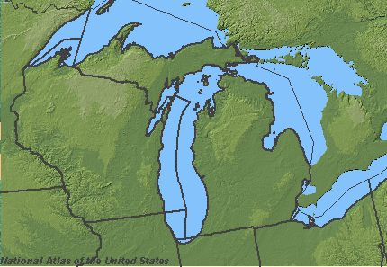

A sample of a topographic map of Michigan that could be generated from the National Atlas of the United States ([www.nationalatlas.gov](http://www.nationalatlas.gov)). To generate maps from this site, click “Make Maps” and choose your state. Then scroll down the menu of possible map elements on the right side. When you have checked those elements that you want on the map check “redraw” and then save the map to your disk by right clicking.

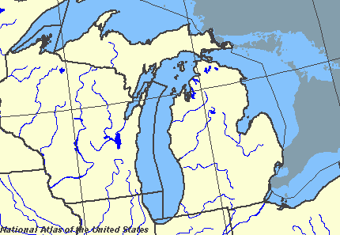

**Water on the Earth (Lesson 6)**

This is a sample of another map, showing water in Michigan, from the National Atlas of the United States. You can zoom in to the area of Michigan that includes your school.

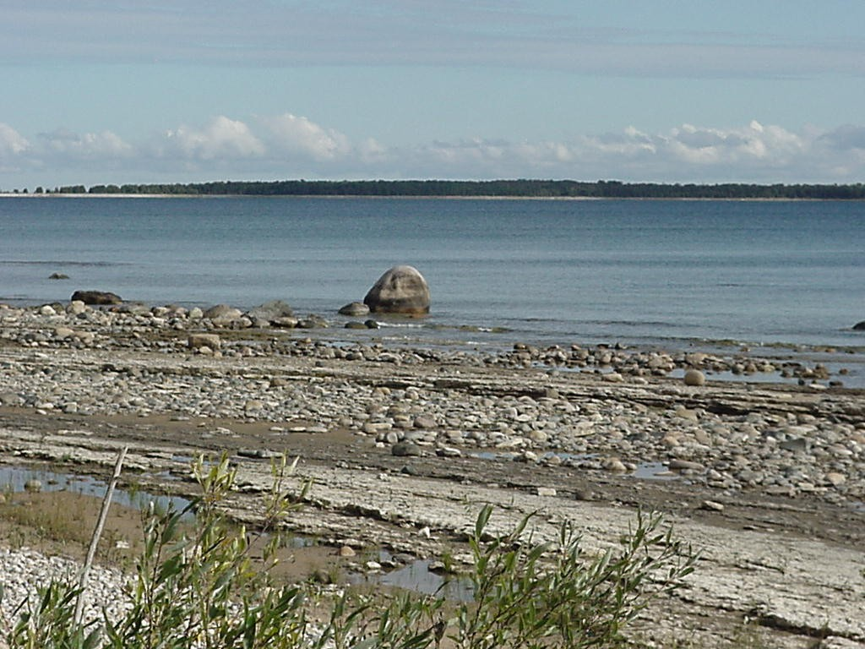

A Michigan Lake

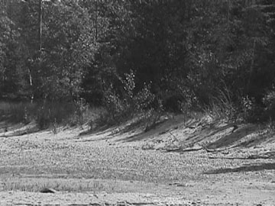

A Michigan dune

How can you keep cool on the desert? What color would be best?

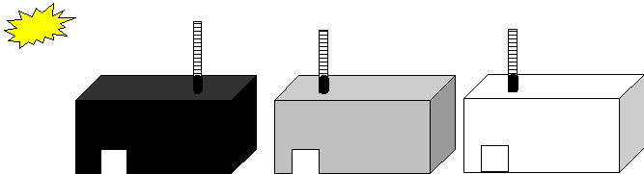

Rivers

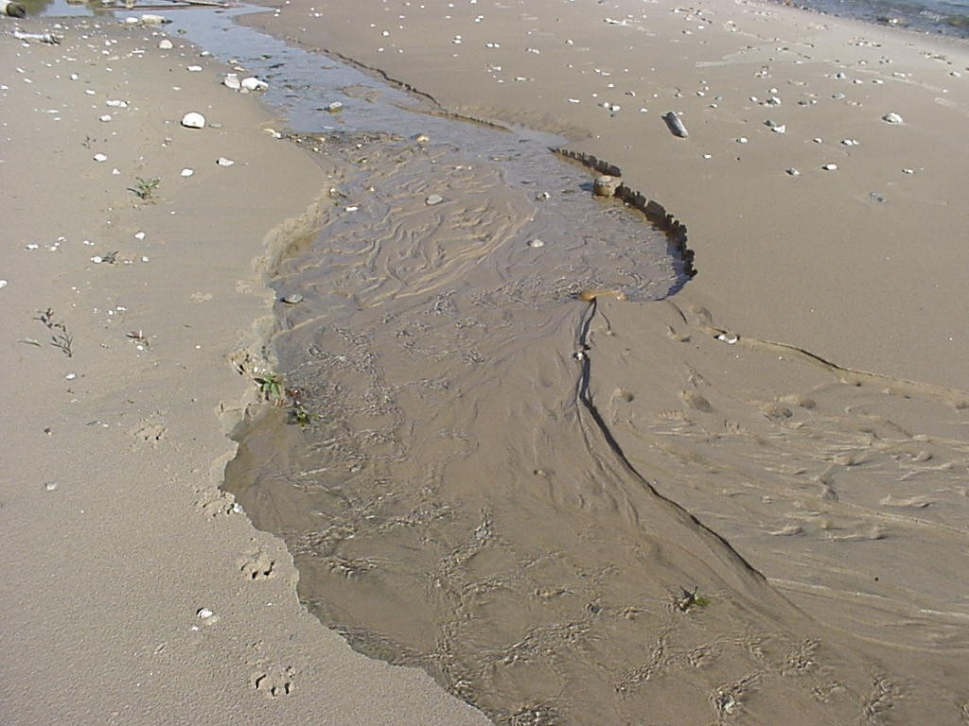

**Word Cards for Unit 3**

|  |  |
| --- | --- |
| **1**  **surface feature**  A landform  on the Earth’s  surface.  ***Example*:** The pond is a surface feature of the Earth. | **2** **landform** A place on the  Earth with a  certain shape  and description.  ***Example*:** The pond is a landform. |
| **3**  **hill**  A raised area  of land.  ***Example:*** The hills are covered with trees. | **4**  **field**  An area of  open land.  ***Example:*** The grass in the field has grown tall. |
| **5**  **lake**  A large body  of water that  is surrounded  on all sides  by land.  ***Example:*** The lake is calm today. | **6**  **river**  A large stream.  ***Example*:** The river flows for many miles. |
| **7**  **valley**  An area of low  land between  mountains or  hills.  ***Example*:** The valley is green and grassy. | **8**  **pond**  A small body  of still water.  ***Example*:** The pond is still and quiet. |
| **9**  **stream**  A small flowing  body of water.  ***Example*:** The stream moves slowly. | **10**  **plains**  A large flat  area of land.  ***Example:*** The plains are a good place for farming. |
| **11**  **mountain**  Very high land  with steep  sides.  ***Example*:** The mountain is the tallest one in our state. | **12**  **characteristic**  A quality of  something.  ***Example*:** A characteristic of the land is that it is dry. |
| **13**  **wildlife**  Wild animals  in an area.  ***Example*:** There is wildlife in the pond. | **14**  **vegetation**  Plants in an area.  ***Example*:** This area has a lot of vegetation. |
| **15**  **bird’s eye view**  A view from  above.  ***Example*:** This map is a bird’s eye view of France. | **16**  **physical relief map**  A map that shows  the Earth’s  features.  ***Example*:** This is a physical relief map of France. |
| **17**  **erosion**  Wearing away  of the earth’s  surface by wind  or water.  ***Example*:** Erosion is wearing away the land. | **18**  **ocean**  A large body  of salt water.  ***Example*:** The ocean is rough today. |
| **19**  **desert**  A dry sandy area  with few trees.  ***Example*:** The days are hot and dry in the desert. | **20**  **sand dune**  A hill of sand  built up by the  wind.  ***Example*:** The sand dunes are hard to climb. |
| **21**  **adobe**  A building  material made  from dried clay.  ***Example*:** The house is made of adobe. | **22**  **globe**  A model of the  Earth.  ***Example*:** The globe shows how much water and land is on the Earth. |
| **23**  **glacier**  A large mass of  ice.  ***Example*:** The glacier is sliding into the sea. | **26**  **model**  A representation  of something else.  ***Example*:** The map is a flat model of the Earth. |

**Questions Chart for Unit 3**

|  |  |
| --- | --- |
| **Question** | **Answer** |
| **What are landforms?** | Surface features are landforms on the Earth’s surface. |
| **What is a bird’s eye view?** | A bird’s eye view is a view from above. |
| **What are two things that can change the shape of the land?** | Wind and water can change the shape of the land. |
| **What are oceans?** | Oceans are large bodies of salty water. |
| **How do people survive in the desert?** | People live in adobe houses, wear white clothing, and stay out of the sun as much as possible. |
| **Is there more land or more water on the Earth?** | There is more water on the Earth. |
| **What is water without salt called?** | Water without salt is called freshwater. |
| **What changes the shape of a river?** | Rocks change the shape of a river. |
| **What are the surface features of the Earth?** | The surface features of the Earth are hills, fields, lakes, rivers, valleys, ponds, streams, mountains, plains, oceans, deserts, and glaciers. |
| **What is a model?** | A model is a representation of something else. |

**Graphic Organizer for Unit 3**

**Graphic Organizer for Lesson 3**

Glacier

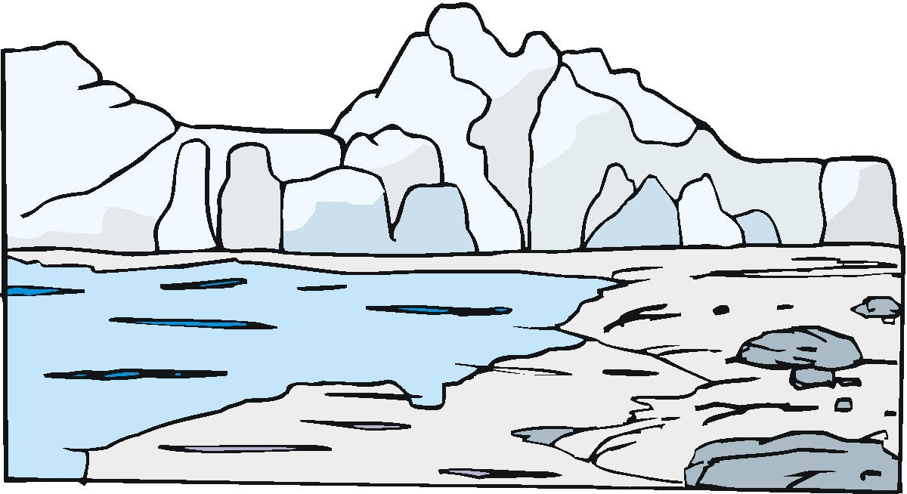

Desert

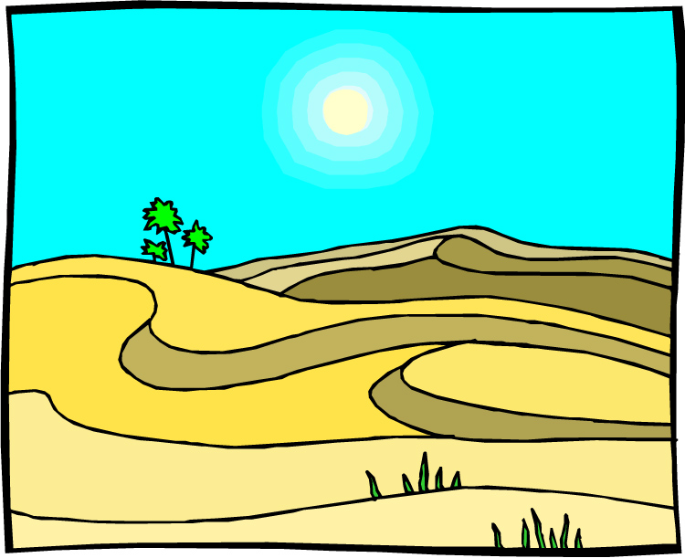

Ocean

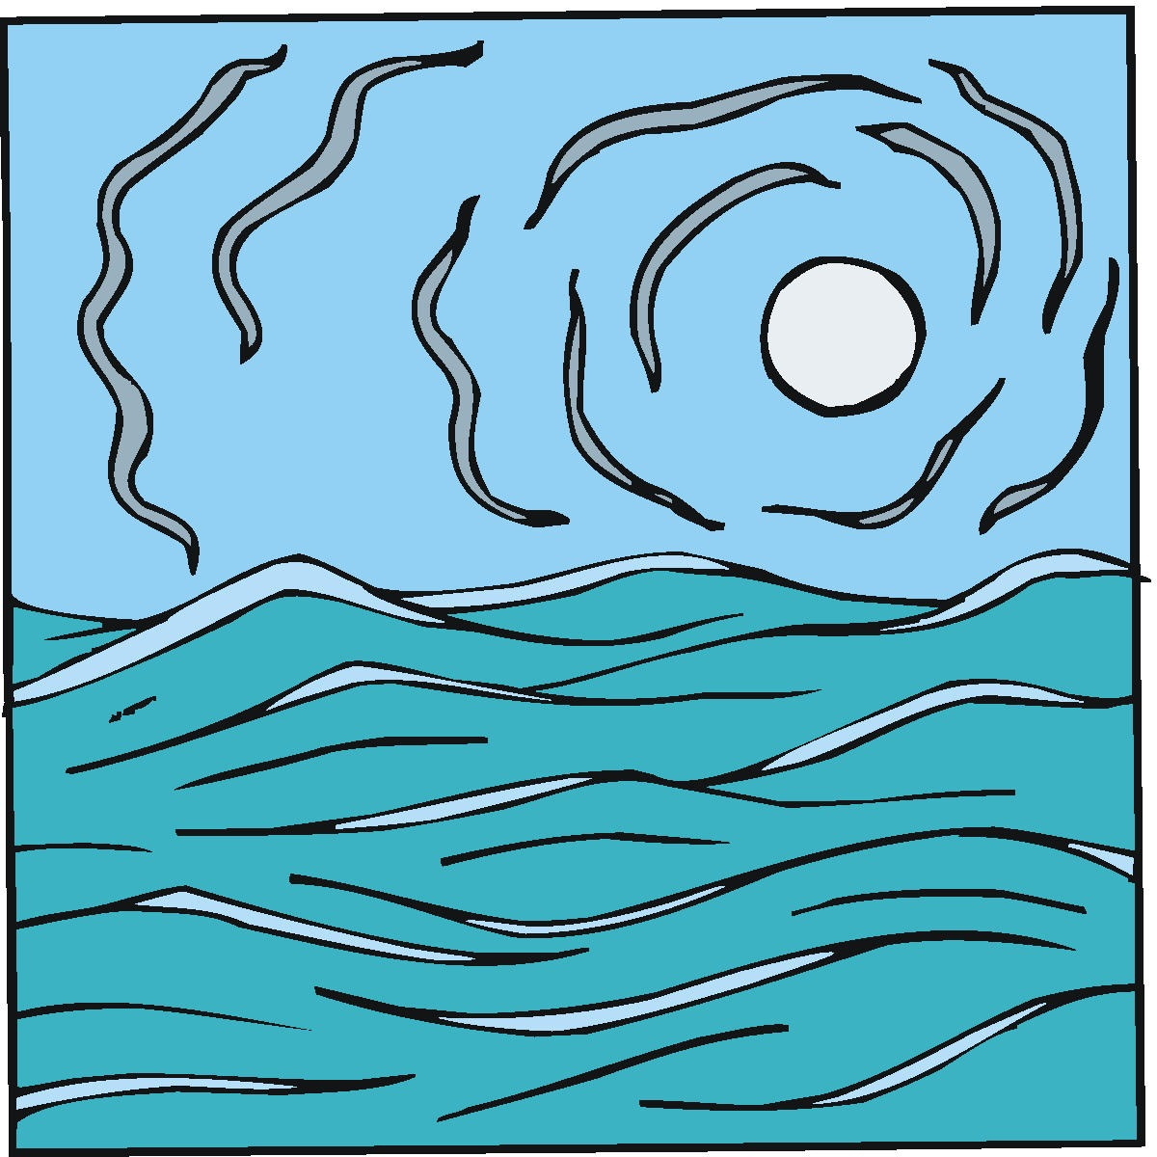

Plains

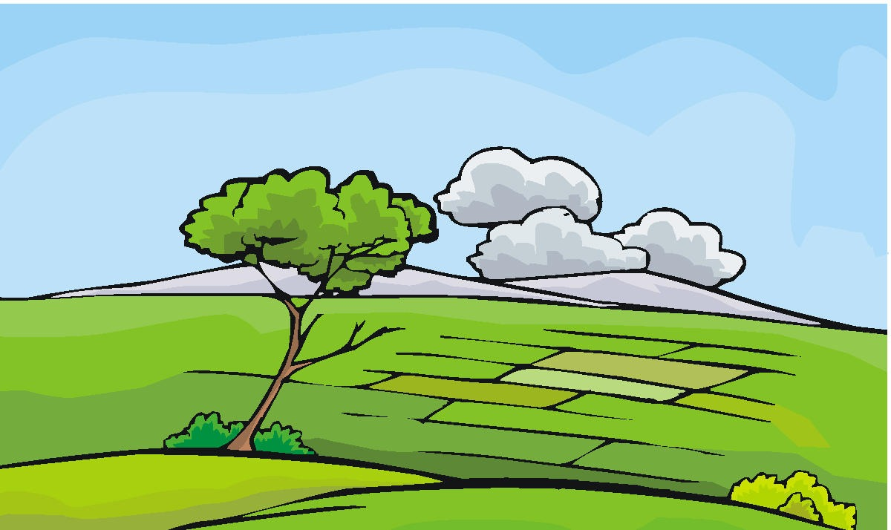

River

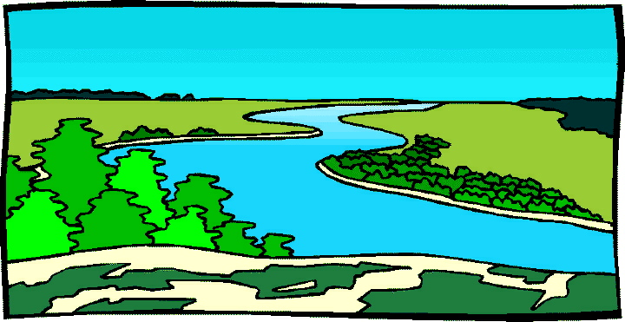

Lake

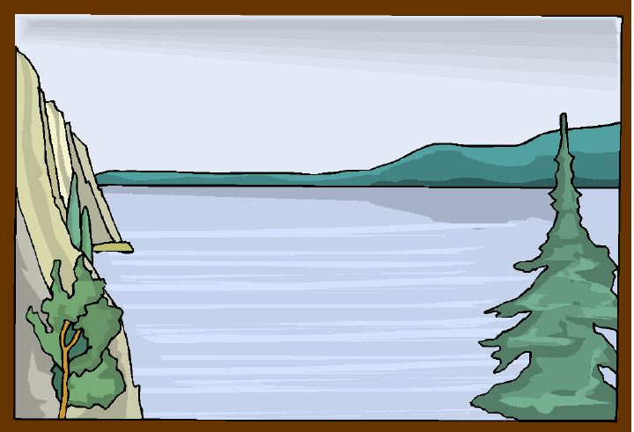

Field

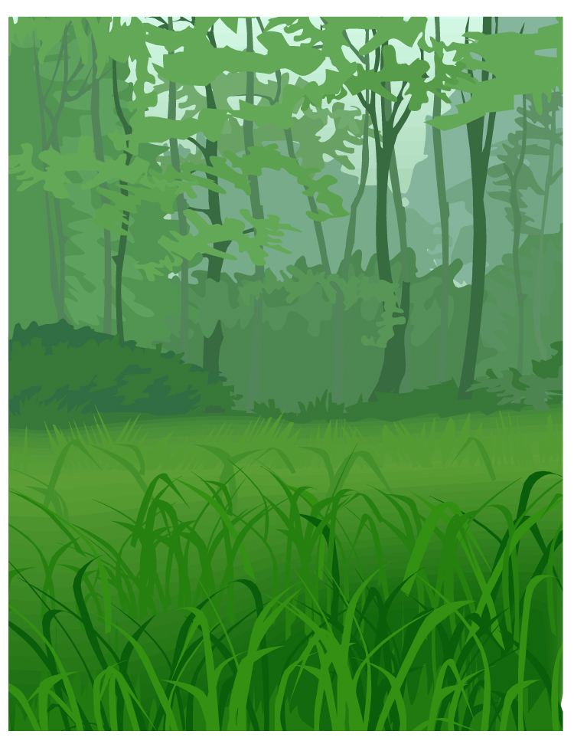

Hill

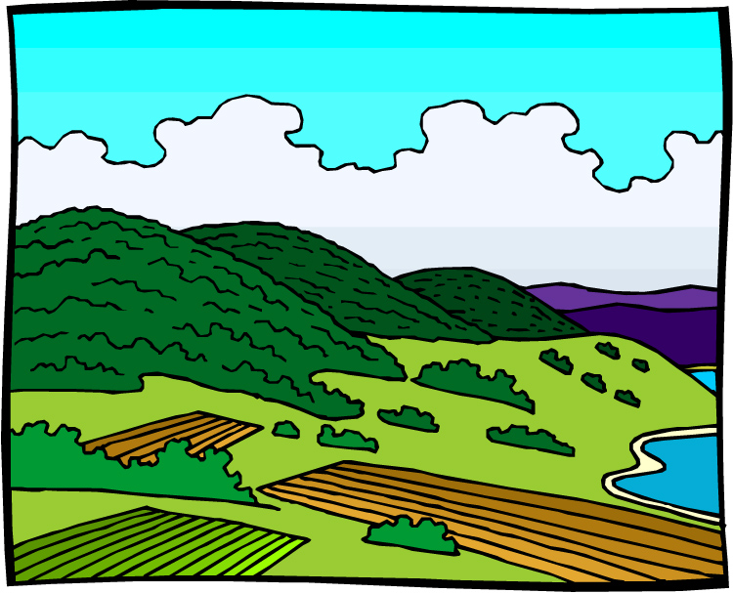

Mountain

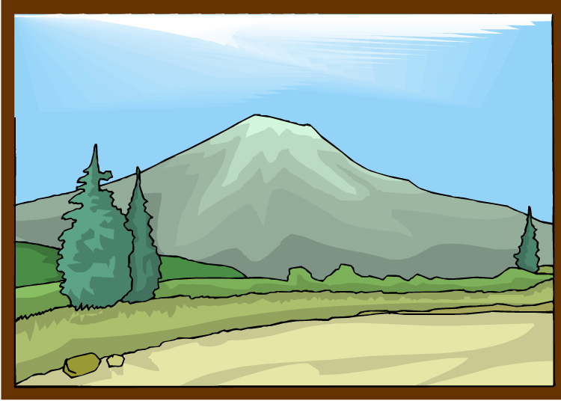

Pond

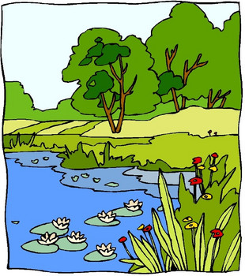

Surface

Features

Stream

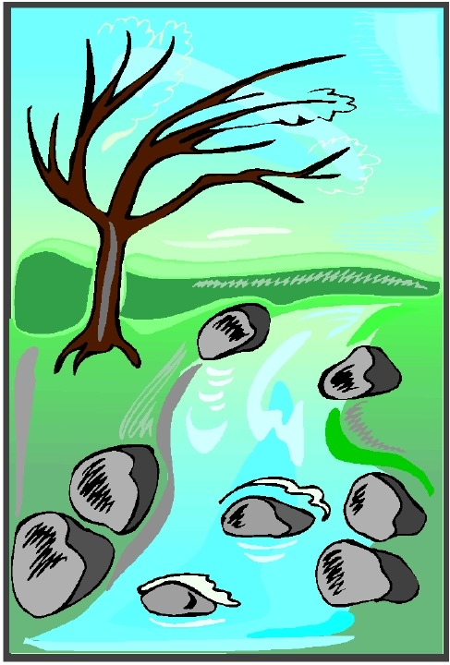

Valley

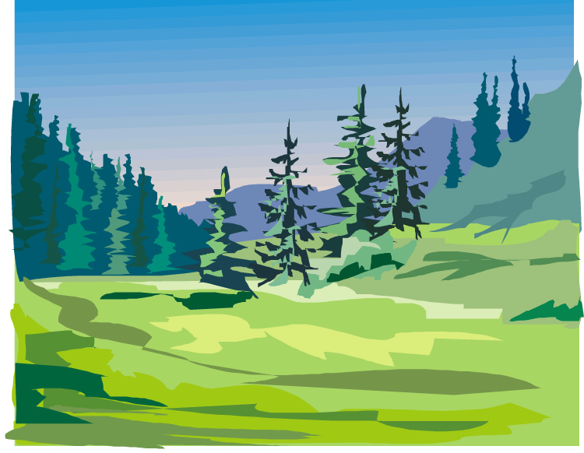

**Graphic Organizer for Lesson 6**

Wind

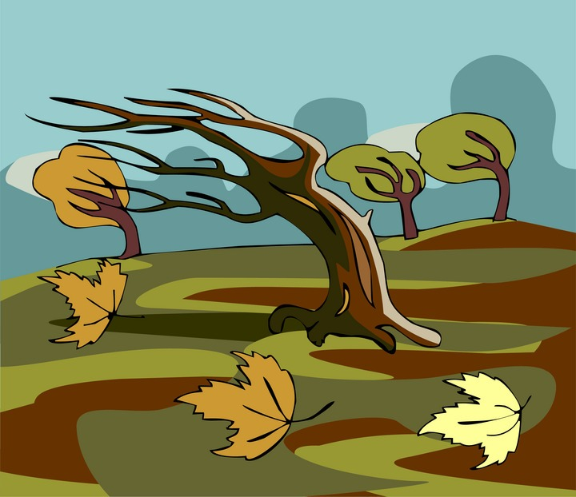

Rain

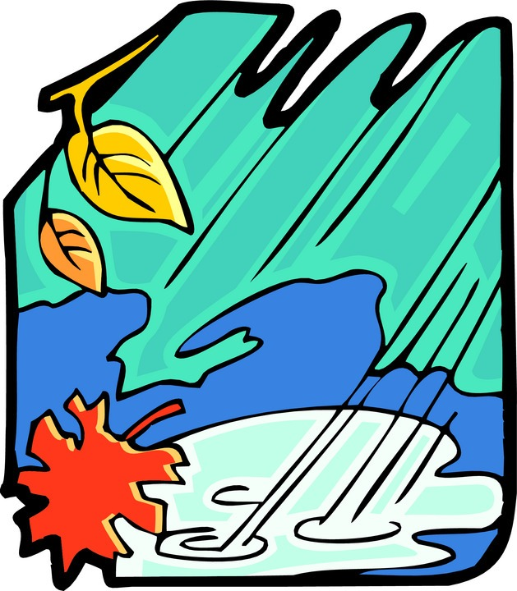

Ocean



Glacier



Bodies of Water

River



Stream



Lake



Pond



**Lesson 1: Take a Trip**

**Big Ideas of the Lesson**

* Surface features are landforms on the Earth’s surface.
* Hills, fields, lakes, rivers, valleys, ponds, and streams are examples of surface features.

**Abstract**

In this lesson children observe the different features on the surface of the earth by visiting a nearby natural area and making observations.

**Grade Level Context Expectation(s)**

Children will:

* describe the major landforms of the surface of the earth (e.g., mountains, plains, plateaus, valleys, hills) (E.SE.02.21).
* describe the major bodies of water of the earth’s surface (e.g., lakes, ponds, oceans, rivers, streams) (E.FE.02.22).
* develop strategies and skills by gathering information about the features of the earth (e.g., books, Internet, ask an expert, observation, investigation, technology tools) (S.IA.02.14).

**Key Concept(s)**

desert

lake

mountain

ocean

plain

river/stream

surface feature

water source

**Instructional Resources**

# Equipment/Manipulative

Camera, iPad, or Cell Phone can be used. (Digital is optimal; one per group is best)

Clipboards (one per child)

# Student Resource

Fanelli, Sara. *My Map Book*. New York: Harper Collins Children’s Books, 2001.

Gabrys, Jennifer, and Claudia Douglass. *Supplemental Materials (SC02030101.doc).* Teacher-made material. Waterford, MI: Oakland Schools, 2009.

Kalman, Bobbie. *The ABC’s of Continents.* New York: Crabtree Publishing, 2008.

---. *Earth’s Coasts (Looking at Earth).* New York:Crabtree Publishing, 2009.

---. *Earth’s Mountains (Looking at Earth).* New York: Crabtree Publishing, 2009.

---. *Earth’s Oceans (Looking at Earth).* New York: Crabtree Publishing, 2008.

---. *Earth’s Rivers (Looking at Earth).* New York: Crabtree Publishing, 2009.

---. *Introducing Landforms (Looking at Earth).* New York: Crabtree Publishing, 2008.

Sweeney, Joan. *Me on the Map*. New York: Random House, 1998.

Teacher Resource

Gabrys, Jennifer, and Claudia Douglass. *Grade 2 Unit 3 Teacher Background (SC020300TB.doc).* Teacher-made material. Waterford, MI: Oakland Schools, 2009.

Kwan, Terry, and Juliana Texley. *Exploring Science Safely.* Arlington, VA: National Science Teachers Association, 2002.

*Oakland County Parks*.29 January 2009 <<http://www.oakgov.com/parksrec/>>.

**Sequence of Activities**

Advance Preparation: Make arrangements to visit a nearby park or natural area that has a variety of surface features for the children to explore. Suggestions include visiting [Ligon Outdoor Center](http://ligon.geneseeisd.org/) (free with busing scholarship) or [Formar Nature Preserve](http://www.geneseecountyparks.org/pages/formar) which are both located in Genesee County. This may be planned as a day trip or for an afternoon. Visit the site beforehand to be sure that the surface features you discuss in class are available and to determine a path for a nature walk that will take the group through these areas. Work with adult group leaders (chaperones) to encourage them to listen to children’s ideas and follow their lead in taking photographs. Make sure they can operate the cameras, and that they keep a log of what they have photographed for later use.

Safety Precautions: Suggest that children wear long sleeves and pants and apply insect repellant to avoid mosquitoes or poisonous plants. (Check with parents regarding allergies.)

1. Lead a discussion with the children about surface features. Tell them that surface features are landforms on the Earth’s surface such as hills. Several landform photos are included in the Teacher Background file for bulletin boards or as starters for discussion. Ask the children to brainstorm a list of surface features that they have seen and what they know about them. Make a list of their responses on the chalkboard and have the children complete the pre-survey portions of the Student Pages. Guide the children to list: hills, fields, lakes, rivers, and valleys.
2. Tell the children that they will be visiting a natural area in order to collect more data about the Earth’s surface features that are near their homes. Explain how they will collect data on the remainder of their Student Page. For each area they visit, they should sketch what the landform looks like and include a drawing of at least one animal (including birds, insects, fish, etc.) and one plant that they observe.
3. Collect the Student Pages so that you can redistribute them at the park.
4. Be sure to discuss guidelines for the field trip including the rule of thumb that the natural areas should not be disturbed. It is important that they use classroom voices even though they will be outside so that they do not disturb any wildlife.
5. At the park, redistribute the Student Pages.
6. Begin a nature walk through the park. When you arrive at a particular surface feature, have the children stop to make observations. While the children are making observations, take pictures of each site to use in the next lesson. Visit as many surface features as are available.
7. Once the trip has been completed, collect the Student Pages for use during the next lesson.

## **Assessment**

Ask the children to write a journal entry about their experience. They may answer questions such as: What did you like best about the trip? What surprised you the most about surface features? What is one new thing you learned?

**Application Beyond School**

Have the children ask their parents about any pictures they may have of travels that include mountains, oceans, deserts, or plains. Encourage the children to share these pictures with the rest of the class.

**Connections**

# English Language Arts

# After taking digital pictures of the visit create a classroom display that describes the visit and have the children use these pictures to create a classroom book about their visit.

# Social Studies

While studying the local surface features, children can read *My Map Book* and create a map of the area that they explored.

**Lesson 1: Take a Trip**

Discover the earth’s surface features by visiting a local nature area.

|  |  |  |  |
| --- | --- | --- | --- |
| **Surface Feature** | **What Do You Already Know?** | **Animals –** List one animal that you observed. | **Plants –** Describe the plants that you observed. |
| Pond/Lake |  |  |  |
| Hill |  |  |  |
| Valley |  |  |  |
| River |  |  |  |
| Stream |  |  |  |
| Field |  |  |  |

Draw a picture of what you see at the pond.

Draw a picture of what you see at the hill.

Draw a picture of what you see at the valley.

Draw a picture of what you see at the river.

Draw a picture of what you see in the field.

**Lesson 2: How Do They Compare?**

**Big Ideas of the Lesson**

* Surface features have various characteristics.
* Wildlife is the wild animals in an area.
* Vegetation is the plants in an area.
* A bird’s eye view is a view from above.

**Abstract**

In this lesson children examine the data they collected on the field trip from the previous lesson to compare the surface features of the earth.

**Grade Level Context Expectation(s)**

Children will:

* describe the major landforms of the surface of the earth (e.g., mountains, plains, plateaus, valleys, hills) (E.SE.02.21).
* describe the major bodies of water of the earth’s surface (e.g., lakes, ponds, oceans, rivers, streams) (E.FE.02.22).
* develop strategies and skills by gathering information about the features of the earth (e.g., books, Internet, ask an expert, observation, investigation, technology tools) (S.IA.02.14).
* demonstrate how the earth’s surface features can be represented through various illustrations, performances, models, and exhibits (S.RS.02.11).

**Key Concept(s)**

desert

lake

mountain

ocean

plain

river/stream

surface feature

water source

**Instructional Resources**

# Equipment/Manipulative

Cafeteria trays or flat Styrofoam meat trays (cleaned) for each child or group

Digital camera (optional)

Modeling clay (brown, green, and blue), small piece of each for each child or group

(You can also substitute colored play dough. The recipe can be found in the Advanced Preparation.)

Pictures of surface features from Lesson 1

# Student Resource

*The Earth.* New York: DK Publishing, Inc., 2002.

Gabrys, Jennifer, and Claudia Douglass. *Supplemental Materials (SC02030201.doc).* Teacher-made material. Waterford, MI: Oakland Schools, 2009.

Kalman, Bobbie. *The ABC’s of Continents.* New York: Crabtree Publishing, 2008.

---. *Earth’s Coasts (Looking at Earth).* New York: Crabtree Publishing, 2009.

---. *Earth’s Mountains (Looking at Earth).* New York: Crabtree Publishing, 2009.

---. *Earth’s Oceans (Looking at Earth).* New York: Crabtree Publishing, 2008.

---. *Earth’s Rivers (Looking at Earth).* New York: Crabtree Publishing, 2009.

---. *Introducing Landforms (Looking at Earth).* New York: Crabtree Publishing, 2008.

Sweeney, Joan. *Me on the Map*. New York: Random House, 1998.

Young, Karen Romano. *Small Worlds: Maps and Mapmaking.* New York: Scholastic Inc., 2002.

Teacher Resource

Gabrys, Jennifer, and Claudia Douglass. *Grade 2 Unit 3 Teacher Background (SC020300TB.doc).* Teacher-made material. Waterford, MI: Oakland Schools, 2009.

Green, David. *The DK Geography of the World*. New York: DK Publishing, Inc., 1996.

**Sequence of Activities**

Advance Preparation: Develop pictures from the field trip of the previous lesson. If you used digital pictures, you may wish to insert them into a master PowerPoint presentation without captions at this time. Detailed directions for PowerPoint are found in the Teacher Background.

If you would like to save your landform sculptures (in Step 8) save Styrofoam meat trays and clean thoroughly with some liquid bleach solution, and let dry. Ingredients for Play Dough: 1 ½ c flour, 1 ¾ c salt, 3 t cream of tartar, 1 ½ c water, 1 ½ T corn oil, food coloring. Directions: Mix dry ingredients in the pan. Add water and food coloring, and stir. Add corn oil and stir. Cook over moderate heat. Stir until dough pulls away from pan. It will become like instant mashed potatoes. It needs to be quite dry and not sticky. Turn onto a board and knead. It will last several months if used often and stored in an airtight container.

Make a very simple “landscape” view of your school grounds. If you have never done this, an easy way is to take digital camera photo, put it in a photo shop program, and make the photo very light. Then place an outline around it and print the outline. Then make a very simple birds’ eye view of the same ground. Make transparencies or enlargements of your maps.

1. Ask children to recall their field trip: “Where did you go?” “What did you see?” “How did you feel?” While it is likely that you will receive many extraneous comments, emphasize the observations you would like them to recall by placing key terms on the board as they come up: climb/ hill, run/field, mud/pond or stream, etc. As they mention landforms that are similar to those near the school, you can also ask them to elaborate with constructivist questions: “What was that place like? Was it like any place on your playground? Was it like a mountain? Like a puddle?”
2. Share the photos that you took. If you used PowerPoint, show them without captions. Stop at each photo to allow children to expand on their comments. Add descriptive words to the word bank that you are building on the board.
3. Tell the children that they are going to compare the similarities and differences of the surface features that they observed during the previous lesson. Review similarities: “A hill is *like* a mountain, but smaller. When you walk on a hill you go up. A field or plain is *different* than a mountain. It is flat and easy to walk on.”
4. Next, separate your word bank into two columns. One column should list the surface features and another “characteristics”.
5. Begin with one surface feature photo and ask children to recall details of what it looked like. List their responses on the class chart. Ask them what they noticed, what the land looked like, and what the wildlife and vegetation looked like. Pass out or display the pictures from the trip to help them remember what they saw. If you are using PowerPoint, you can then double click the photo and edit in some key words for it that children have contributed.
6. Continue to complete the chart with each of the additional surface features. The children should note, in particular, that the hills were sloped and perhaps had grasses and trees with birds; the valleys were low, at the bottom of hills, and contained more types of vegetation and possibly smaller animals; the ponds were large “pools” of water with plants growing around the edges, many animals, and a variety of vegetation; the rivers/streams were narrow with vegetation along either side and were moving swiftly in one direction; and the fields were flat and had many grasses, but not many trees.
7. Help the children compile the data onto the graphic organizer on the Student Page. They should include information about how the land was shaped if they know it. (For example, there was a ditch that water had made deep, or a hill that someone made with a pile of sand.)
8. Give each child pieces of clay: blue, brown, and green, and a Styrofoam tray or cafeteria tray. Ask them to make a model of what a stream or river (long and thin), pond or lake (wide and flat), hill (steep and curving), field (wide and flat), and valley (with hills on either side) look like.
9. Ask children to scoot down and kneel parallel to their desks, looking at their sculptures from the side. Ask: “Is this what you saw?” Allow them to use their own words to describe again. Then have them look down on their sculpture. (If your chairs are stable, they might *carefully* stand on them to look down. “What if you were flying in the sky? Sometimes we call this a ‘bird’s eye view.’ Can you guess why? What would you see?” [Lakes look rounder, but it is harder to tell hills unless there are different kinds of plants or soil on them.] “Most maps look like this. You can see down. Lakes are easy to see. But we need special maps to show us hills and valleys, because the ‘bird’s eye view’ does not show them as well.”
10. Show children your “bird’s eye view” of the school ground. Ask them to guess what it is. Then show them the landscape view of the same area. Can they guess now? Remember, this is probably their first exposure to maps, so make the guessing game fun. Tell them they will learn more about maps later.
11. Begin a word bank of landforms on a bulletin board or adjacent to a board of photographs. Continue it throughout the unit.

## **Assessment**

Have the children draw and label each surface feature discussed.

**Application Beyond School**

Encourage the children to discuss what they have learned with their families and to take trips to additional nature centers or parks.

**Connections**

# Arts

# Children can create dioramas of different surface features and include the wildlife and vegetation.

# Social Studies

While learning about surface features children can discuss the formation of various surface features and how these features affect where people live.

**Lesson 2: How Do They Compare?**

Write words next to each surface feature to describe what the land looks like.

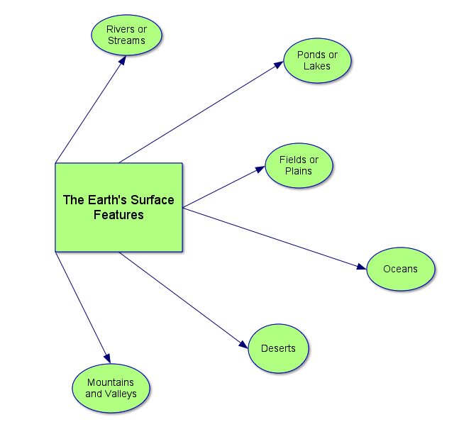

**Lesson 3: Mountains and Hills**

**Big Ideas of the Lesson**

* A relief map shows the Earth’s features.
* Wind and rain change the shape of the land.

**Abstract**

In this lesson children are introduced to a relief map and explore the characteristics of mountains. They make models of mountains.

**Grade Level Context Expectation(s)**

Children will:

* describe the major landforms of the surface of the earth (e.g., mountains, plains, plateaus, valleys, hills) (E.SE.02.21).
* develop strategies and skills by gathering information about the features of the earth (e.g., books, Internet, ask an expert, observation, investigation, technology tools) (S.IA.02.14).
* demonstrate how the earth’s surface features can be represented through various illustrations, performances, models, and exhibits (S.RS.02.11).
* identify technology used in the exploration of the earth’s surface (S.RS.02.16).

**Key Concept(s)**

mountain

surface feature

**Instructional Resources**

# Equipment/Manipulative

Book

Large shallow pan

Relief map

Sand

Spray bottle of water

Straws

# Student Resource

Asch, Frank. *The Earth and I*. New York: Harcourt Children’s Books, 1994.

*The Earth.* New York: DK Publishing, Inc., 2002.

Gabrys, Jennifer, and Claudia Douglass. *Supplemental Materials (SC02030301.doc).* Teacher-made material. Waterford, MI: Oakland Schools, 2009.

Kalman, Bobbie. *Earth’s Mountains (Looking at Earth).* New York: Crabtree Publishing, 2009.

---. *Introducing Landforms (Looking at Earth).* New York: Crabtree Publishing, 2008.

Richardson, Gillian. *Extreme Nature: Mountain Extremes.* New York: Crabtree Publishing, 2009.

Ruurs, Margriet. *Mountain Alphabet*. Plattsburgh, NY: Tundra Books of Northern New York, 1996.

Teacher Resource

Farndon, John. *How the Earth Works*. Pleasantville, NY: Reader’s Digest Association, Inc., 1992.

Gabrys, Jennifer, and Claudia Douglass. *Grade 2 Unit 3 Teacher Background (SC020300TB.doc).* Teacher-made material. Waterford, MI: Oakland Schools, 2009.

Galko, Francine. *Mountain Animals*. Chicago, IL: Heinemann Library, 2001.

*Mountain: The Origin of Mountains*. 2001 – 2008. InfoPlease. 29 January 2009 <<http://www.infoplease.com/ce6/sci/A0859802.html>>.

Pfeffer, Wendy. *High Mountains*. New York: Benchmark Books, 2002.

Additional ebooks can be found by going to <http://kids.mel.org/HomeworkHelpers> and clicking on the eBook K-8 Collection link. Then type “Mountains” in the search bar.

**Sequence of Activities**

Advance Preparation: Collect enough raised physical relief maps or globes for one per group of four children. If working as a whole class, place the map or globe in a central location so that the children can gather around it. Pour dry sand in a pan, making a “mountain.”

1. Ask the children to put their hand on their face and feel all of their facial features. Ask the children to describe what the following features feel like: nose, mouth, eyebrows, lips, eyes, and chin.
2. Tell the children that just like a face the Earth has features too. We call them surface features and we saw many of them on the field trip. Show the children the raised physical relief map or globe. Explain that it is a special kind of map that shows the Earth’s features. Ask: “What do you notice that is different or unusual about this map?” [It is not flat. It has raised features.] Explain to the children that the map is a model of how the surface of the Earth might actually look or feel.
3. Allow the children a few minutes to examine the map and to feel the raised features.
4. Ask the children to find mountains on the map. Guide them to the Rocky or Appalachian Mountain ranges. Ask: “How do the mountains feel?” Make a list of their observations on the chalkboard. “How are they different from the area around them?” [They are raised, pointed, higher, etc.] Add the term *mountain* to the children’s word bank. If you are creating an ongoing bulletin board of landform pictures, you can find a sample hill in the Teacher Background section.
5. Tell the children that they are going to learn more about mountains. Direct the children the mountain of sand. Ask one child to blow on the mountain with a straw. **Note:** Be sure that the child is blowing away from the other children. Ask the children to explain what is happening. [They should observe that the wind is blowing the sand off the “mountain.”] Ask: “Has the wind ever blown across your sand box or a pile of dirt? What happens?” [The sand or dirt blows away, making the pile smaller. The sand or dirt might blow in the children’s eyes.] Guide the children to the conclusion that the wind can blow dirt from mountains as well. Review the straw activity and have the children circle the correct picture on their Student Page. [When the sand hill was blown on by the straw, it was like the wind.] **Note:** If there is a sand box or pile of dirt in the school yard, your class might set up a large fan and see how much sand/dirt is moved during a school day. Also, dump trucks are required to have covers so that the material they are carrying is not blown out of the truck bed and onto the cars as the truck travels down the highway.
6. When some of the sand in your “mountain” has worn away, have one or two children push the sand together again making the mountain a little higher. Say: “The Earth sometimes pushes, too, but very, very slowly. No one could live long enough to see a mountain get pushed a little higher, but over time it could happen.”
7. Next, dampen the sand with the spray bottle and push it into a “mountain” at one end of the pan. Place the book underneath that end of the pan to raise it. Ask one child to spray water on the top of the mountain. Ask: “What is happening?” [Children may say that the water is washing the sand away.] Ask; “Where does the sand end up?” [Washed away at the bottom of the mountain.] Ask: “Might this ever happen in real life? Would the dirt on a mountain ever be washed away?” [Accept all reasonable answers, but guide the children to the idea that when it rains, dirt is washed from the mountain.] Have the children circle the appropriate picture on their worksheet. [When the sand was sprayed, it was like the rain.] **Note:** If there has recently been a hard rain, you might be able to go outdoors and see evidence of the rain moving dirt. Sometimes near a downspout there are signs of erosion. Sometimes water carries the wood chips from the playground across the pavement or into the gutter.
8. Finally, ask: “Do you think that wind and rain could ever change how things look?” [Most children will understand that they will both cause the sand/dirt to move off the mountain.]
9. Help children add the word *hill* to their word bank. “A hill is a very small mountain. In Michigan, we only have a few mountains (and unless you are in the Western Upper Peninsula, you can add that they are far away.) “But we have many hills, that have been pushed up or made by very big piles of ice and snow long ago. Other hills are made by the wind moving sand around like you did.” Allow children to recall a hill or mountain that they may have visited, or a high point in your community or neighborhood.
10. Save the sand for a xeriscape in Lesson 5.

## **Assessment**

Observe the children as they complete the Student Page. Ask them to draw a picture of what happens to a mountain when water falls on it and when the wind blows.

**Application Beyond School**

Have the children observe their backyards after it rains. Does the water run from a high place to a low place? After it stops raining and the ground dries, can you tell that the water ran past that place?

**Connections**

Mathematics

Children can use two-dimensional [triangle] and three-dimensional [cone] shapes to represent a mountain.

# Social Studies

Discuss with the children the sand dunes and how they are moved by the wind leaving them bare of vegetation. Discuss why nothing grows on the dunes and why no one builds a house there.

**Lesson 3: Mountains and Hills**

Draw a picture of the mountain of sand.

Circle the best picture to finish each sentence.

When the sand was blown on by the straw it was like the …



When the sand was sprayed, it was like the….



**Lesson 4: Oceans**

**Big Ideas of the Lesson**

* Oceans are very large bodies of salty water.
* It is easier to float in the ocean than a lake because of the salt in the water.

**Abstract**

In this lesson children explore the characteristics of oceans and use a relief map to locate the oceans of the world. They read about the life in the ocean and learn that the ocean is salty. Children conduct an experiment to show buoyancy in the ocean.

**Grade Level Context Expectation(s)**

Children will:

* describe the major bodies of water of the earth’s surface (e.g., lakes, ponds, oceans, rivers, streams) (E.FE.02.22).
* develop strategies and skills by gathering information about the features of the earth (e.g., books, Internet, ask an expert, observation, investigation, technology tools) (S.IA.02.14).
* demonstrate how the earth’s surface features can be represented through various illustrations, performances, models, and exhibits (S.RS.02.11).

**Key Concept(s)**

ocean

surface feature

water source

**Instructional Resources**

# Equipment/Manipulative

Hard boiled eggs (two, medium sized)

Kosher salt

Pint jars (2)

Relief map

Water

# Student Resource

Berger, Melvin, and Gilda Berger*. What Makes an Ocean Wave? Questions and Answers About Ocean Life.* New York: Scholastic, Inc., 2001.

Castaldo, Nancy. *Ocean Activity Guide for Ages 6-9.* Chicago, IL: Chicago Review Press, 2002.

Cole, Joanna. *The Magic School Bus on the Ocean Floor*. New York: Scholastic, Inc., 1996.

Gabrys, Jennifer, and Claudia Douglass. *Supplemental Materials (SC02030401.doc).* Teacher-made material. Waterford, MI: Oakland Schools, 2009.

Hyde, Natalie. *Extreme Nature: Deep Sea Extremes.* New York: Crabtree Publishing, 2009.

Kalman, Bobbie. *The ABC’s of Continents.* New York: Crabtree Publishing, 2008.

---. *Earth’s Coasts (Looking at Earth).* New York:Crabtree Publishing, 2008.

---. *Earth’s Oceans (Looking at Earth).* New York: Crabtree Publishing, 2008.

---. *Introducing Landforms (Looking at Earth).* New York: Crabtree Publishing, 2008.

Ryan, Pam Munoz. *Hello Ocean*. Watertown, MA: Charlesbridge Publishing, Inc., 2001.

Additional ebooks can be found by going to <http://kids.mel.org/HomeworkHelpers> and clicking on the eBook K-8 Collection link. Then type “Ocean” in the search bar.

Teacher Resource

Gabrys, Jennifer, and Claudia Douglass. *Grade 2 Unit 3 Teacher Background (SC020300TB.doc).* Teacher-made material. Waterford, MI: Oakland Schools, 2009.

Pike, Katy, and Maureen O’Keefe. *Oceans*. Philadelphia, PA: Chelsea Clubhouse, 2003.

*Why are the Oceans Salty?* All About Oceans and Seas. 29 January 2009 <<http://www.enchantedlearning.com/subjects/ocean/Salty.shtml>>.

**Sequence of Activities**

Advance Preparation: Hard boil two medium-sized eggs. Use your newsletter to encourage families who may have visited the ocean to share a few photos, since the landform is out of reach of Michigan. You can also provide QuickTime© videos of ocean waves to help children visualize the ocean from the web at sites like <http://www.surftv.com/>. An ideal anticipatory experience for this lesson is a mini-trip to a local aquarium store to observe a marine aquarium. Ask the aquarium store manager to discuss with children how the marine animals are different from fresh water animals.

1. Ask the children if they have ever been to the ocean. Encourage those who have to share their experiences with the rest of the class. Visit an aquarium store to look at a marine aquarium, or watch a video on the ocean. If you are maintaining a landforms bulletin board, add a photo from the Teacher Background or other source to spark discussion.
2. Tell the children that they are going to explore some things about oceans, another surface feature of the Earth. Ask the children what they already know about oceans. List their ideas on the board without correction. [The list should include that oceans are very large, there are many of them, they are salty, ships travel on them, people deep-sea dive in them, etc.]
3. Bring out the relief map and ask a volunteer to identify one ocean. Put a small sticky note on that ocean. Ask for another volunteer to point out another ocean and put a sticky note on that one also. Continue until either all the oceans have been identified, or until the children cannot identify the ocean. Review the idea of “bird’s eye view” from Lesson 2: “If we were on the edge of the ocean, would it look round?” [No, but it might look “bumpy” from waves.]
4. Ask the children to describe how the ocean looked and felt on the relief map.
5. Read aloud “The Magic School Bus Explores the Ocean” or show the video. The book is quite long (56 pages) so you may choose to complete it in over several days, having a class discussion about each section.
6. Have children complete the Student Page about oceans.
7. Ask if any of the children have ever been swimming in the ocean. Have them describe their experiences. Prompt them to share that the ocean is salty and that it is very easy to float in the ocean, much easier than in a lake because of the salt.
8. Ask several children to help you with a demonstration (or do this in small groups).
9. Label one-pint jar with the word “Water” and the other jar with the words “Salt Water.” Fill both jars about 1/2 with water. Add one cup Kosher Salt to the “Salt Water” jar. Ask if any child would like to taste the water and tell the class what it tastes like.
10. Show the children the two hard boiled eggs. Ask what they think will happen when you put one egg into the plain water. [Accept all ideas.] Ask a volunteer to gently place the egg in the jar. Observe what happens. [The egg sinks to the bottom.]
11. Now ask the children to predict what will happen when a hard boiled egg is placed into the jar with the salt. [Accept all ideas, but recall that those who have visited the ocean say that it is easier to swim in the ocean.] Ask a volunteer to gently place the egg in the jar. Observe what happens. [The egg should float. If it does not, add more salt.]
12. Ask the children what made the egg float. [Salt.] **Note:** Noting that salt in the water makes it easier to float is probably enough for this age group. Ask the children if they would rather swim in fresh or salt water. [Accept all answers in favor of both places.]
13. To conclude the lesson on oceans, read *Why the Sea Is Salty*.

## **Assessment**

Ask children to recall five facts that they learned about oceans. They can make a booklet of what they have learned.

**Application Beyond School**

Have children bring in shells, rocks, pictures, or other artifacts from their ocean vacations for show and tell. If they have not been to the ocean, have them find a picture of an ocean from a magazine to share with the rest of the class. Use these items to create a classroom “Ocean Life” bulletin board.

**Connections**

# Arts

# Children can create a mural of an ocean ecosystem.

# Social Studies

While learning about oceans as a surface feature, children can learn about how oceans have affected how people live and move: sailing across the ocean, pirates on the ocean, shipwrecks of the ocean.

**Lesson 4: Oceans**

Draw a picture of an ocean scene.

Circle the best picture to finish each sentence.

If you tasted ocean water it would taste like …



The ocean’s size is ….

In the ocean there are many different….



**Lesson 5: Deserts and Dunes**

**Big Ideas of the Lesson**

* Plants that live in the desert have thick stems, tiny leaves, and waxy covering.
* Plants in the desert also have needles to keep the animals from drinking the water.
* A sand dune is a hill of sand built up by the wind.
* Animals that live in the desert stay in the shade, only go out at night, and have special coverings.
* Animals in the desert also drink lots of water or keep in their water by resting.
* People who live in the desert live in adobe houses and wear white clothing to protect them from the sun.
* People in the desert also stay out of the sun as much as possible.

**Abstract**

In this lesson children explore and gather information about the characteristics of deserts. They plan and conduct an experiment to determine how best to survive the heat. Children examine the sand due environment to see that it is much like a desert. They create a desert plant or animal and explain its adaptations.

**Grade Level Context Expectation(s)**

Children will:

* describe the major landforms of the surface of the earth (e.g., mountains, plains, plateaus, valleys, hills) (E.SE.02.21).
* develop strategies and skills by gathering information about the features of the earth (e.g., books, Internet, ask an expert, observation, investigation, technology tools) (S.IA.02.14).
* demonstrate how the earth’s surface features can be represented through various illustrations, performances, models, and exhibits (S.RS.02.11).

**Key Concept(s)**

desert

surface feature

**Instructional Resources**

# Equipment/Manipulative

Assorted pictures of the desert

Clay (plasticene or play dough)

Drawing supplies (crayons, markers, etc.)

Plants (2 as closely identical as possible, not succulents or geraniums, and several small cactus plants)

Sand

Thermometers (outdoor, as many as five may be needed)

Tubs (as many as five may be needed)

White cloth

# Student Resource

Dennard, Deborah. *Coyote at Pinon Place.* Norwalk, CT: Soundprints, 2001.

Dewey, Jennifer Owens. *Paisano, the Road Runner.* Brookfield, CT: Millbrook Press, 2002.

Gabrys, Jennifer, and Claudia Douglass. *Supplemental Materials (SC02030501.doc).* Teacher-made material. Waterford, MI: Oakland Schools, 2009.

Hyde, Natalie. *Extreme Nature: Desert Extremes.* New York: Crabtree Publishing, 2009.

Kalman, Bobbie. *Introducing Landforms (Looking at Earth).* New York: Crabtree Publishing, 2008.

*What’s It Like Where You Live? – Desert.* 2002. Missouri Botanical Garden. 29 January 2009 <<http://www.mbgnet.net/sets/desert/index.htm>>.

Teacher Resource

Auch, Alison. *Desert Animals*. Minneapolis, MN: Compass Point Books, 2003.

*Deserts.* Videocassette. Madison, WI: Hawkhill Associates, 1999.

*The Desert Field Trip*. 1997 – 2001. Tramline Inc. 29 January 2009 <<http://www.field-trips.org/tours/sci/desert/_tourlaunch5.htm>>.

*Desert USA*. 29 January 2009 <<http://www.desertusa.com/index.html>>.

Gabrys, Jennifer, and Claudia Douglass. *Grade 2 Unit 3 Teacher Background (SC020300TB.doc).* Teacher-made material. Waterford, MI: Oakland Schools, 2009.

Longnecker, Theresa, and Melissa Carpenter. *Who Grows Up In The Desert: A Book About Desert Animals and Their Offspring*. Minneapolis, MN: Picture Window Books, 2002.

Whitehouse, Patricia. *Hiding in the Desert*. Chicago, IL: Heinemann Library, 2003.

Additional ebooks can be found by going to <http://kids.mel.org/HomeworkHelpers> and clicking on the eBook K-8 Collection link. Then type “Desert” in the search bar.

**Sequence of Activities**

Advance Preparation: Gather pictures of scenes from the desert, including the plants and animals, and several pictures of Michigan dunes. (One is provided in Teacher Background.) Deny water to one of the two plants for just enough time for it to wilt slightly (one or two days), so that children can see that it needs water.

1. Casually bring out or take note of the two non-succulent plants (one of which is wilted). Ask children: “Look at my plant. What is wrong with it?” [It needs water.] “Don’t you think that the plant could get along without water?” [No, all living things need water.]
2. Provide a small succulent plant (like tiny cacti) for groups of children to observe. Say: “Here is a plant that comes from the desert. It does not seem to get very thirsty when I forget to water it. Look carefully. Can you see any ways that these plants can keep from getting too thirsty?” [Accept reasonable answers. Succulents have thick stems, a waxy or shiny substance on the stems to keep the water in, and very tiny leaves or needles so the water does not escape. The needles also keep animals from biting the plant and drinking the water inside.] There are additional pictures of plants adapted for dry habitats in Teacher Background. **Note:** Deserts are *not always hot.* Cold deserts like those in Montana are common in the United States.
3. Ask children if they have ever been to the desert. Have those children share their experiences with the rest of the class. Ask specifically if it was sunny and hot, what was the ground like. Were there many animals in sight, what kinds of plants were there, and did they take any safety precautions before going into the desert (for example, check the car, take bottles of water, etc.). Then show a picture of a Michigan sand dune. Ask children what parts of the dune might be like the desert. [The sand is very porous to water, and the water table is usually much lower than the crest of the dune, so the conditions there are quite arid.] While the narrative is above first grade level, you can view the video *Deserts* with your the children.
4. Bring out the relief map or globe and ask the children if they can find a desert. Although there are deserts in many parts of North America, the largest deserts are in Africa.
5. Return to the pictures you have of the desert. Say: “We know that plants have ways to help them live in the desert. How about animals? How can they survive?” [Children will have many suggestions: Stay in the shade, go out at night, have special coverings, drink lots of water or keep in their water by resting, have special colors like white that reflect the sun.]
6. Ask the children what people do to survive in the desert. Some desert people live in adobe or mud houses to protect them from the heat and cold, some herders wrap themselves in long robes, usually white, to protect themselves from the sun. They work early in the morning and late at night and, like desert animals, often nap in the afternoon.
7. Read aloud *This Desert Is Theirs, Coyote at Pinon Place,* or *Paisano, the Road Runner* and discuss some of the animal adaptations. Add the new words to the word bank.
8. Engage the children in an experiment to determine how effect different strategies are for protecting them from the heat. Brainstorm various ways that humans and animals protect themselves from the heat in the desert climate. Suggestions might include wearing white clothing, burrowing and finding shelter in a clay hut. Ask: “How can we test whether these methods are effective?” Entertain all ideas and decide on a way to test them. One way is to put tubs of sand in the sun on the playground. Lay one thermometer on the sand, one under some white clothing, bury the end of one in the sand (a burrow) and lay the bulb of one in a clay hut made by the children. Make a three-column chart on the board or overhead that shows the conditions in column one, the beginning temperature in column two and the ending temperature in column three. Very late on a sunny afternoon, go out and take the temperatures and record them. Discuss which condition offered the most protection (coolest temperature) and which offered the least (hottest temperature). You can also use the graphics of colors, coverings, and temperatures from Teacher Background as transparencies.
9. Using the sand from Lesson 1 and the cacti observed in this lesson, you can create a desert xeriscape in an old terrarium or aquarium. Put a few succulent or dune plants on the top of the sand. (Even some beach grasses will grow well there.) Small lizards survive well in that environment. Consult your aquarium specialist for species, food, and safety precautions. Place the terrarium in an observation station, where children can make observations. After Lesson 7, ask them to compare the desert and pond environments.

## **Assessment**

Make a “Desert” mural in the classroom. Ask the children to create their own desert plant or animal that shows special desert survival traits. Have them put their plant or animal in the desert environment and explain how it is able to live in the desert.

**Application Beyond School**

Children with Internet access at home may learn more about the desert habitat with their families. They might be able to telephone or write to friends and relatives who live in the Southwest and talk about the climate, animals, and plants.

**Connections**

# Social Studies

While studying about the earth’s features, children can connect to how people that live in the desert.

**Lesson 5: Deserts and Dunes**

Circle the best underlined word for each sentence. Cross out the other word.

1. The desert is usually very hot cold during the day.
2. In the desert, there is a lot of not very much of rain.
3. Most of the animals in the desert are large small.
4. There are few many types of plants in the desert.
5. In Michigan, large hills of dirt sand can be like deserts.

Now think about the facts you have learned about the desert. Draw a picture of a desert plant or an animal that could survive in the desert.

**Lesson 6: The Blue Planet**

**Big Ideas of the Lesson**

* A globe is a model of the Earth.
* There is more water than land on the Earth.
* Water on Earth includes oceans, lakes, ponds, rivers, streams, and glaciers.
* Glaciers are frozen water.

**Abstract**

In this lesson children determine that the earth is mostly made up of water. They compare and contrast the main bodies of water that exist.

**Grade Level Context Expectation(s)**

Children will:

* describe the major bodies of water of the earth’s surface (e.g., lakes, ponds, oceans, rivers, streams) (E.FE.02.22).
* develop strategies and skills by gathering information about the features of the earth (e.g., books, Internet, ask an expert, observation, investigation, technology tools) (S.IA.02.14).
* demonstrate how the earth’s surface features can be represented through various illustrations, performances, models, and exhibits (S.RS.02.11).

**Key Concept(s)**

lake

ocean

river/stream

surface feature

water source

**Instructional Resources**

# Equipment/Manipulative

Books, posters, or Internet sites featuring various bodies of water

Clipboard

Globes (1 standard and 1 inflatable are best)

# Student Resource

*Earth From Space – Earth’s Water Habitats*. NASA. 29 January 2009 <<http://earth.jsc.nasa.gov/sseop/efs/water.htm>>.

*Earth: The Water Planet*. NASA. 29 January 2009 <[http://starchild.gsfc.nasa.gov/docs/StarChild/solar_system_level1/Earth.html](http://starchild.gsfc.nasa.gov/docs/StarChild/solar_system_level1/earth.html)>.

Gabrys, Jennifer, and Claudia Douglass. *Supplemental Materials (SC02030201.doc).* Teacher-made material. Waterford, MI: Oakland Schools, 2009.

*The Great Globe Gallery*. 29 January 2009 <<http://hum.amu.edu.pl/~zbzw/glob/glob1.htm>>.

Hyde, Natalie. *Extreme Nature: Deep See Extremes.* New York: Crabtree Publishing, 2009.

Kalman, Bobbie. *The ABC’s of Continents.* New York: Crabtree Publishing, 2008.

---. *Earth’s Coasts (Looking at Earth).* New York:Crabtree Publishing, 2008.

---. *Earth’s Oceans (Looking at Earth).* New York: Crabtree Publishing, 2008.

---. *Earth’s Rivers (Looking at Earth).* New York: Crabtree Publishing, 2008.

Knowlton, Jack, and Harriett Barton. *Geography from A to Z: A Picture Glossary*. New York: HarperCollins, 1997.

Leedy, Loreen. *Blast Off to Earth*. New York: Holiday House, Inc., 1992.

Teacher Resource

Gabrys, Jennifer, and Claudia Douglass. *Grade 2 Unit 3 Teacher Background (SC020300TB.doc).* Teacher-made material. Waterford, MI: Oakland Schools, 2009.

*National Atlas of the United States.* 29 January 2009 <<http://www.nationalatlas.gov>>.

**Sequence of Activities**

Advance Preparation: Collect a variety of posters, books, and Internet pictures so that you have enough to represent each of the discussed water features. Create a map of your local area with water bodies from the National Atlas. (Directions are in Teacher Background.) This activity can be done with the standard globe or the inflatable globe, but optimally it is best to use both to reinforce the concept.

Safety Precautions: You may choose to play this game in an open area or outside.

1. Show the children the inflatable globe and an image of Earth from space. Point out that the globe is a model of the Earth. On the board, draw two columns. At the bottom (the X axis of a histogram) label one column “Water” and the other “Land.” Ask a child to come up to the front and close his/her eyes. With the pointer finger, have them touch the globe anywhere. The class should say “water” or “land” to indicate to what kind of area the child points. Color a block in the appropriate column. Then ask another child to come up and close his/her eyes. Spin the globe, and have the child point randomly again. Again have the class call out “water” or “land” and then mark another block in the appropriate column. Continue with at least 10 children.
2. Ask: “Do you think that there is more water or more land on the Earth? Raise your hand if you think that there is more water.” [Count the children.] “Raise your hand if you think that there is more land.” [Again, count the children] Without commenting on the numbers, say: “Let’s do another experiment.”
3. Go to where there is plenty of space. A gymnasium is better than outdoors because the wind will carry the inflatable globe.
4. Have all of the children stand in a circle and hold up their right “pointing finger.” Tell them that they are going to gently toss the ball from person to person. **Note**: Depending on your class, you may want the children to sit in a circle and roll the ball to one another. When someone catches the ball, they need to look at where their right pointing finger lands. If it is on something blue, they shout “water” if it is on something else, they shout “land.”
5. Practice tossing the ball gently, underhand to a child. Assist as he or she looks at the right index finger and shouts “water” or “land.”
6. Begin play, keeping a tally of the responses the children shout out.
7. After approximately 50 tosses, stop the game and post the results. Ask: “What do you notice about the results?” [Accept any answers that are based on the data. The results should show more water.]
8. Explain to the children that the Earth is made of mostly water. Discuss the ways that water exists on Earth including oceans, lakes, ponds, streams, and glaciers (frozen water).
9. Next, show children a picture of Michigan with its surrounding lakes. Here is a sample of one that could be generated from the National Atlas.



Ask children to close their eyes and point to an area of Michigan with a pencil (*carefully*). “Did they land on water or land?” [If the photo is cropped appropriately, it will be approximately 50-50.]

1. Show the children pictures of different bodies of water and discuss the similarities and differences between these bodies of water. The children should record their responses on their student worksheet. Mainly, children should be aware that: oceans are the largest bodies of water and are salty, lakes have many different sizes and are mostly freshwater, ponds are smaller than lakes and are freshwater, rivers are large streams of freshwater, and glaciers are frozen water.
2. Remind children that maps show us lakes and oceans from a “bird’s eye view.” Ask them what it would look like if they were standing by a lake or an ocean. [It would look flat or have waves.] **Note:** The concept of a map is new to children of this age. Continue to reinforce it whenever possible, but do not assess.

## **Assessment**

Carefully listen to the children’s contributions to the last discussion comparing different bodies of water. The children should be able to name several different types of bodies of water and explain some of the characteristics.

**Application Beyond School**

Suggest various aquariums for families to visit. Encourage families to visit one of the Great Lakes.

**Connections**

Social Studies

While studying the earth’s features found around the community, children can discover how these features are shown on maps.

**Lesson 6: The Blue Planet**

Look at the different bodies of water. How are they the same? How are they different?



#### Rivers

#### Lakes

#### Ponds

#### Oceans

#### Glaciers

**Lesson 7: What’s In a Pond?**

**Big Ideas of the Lesson**

* Freshwater is water without salt.
* A freshwater environment may include gravel, rocks, freshwater, plants, fish, and snails.

**Abstract**

In this lesson children explore the characteristics of pond habitats by creating a model of one. As a class, they replicate a pond environment in their classroom.

**Grade Level Context Expectation(s)**

Children will:

* describe the major bodies of water of the earth’s surface (e.g., lakes, ponds, oceans, rivers, streams) (E.FE.02.22).
* develop strategies and skills by gathering information about the features of the earth (e.g., books, Internet, ask an expert, observation, investigation, technology tools) (S.IA.02.14).
* demonstrate how the earth’s surface features can be represented through various illustrations, performances, models, and exhibits (S.RS.02.11).

**Key Concept(s)**

surface feature

water source

**Instructional Resources**

# Equipment/Manipulative

Aquarium or child’s wading pool

Aquarium bubbler

Aquarium gravel (natural color, enough to cover two inches of tank)

Aquatic plants

Assorted rocks (2-3)

Colander

Fish (guppies, goldfish)

Fish food

Hand lenses (optional)

Pan (white enamel, shallow and flat)

Relief map

Scoop or ladle

Snails

Water to fill aquarium

# Student Resource

Fleming, Denise. *In the Small, Small Pond*. New York: Henry Holt and Company, Inc., 1998. Also available as at the following link: <https://www.youtube.com/watch?v=GO6sirMAlZ8>

Gabrys, Jennifer, and Claudia Douglass. *Supplemental Materials (SC02030701.doc).* Teacher-made material. Waterford, MI: Oakland Schools, 2009.

Heinz, Brian J. *Butter Nut Hollow Pond.* Brookfield, CT: Millbrook Press, 2000.

Hunter, Anne. *What’s in the Pond?* New York: Houghton Mifflin Company, 1999.

Kalman, Bobbie. *Introducing Landforms (Looking at Earth).* New York: Crabtree Publishing, 2008.

Korman, Susan. *Box Turtle at Silver Pond Lane.* Norwalk, CT: Soundprints, 2001.

Pfeffer, Wendy. *Mallard Duck at Meadow View Pond.*  Norwalk, CT: Soundprints, 2002.

Additional ebooks can be found by going to <http://kids.mel.org/HomeworkHelpers> and clicking on the eBook K-8 Collection link. Then type “Ponds” in the search bar.

Teacher Resource

*Elementary School Field Trips: Off-Site Ideas and Resources*. Ed. Kathleen A. Wildasen. Elementary Educators. 29 January 2009 <<http://k-6educators.about.com/library/weekly/aa040101b.htm?iam=dpile_1&terms=how+to+make+a+classroom+pond>>.

*Explor-A-Pond*. 29 January 2009 <<http://www.uen.org/utahlink/pond/>>.

Gabrys, Jennifer, and Claudia Douglass. *Grade 2 Unit 3 Teacher Background (SC020300TB.doc).* Teacher-made material. Waterford, MI: Oakland Schools, 2009.

Hargrave, Maddy, and Mic Hargrove. *Aquariums for Dummies*. New York: John Wiley and Sons, Inc., 1999.

Kwan, Terry, and Juliana Texley. *Exploring Science Safely.* Arlington, VA: National Science Teachers Association, 2002.

**Sequence of Activities**

Advance Preparation: Visit a pet store or use a science supply catalog to obtain all of the supplies. (This can be ideally combined with the tour in Lesson 5.) **Note:** The number of fish will depend on the size of your tank. Make sure the aquarium is clean. Using a colander, rinse the gravel to remove any fine particles or dust. Fill a container with enough tap water for the aquarium and allow it to sit for 24 hours in order for the chlorine in the water to evaporate. If you do not want to continually heat your tank, you can easily choose “cold water” fish like guppies and goldfish.

Safety Precautions: On a field trip, watch *any* depth of water. Children can drown even in a very shallow body of water. Children should not put their hands in the tank. If they do, make sure that they wash them with soap and water.

1. Explain to the children that one of the surface features of the Earth are bodies of water. Say: “We have already talked about the oceans. What kind of water is in the oceans?” [Salt water.] Ask: “Is that the only kind of water on Earth?” [No.] “What other kind is there?” [Water without salt (freshwater) like that found in lakes and rivers.]
2. Almost every Michigan child has gone swimming in a lake or a pond. Allow them to talk about swimming in a lake. Ask them: “Were there any other living things in the lake with you?” [Fish, plants.] Make sure that you do not create a fear of swimming. Michigan has no sharks or other biting lake fish.
3. If you can take a walking field trip to a shallow body of water, do so. Ask children to observe living things. Take a scoop or soup ladle and scoop up some of the bottom “muck” (called *detritus* by biologists) to find little bugs, crustaceans, plants, and worms. Allow children to look but not touch. Hand lenses are an asset in this sort of observation if you have them. It is not necessary for children to name the living things they see. The object of the study is to learn that there are many kinds of living things, big and small, in ponds.
4. Returning to the classroom, read aloud *Esmeralda and the Enchanted Pond.* This is a story about a little girl and her father, discussing the animals in a pond. Esmeralda has a vivid imagination; her father gives her the accurate name of each of the things she sees. Remind children that scientists use *different words* to describe what they observe: “Remember, both Esmeralda and her father are using good words. But they are useful for different purposes. What would the father’s words be better for?” [Science, classification.] (The book is accompanied by an exceptional teachers’ guide with activities.)
5. Tell the children that they are going to create and observe a freshwater environment in the classroom.
6. Show the children all of the materials and explain what each item is. **Note**: As an alternative to purchasing aquarium plants and animals, you can collect pond water and bring it to the classroom. It will contain many small aquatic creatures and plenty of pond plant life. However, it generally does not remain “fresh” very long, and fungi and worms take over the microhabitat in a jar.
7. Begin creating the “pond” by placing the aquarium on a sturdy surface, away from direct sunlight and low enough for the children to see.
8. Tell the children that the first item to put in the tank is the gravel, which represents the pond floor. Have the children draw and label the pond floor in their Student Pages.
9. Place rocks in different places in the gravel. Tell the children that there are rocks in the bottom of ponds and lakes and have them draw and label the rocks.
10. Pour the water into the aquarium. Have the children draw and label the water on their worksheet.
11. After allowing the water to sit for 24 hours add the plants to the aquarium, taking care to anchor them firmly in the gravel. Explain to the children that there are many plants that will grow in lakes and ponds. Have them draw and label the plants.
12. Add the fish to the tank. Tell the children that there are many types of fish that can live in a pond, such as the goldfish that you have added. Have the children draw and label the fish. **Note**: Some goldfish are raised as “feeder fish” and have a very short life span. Guppies survive well in tanks and will often give live birth. Beta fish are especially well adapted to unclean water, but only one can be in a tank. Get advice from a local fish dealer to avoid disappointment.
13. Add the snails to the tank. Explain that the snails are like natural cleaners in a pond or lake because they eat the algae, an aquatic plant, that will grow there. Have the children draw and label the snails.
14. Tell the children that you have made a model of a pond for them to observe in the classroom. Discuss the other things that may exist in an actual pond and why their classroom pond or lake does not have all of those things, reinforcing the idea of a model being a replication of the real pond or lake.
15. Give children the responsibility of feeding the fish and caring for the two environments you have created. Emphasize humane treatment of animals and plants.
16. Set time aside each day to share observations of the aquarium and the xeriscape that you created in Lesson 5. Take advantage of spare moments to continually compare and contrast the landforms and the organisms in them.

## **Assessment**

Have children sequence the steps that take place in creating a model of a pond.

**Application Beyond School**

Suggest local ponds or lakes for families to visit, including any nature centers that provide demonstrations or further information.

**Connections**

# English Language Arts

While studying about the earth’s features, children can use informational texts to further their understanding of ponds, lakes, rivers, streams, and oceans.

**Lesson 7: What’s In a Pond?**

As you create a classroom pond, draw and label the parts in the ‘aquarium’ below.

**Lesson 8: Rivers**

**Big Ideas of the Lesson**

* Rivers can change the shape of the land.
* Rivers flow downhill and carry bits of sand along the way.
* Rocks change the shape of a river.

**Abstract**

In this lesson children learn two different characteristics of rivers: how the speed of moving water in a river affects the land and the reason for the shapes of rivers.

**Grade Level Context Expectation(s)**

Children will:

* describe the major bodies of water of the earth’s surface (e.g., lakes, ponds, oceans, rivers, streams) (E.FE.02.22).
* develop strategies and skills by gathering information about the features of the earth (e.g., books, Internet, ask an expert, observation, investigation, technology tools) (S.IA.02.14).
* demonstrate how the earth’s surface features can be represented through various illustrations, performances, models, and exhibits (S.RS.02.11).

**Key Concept(s)**

river/stream

surface feature

water source

**Instructional Resources**

# Equipment/Manipulative

Clay

Cookie sheet

Drinking straw

Gallon milk jug filled with water

Paper cup

Pencil

Ruler

Scissors

Small rocks (4-5)

Soil

Three books (each 2 inches thick)

# Student Resource

Chambers, Catherine. *Rivers.* Crystal Lake, IL: Heinemann, 2000.

Cherry, Lynne. *A River Ran Wild: An Environmental History*. New York: Harcourt, 2002.

Gabrys, Jennifer, and Claudia Douglass. *Supplemental Materials (SC02030801.doc).* Teacher-made material. Waterford, MI: Oakland Schools, 2009.

Hablitzel, Marie, and Kim Stitzer. *Draw, Write, Now-Book 6: Animal Habitats on Land, Ponds, and Rivers, Oceans, Vol. 6*. Poulsbo, WA: Barker Creek Publishing Inc., 1999.

Kalman, Bobbie. *Earth’s Rivers (Looking at Earth).* New York: Crabtree Publishing, 2008.

---. *Introducing Landforms (Looking at Earth).* New York: Crabtree Publishing, 2008.

Kurtz, Jane. *River Friendly, River Wild*. New York: Simon and Schuster Children’s, 2000.

Taylor, Barbara. *Rivers and Oceans*. New York: Kingfisher, 2002.

Tomacek, Steve. *Dirt.* Washington, DC: National Geographic Society, 2002.

Teacher Resource

*Friends of the Rouge*. 29 January 2009 <<http://www.therouge.org/>>.

Gabrys, Jennifer, and Claudia Douglass. *Grade 2 Unit 3 Teacher Background (SC020300TB.doc).* Teacher-made material. Waterford, MI: Oakland Schools, 2009.

Harrison, David, and Cheryl Nathan. *Rivers: Nature’s Wondrous Waterways*. Honesdale, PA: Boyds Mills Press, 2002.

Nadeau, Isaac. *Water in Rivers and Lakes*. New York: PowerKids Press, 2003.

VanCleave, Janice. *Janice VanCleave’s 202 Oozing, Bubbling, Dripping, and Bouncing Experiments*. New York: John Wiley and Sons, Inc., 1996.

Additional ebooks can be found by going to <http://kids.mel.org/HomeworkHelpers> and clicking on the eBook K-8 Collection link. Then type “Rivers” in the search bar

**Sequence of Activities**

Advance Preparation: Prepare the demonstration by using the pencil to make a hole in the side of the paper cup near the bottom. Cut the straw in half and insert it into the hole, sealing it to the cup with the clay. Put the cookie sheet on the ground or table and raise one end by placing the book beneath it. Cover the sheet with a thin layer of soil.

1. Explain to the children that rivers on Earth are powerful surface features because they can change the shape of the land.
2. Show the children the model of land that you have set up. Explain that rivers run downhill and as they do, they change the land. Show or post the photo of water channeling through sand found in the Teacher Background file. Ask children discuss what they see, what is happening, and what will happen “later on” when this process continues. [Water is cutting through the sand and making a channel.]



1. Help children understand that water is very powerful. It can only carry tiny bits of sand, but it comes again and again. If weather permits, take a walk on the playground after a rain. Ask the children to look for signs of “water work”—places where water has moved some dirt or sand. Have the children draw on their Student Pages what the “land” looked like prior to the river running through it.
2. Returning to class, do a demonstration for children. Placing a finger over the end of the straw, fill the cup with water from the gallon jug. Explain to the children that you are going to demonstrate what a river does to land. Have them predict what will happen. [Accept all answers. Encourage the children to share observations they have made at home or on the playground.]
3. Place the cup at the raised end of the pan and release the water while the children observe the effect. Discuss the results and allow time for the children to draw what took place on their Student Page. [The water will carry dirt with it as it runs along the cookie sheet. Depending upon how much water there is and how hard the dirt may be, the water in time will cause a river bed to form, that is, the running water will leave a trough.]
4. Place another thin layer of soil on the cookie sheet. Now place two more books under the cookie sheet and refill the cup with water. Ask: “You will notice that the slope or tilt of the cookie sheet is higher. What will happen when the water is released?” [Accept all responses without comment.]
5. Let the water run on the dirt. Ask the children for their observations. After much discussion, point out that the slope of the pan is greater and therefore, the water moves faster. As a result, there is more soil carried away. **Note:** The amount of soil carried away by the water can be seen clearly if the water is collected in a white ice cream tub. Have the children record their observations on their Student Page.
6. Ask the children to describe the shape of the “river”. They should see that the “river” is mostly straight. Discuss the reasons why some rivers are not straight. They should arrive at the conclusion that there are natural objects in the way of the water, causing it to be twisted.
7. Place one of the rocks on the cookie sheet directly in front of the straw. Pour water from the jug into the cup. Continue to pour the water into the cup, adding rocks in the path of the water to change its course. Ask the children to draw what they see.
8. Ask: “Why did the water go around the rocks? Why were the rocks able to change the course of the river?” [The children should note that the rocks are too heavy for the water to move. Since the soil is easier for the water to move, that is what the water carries away.]
9. If you have a river near your school, provide children with some pictures. Encourage visits by families. (Field trips to rivers can be quite dangerous if the water is fast moving, and are not recommended for school classes. However, if there is a very small brook or stream near the school, you may want to ask for adult help to allow children to explore the stream.) When exploring a river or a stream, see how fast the water is moving by putting a tiny bit of torn paper or confetti on the stream. (Just a bit—do not pollute!) Then look carefully for living things that “hold fast” to rocks to avoid being pushed down the stream by the “working water.”
10. Show children a map of Michigan with rivers. Ask them to imagine what they would see if they visited one. **Note:** You can provide a closer look at your own area by using the “zoom” function of the National Atlas.



## **Assessment**

Show the children pictures of different rivers, some straight and others twisted. Ask them to explain why they look as they do.

**Application Beyond School**

If a student lives near a river or stream, ask them to take pictures or make drawings of what it looks like to share with the class. Discuss why the river looks like it does.

**Connections**

# English Language Arts

While studying features of the earth, children can read the story *River Friendly, River Wild* and discuss the different ways that rivers can be friendly and wild.

**Lesson 8: Rivers**

What did the water do to the soil?

What did the scene look like after the first book was put under the cookie sheet and water was poured on it?

What did the scene look like before the water?

What did the scene look like after more books were added and water was poured on the cookie sheet?

What did the scene look like when rocks were added?

## Rivers flow _____________________________________________



a. up to higher land



b. down to lower land

Rivers flow faster when ______________________________________



a. the land is steeper

b. the land is more flat



_______________________________ make rivers twist and turn.



a. Rocks

b. Leaves



**Lesson 9: Scavenger Hunt**

**Big Ideas of the Lesson**

* The surface features on the Earth include hills, fields, lakes, rivers, valleys, ponds, streams, mountains, plains, oceans, deserts, and glaciers.

**Abstract**

In this lesson children make a book of surface features that demonstrates an understanding of the landforms studied in this unit.

**Grade Level Context Expectation(s)**

Children will:

* describe the major landforms of the surface of the earth (e.g., mountains, plains, plateaus, valleys, hills) (E.SE.02.21).
* describe the major bodies of water of the earth’s surface (e.g., lakes, ponds, oceans, rivers, streams) (E.FE.02.22).
* develop strategies and skills by gathering information about the features of the earth (e.g., books, Internet, ask an expert, observation, investigation, technology tools) (S.IA.02.14).
* demonstrate how the earth’s surface features can be represented through various illustrations, performances, models, and exhibits (S.RS.02.11).

**Key Concept(s)**

desert

lake

mountain

ocean

plain

river/stream

surface feature

water source

**Instructional Resources**

# Equipment/Manipulative

A variety of magazines, calendars, travel advertisements as sources of pictures

Brown envelopes (large, brown, 1 per pair or per individual child)

Crayons

Glue

Markers

Scissors

Student Resource

Gabrys, Jennifer, and Claudia Douglass. *Supplemental Materials (SC02030901.doc).* Teacher-made material. Waterford, MI: Oakland Schools, 2009.

Kalman, Bobbie. *Earth’s Coasts (Looking at Earth).* New York: Crabtree Publishing, 2008.

---. *Earth’s Mountains (Looking at Earth).* New York: Crabtree Publishing, 2008.

---. *Earth’s Oceans (Looking at Earth).* New York: Crabtree Publishing, 2008.

---. *Earth’s Rivers (Looking at Earth).* New York: Crabtree Publishing, 2008.

---. *Introducing Landforms (Looking at Earth).* New York: Crabtree Publishing, 2008.

Teacher Resource

Gabrys, Jennifer, and Claudia Douglass. *Grade 2 Unit 3 Teacher Background (SC020300TB.doc).* Teacher-made material. Waterford, MI: Oakland Schools, 2009.

**Sequence of Activities**

Advance Preparation: The booklets need to be made prior to this lesson. It is suggested that this lesson be spread out over several days to ensure the quality of the illustrations. Consider enlisting the help of a parent to make the booklets. Gather magazines and other sources of pictures.

1. Review the terms for the surface features covered throughout this unit. Refer to the concept web in the Lesson 2 and the display of pictures used in Lesson 1.
2. Tell the children that they are going to go on a scavenger hunt. A scavenger hunt is when you collect things from a list. Ask the children to name the features and write them on the board: rivers or streams, hills or mountains, deserts, oceans, fields or plains, and ponds or lakes. Have them go through the magazines and pictures to find pictures of each of the six surface features they have studied.
3. Pass out the booklet and show the children the title *The Earth’s Surface Features*. Have the children read the title out loud and together. Show them where to write their name. Tell the children they can illustrate the front cover of their booklet so that it gives the reader an idea of what is inside. Encourage them to share ideas and model for them by drawing the pictures on the cover of mountains, hills, rivers, oceans, desert plants, etc.
4. Show the children each page. Read the words together and talk about what might go on that page. The children can include pictures of plants, animals, people, or just the surface feature.
5. Show the children where the magazines are pictures are located. Tell them to take the materials to their seat to cut and to look carefully through the magazines. They can look for one surface feature at a time or they can collect a variety of pictures.
6. Give each child a large brown envelope and tell them to write their names on it. This envelope can be used to save the pictures before they are glued to the pages of the booklet.
7. Set aside time each day for a few days to work on the book. As children finish, they can help others find pictures.

## **Assessment**

An informal assessment can be done by looking at each child’s booklet and checking for an appropriate picture and asking them to describe the surface feature on each page.

**Application Beyond School**

Children can take their booklets home to share with their family. Children can add pages of surface features near their homes with their families.

**Connections**

# Social Studies

While studying about the earth’s features, children can research different regions of the earth that have mountains, deserts, plains, lakes or rivers

**Lesson 9: Scavenger Hunt**

The Earth’s Surface Features

by

Mountains and Hills

Deserts

Fields or Plains

Oceans

Rivers or Streams

Ponds or Lakes

**Lesson 10: Putting It All Together In a Model**

**Big Ideas of the Lesson**

* Science words are more specific than everyday words.
* A model is a representation of something else.

**Abstract**

In this culminating lesson, children work in small groups to demonstrate their understanding of the surface features by making a model.

**Grade Level Context Expectation(s)**

Children will:

* describe the major landforms of the surface of the earth (e.g., mountains, plains, plateaus, valleys, hills) (E.SE.02.21).
* describe the major bodies of water of the earth’s surface (e.g., lakes, ponds, oceans, rivers, streams) (E.FE.02.22).
* develop strategies and skills by gathering information about the features of the earth (e.g., books, Internet, ask an expert, observation, investigation, technology tools) (S.IA.02.14).
* demonstrate how the earth’s surface features can be represented through various illustrations, performances, models, and exhibits (S.RS.02.11).

**Key Concept(s)**

desert

lake

mountain

ocean

plain

river/stream

surface feature

water source

**Instructional Resources**

# Equipment/Manipulative

A variety of materials for modeling – clay, play dough, construction paper, paper mache, etc.

Glue

Scissors

Several cardboard boxes cut to 4 inches in height

# Student Resource

Gabrys, Jennifer, and Claudia Douglass. *Supplemental Materials (SC02031001.doc).* Teacher-made material. Waterford, MI: Oakland Schools, 2009.

Kalman, Bobbie. *The ABC’s of Continents.* New York: Crabtree Publishing, 2008.

---. *Earth’s Coasts (Looking at Earth).* New York: Crabtree Publishing, 2008.

---. *Earth’s Mountains (Looking at Earth).* New York: Crabtree Publishing, 2008.

---. *Earth’s Oceans (Looking at Earth).* New York: Crabtree Publishing, 2008.

---. *Earth’s Rivers (Looking at Earth).* New York: Crabtree Publishing, 2008.

---. *Introducing Landforms (Looking at Earth).* New York: Crabtree Publishing, 2008.

Lynn, Sara, Diane James, and Ivan Bullock. *The Big Books of Cool Crafts: Playing with Paint, Paper, and Models*. Minneapolis, MN: First Avenue Editions, 2000.

Young, Karen Romano. *Small Worlds: Maps and Mapmaking.* New York: Scholastic Inc., 2002.

Teacher Resource

*Environmental Education*. National Wildlife Federation. 29 January 2009 <<http://www.nwf.org/education/>>.

Gabrys, Jennifer, and Claudia Douglass. *Grade 2 Unit 3 Teacher Background (SC020300TB.doc).* Teacher-made material. Waterford, MI: Oakland Schools, 2009.

Grisewood, Sara, and Jim Robins. *Making Models*. London, England: Kingfisher, 2001.

Additional ebooks can be found by going to <http://kids.mel.org/HomeworkHelpers> and clicking on the eBook K-8 Collection link. Then type “Landorms” in the search bar

**Sequence of Activities**

Advance Preparation: Make arrangements for additional help during this lesson. This is a good time to involve the high school art classes. Meet with those children in advance to acquaint them with the project. Collect and cut cardboard boxes so that they can hold the model. Anticipate what might be needed for a model and collect those materials.

1. Review the terms for the surface features covered throughout this unit. Refer to the concept web in Lesson 2, the display of pictures used in the lessons and the booklets made in Lesson 9.
2. Refer children to the word bank you have been building during the unit. “How are science words different than the words we use every day?” [They are more specific. For some jobs, they are more useful. They are more descriptive.]
3. Tell the children that they are going to make a model of the surface features they have been studying. Review that a model is a representation of something else. If you retained the models of the features the children made for Lesson 2 (the walking field trip) show them again to children. Ask them what landforms they built at the beginning of the unit. Then ask them what new landforms they have learned. The new model they build will include these new landforms. [In Michigan, it is likely that children will be adding mountains and perhaps an ocean.]
4. Emphasize to children that a model is a tool that scientists use. It is something like a map, but shows different things. “We use models when something is too large for us to work with. For example, some children might have model cars and trucks because the real thing would be too big, heavy, and dangerous.”
5. Ask: “How might you make a model of mountains?” [Accept all reasonable answers that fit the definition of a model.] Ask: “How might you make a model of a desert?” [Again accept reasonable answers including gluing sand to the model.] Ask: “How might you make a model of a lake, ocean, or pond?”
6. Assign the children to groups of three or four. You can assign a different feature to each of the groups or ask them to discuss the idea and decide among themselves what they will build. Another option would be to ask children to choose their favorite book about a landform that they read during the unit, and build their model to match the book. (For example, if *Paisano, the Road Runner* was their favorite book, they would build a desert scene. If *Esmeralda and the Enchanted Pond* was their favorite book they would build a pond scene.) Remind them must include that feature and two more of their choice.
7. This activity is ideal for peer tutoring. If you can partner with an older class, students from that class can come to work with each group. They can reread the books the children have chosen, or help the children decide on landforms and complete their models. The first meeting should be a planning meeting. At the end of the time, the group should have a list of the features it is going to include in the model. If time permits, they might have a list of special materials they will need to make the model. Arrange for two more visits from the class that is helping. The first visit will be used to rough in the model and the second visit will be used to finish the model, adding paint or detail.
8. Display the models for the school and invite the children’ families to view them as well.

## **Assessment**

An informal assessment can be done by observing the group interaction. Each child should understand the surface feature and the purpose of a model.

**Application Beyond School**

The children can invite their families to view the models. Also, models made at home can be shared during show and tell.

**Connections**

# English Language Arts

While creating models of features of the earth, children can use informational texts to further their understanding and prepare an oral explanation of their model pointing out and defining each surface feature.

# 

**Lesson 10: Putting It All Together – Making a Model Landform**

|  |  |
| --- | --- |
| I want to build a model of |  |
| A book about this landform is |  |
| Some things I will need to build my model are |  |
| When my model is done, I will add some extra things like |  |
| If I could visit this landform in Michigan, I would see |  |