Thermometer

Weather Words
Flipchart available- http://flintsciencesource.weebly.com/1st--2nd-mk-periods-weather.html

Seasons
Summer
Fall
Winter
Spring

Hot Breeze
Cold Gust
Warm Wind
Cool Gale

Rain Storm
Snow Tornado
Sleet Blizzard
Ice Flood

Our Class Weather Chart
Our Class Weather Chart
Day | Precipitation | Temperature | Sky | Wind  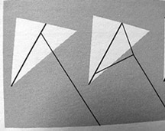
Pinwheel Pattern

Cut from each corner line to the center, stopping at the larger circle. Bend each corner to the center and secure with thread or tape.

Questions and Answers About Tornadoes

Where do they come from?
Tornadoes come from the energy released in a thunderstorm. As powerful as they are, tornadoes account for only a tiny fraction of the energy in a thunderstorm. What makes them dangerous is that their energy is concentrated in a small area, perhaps only a hundred yards across. Not all tornadoes are the same, of course, and science does not yet completely understand how part of a thunderstorm's energy sometimes gets focused into something as small as a tornado (but see "5" below).

Where do they occur?
Whenever and wherever conditions are right, tornadoes are possible, but they are most common in the central plains of North America, east of the Rocky Mountains and west of the Appalachian Mountains. They occur mostly during the spring and summer; the tornado season comes early in the south and later in the north because spring comes later in the year as one moves northward. They usually occur during the late afternoon and early evening. However, they have been known to occur in every state in the United States, on any day of the year, and at any hour. The also occur in many other parts of the world, including Australia, Europe, Africa, Asia, and South America.

What type of damage can they do?
The damage from tornadoes comes from the strong winds they contain. It is generally believed that tornadic wind speeds can be as high as 300 mph in the most violent tornadoes. Wind speeds that high can cause automobiles to become airborne, rip ordinary homes to shreds, and turn broken glass and other debris into lethal missiles. The biggest threat to living creatures (including humans) from tornadoes is from flying debris and from being tossed about in the wind. It used to be believed that the low pressure in a tornado contributed to the damage by making buildings "explode" but this is no longer believed to be true.

How are they detected?
Today, the development of Doppler radar has made it possible, under certain circumstances, to detect a tornado's winds with radar. However, human beings remain an important part of the system to detect tornadoes, because not all tornadoes occur in situations where the radar can "see" them. Ordinary citizen volunteers make up what is called the SKYWARN (www.skywarn.org) network of storm spotters, who work with their local communities to watch out for approaching tornadoes, so that those communities can take appropriate action in the event of a tornado. Spotter information is relayed to the National Weather Service which operates the Doppler radars and which issues warnings (usually relayed to the public by radio and TV) for communities ahead of the storms, using all the information they can obtain from weather maps, modern weather radars, storm spotters, monitoring power line breaks, and so on.

Can they be predicted?
Yes, but only to a limited extent. Although the process by which tornadoes form is not completely understood, scientific research has revealed that tornadoes usually form under certain types of atmospheric conditions. Those conditions can be predicted, but not perfectly. When forecasters see those conditions, they can predict that tornadoes are likely to occur. However, it is not yet possible to predict in advance exactly when and where they will develop, how strong they will be, or precisely what path they will follow. There are some "surprises" every year, when tornadoes form in situations that do not look like the right conditions in advance, but these are becoming less frequent. Once a tornado is formed and has been detected, warnings can be issued based on the path of the storm producing the tornado, but even these cannot be perfectly precise about who will or will not be struck.

How can I keep myself safe?
A complete list of tornado safety rules can be found at the FEMA tornado safety Website (also see Fema for Kids). To summarize briefly, the main point is to be protected from flying and falling debris. A storm shelter is your best choice, if you have one. If you have a basement, go there and get under something sturdy to shelter you from falling debris (for instance, a strong workbench, or a staircase). If you have no basement or storm shelter, go to an interior room without windows on the first floor of your home. Bathrooms are a good choice because the plumbing reinforces the walls. Closets are also a good choice since they normally have no windows. The idea is to put as many walls between you and an approaching tornado as possible; flying debris can penetrate exterior walls. Stay away from windows entirely! It used to be thought that opening windows would reduce a tornado's damage to a home. This is no longer considered to be good advice: leave windows alone completely and get to a safe place immediately. If you live in a mobile home, it should be abandoned; seek shelter in a neighboring frame home or, better yet, a storm shelter. If you are in a motor vehicle in a populated area, do not try to drive away from a tornado abandon your vehicle and seek shelter nearby. If you are traveling in a rural area, drive away from the tornado at a right angle to its path. If caught in the open, get down in a sheltered low spot, and cover your head with your arms; hang on to something if it is available.

My Weather Book
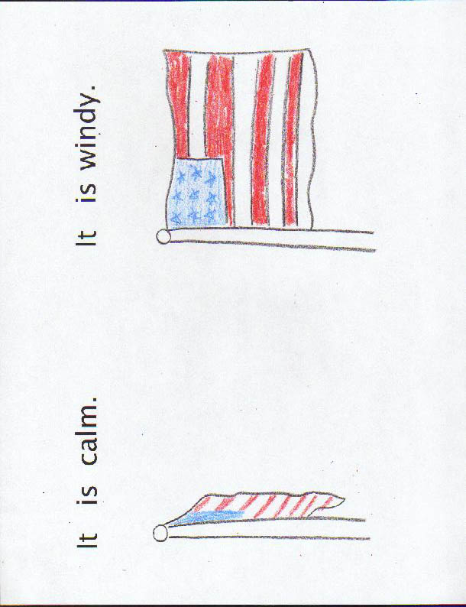
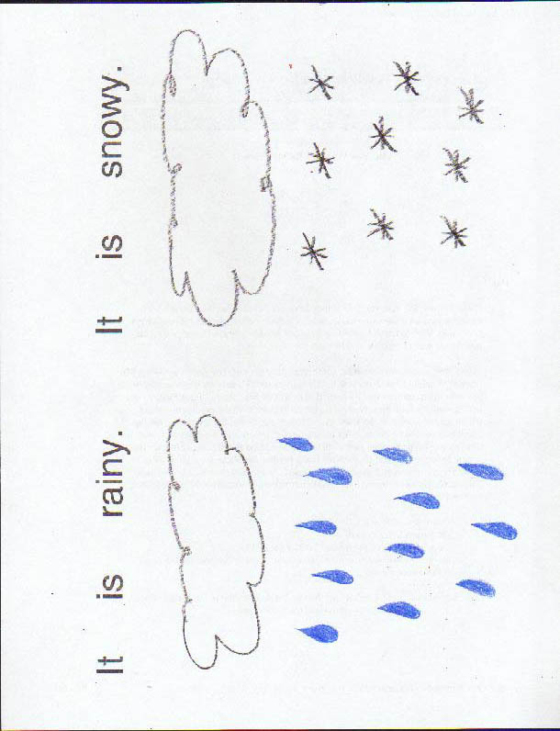
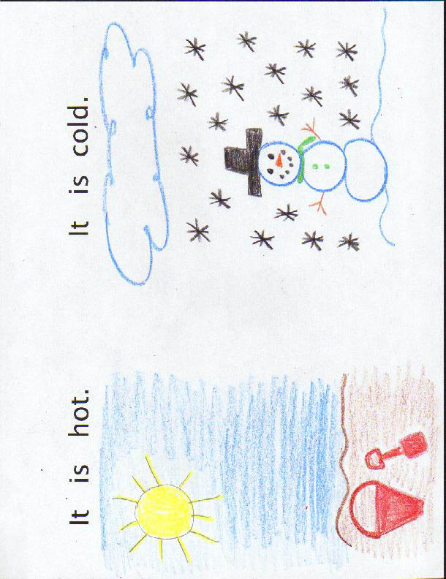
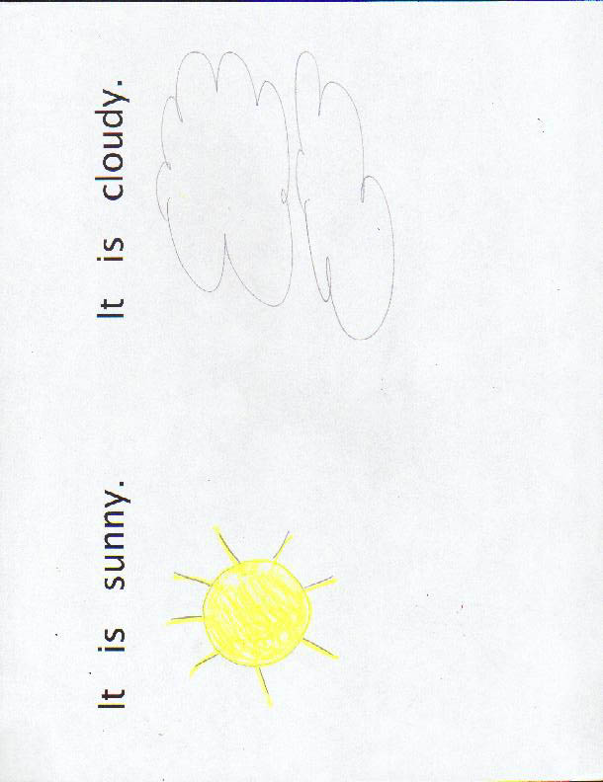
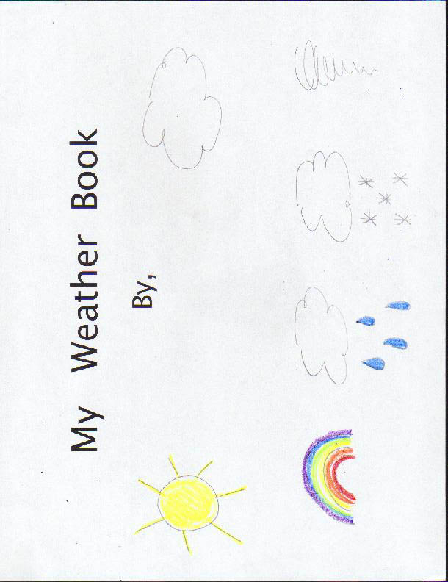

Questions Chart for Unit 4

Question | Answer
What is weather? | Weather is the conditions outside.
What does the word temperature mean? | The temperature is how hot or cold a place is.
How do we measure the temperature? | We measure the temperature with a thermometer.
What are clouds? | Clouds are white or gray shapes in the sky.
What is precipitation? | Precipitation is liquid or solid water falling from the sky.
What measures rain? | A rain gauge measures rain.
What is the source of heat for our weather? | The source of heat for our weather is the sun.
What is wind? | Wind is moving air.
What makes air move? | When air gets warm, it moves up. When air gets cool, it moves down.
At what temperature does it rain and when does it snow? | It may snow when the temperature is below 32 degrees Fahrenheit. It may rain when the temperature is above 32 degrees Fahrenheit.
What are the four seasons? | Spring, summer, fall/autumn, and winter are the four seasons.
How do the seasons affect the weather? | Certain weather conditions only occur in certain seasons.
What is a tornado? | A tornado is a strong wind in the shape of a funnel that can cause a lot of damage.
Graphic Organizer for Unit 4

Weather Features
Temperature
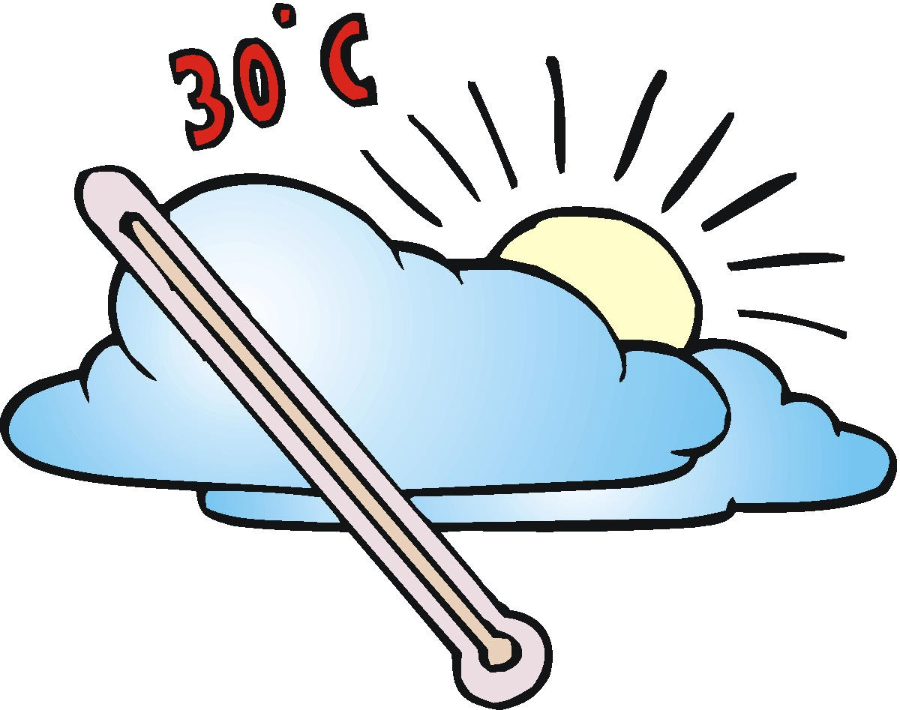
Cloud Cover

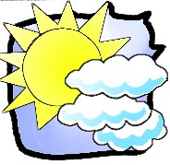
Wind
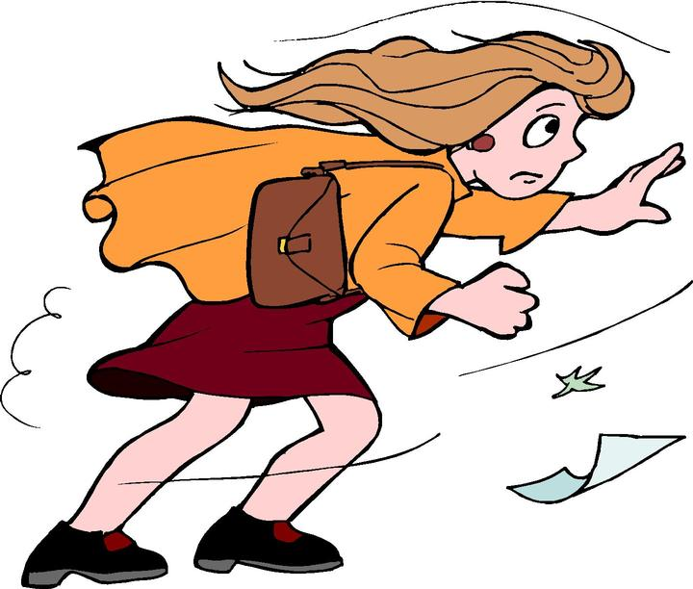
Precipitation
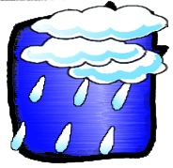
Severe Weather
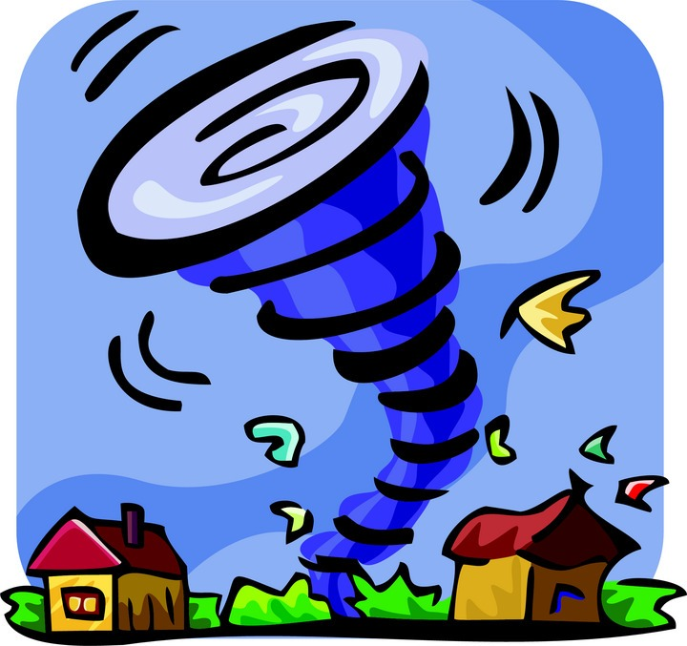

Graphic Organizer for Unit 4

Weather

Temperature
How hot or cold it is outside

Sky

Clear or clouds

Wind

Moving air

Precipitation
Water that falls to Earth in some form
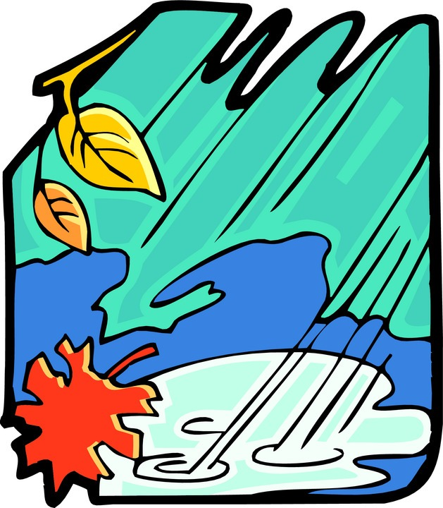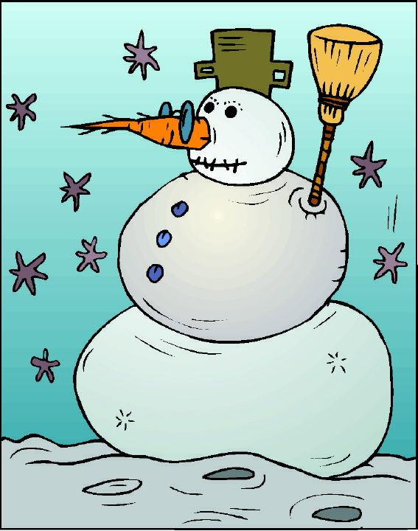
Graphic Organizer for Lesson 2

Hot

Cool
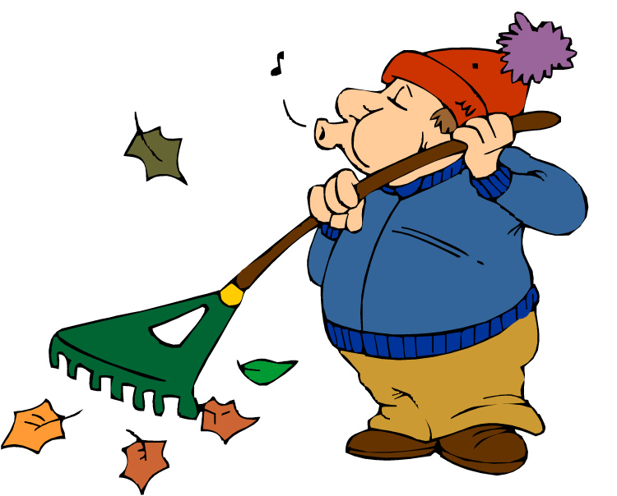
Cold


Temperature

Warm
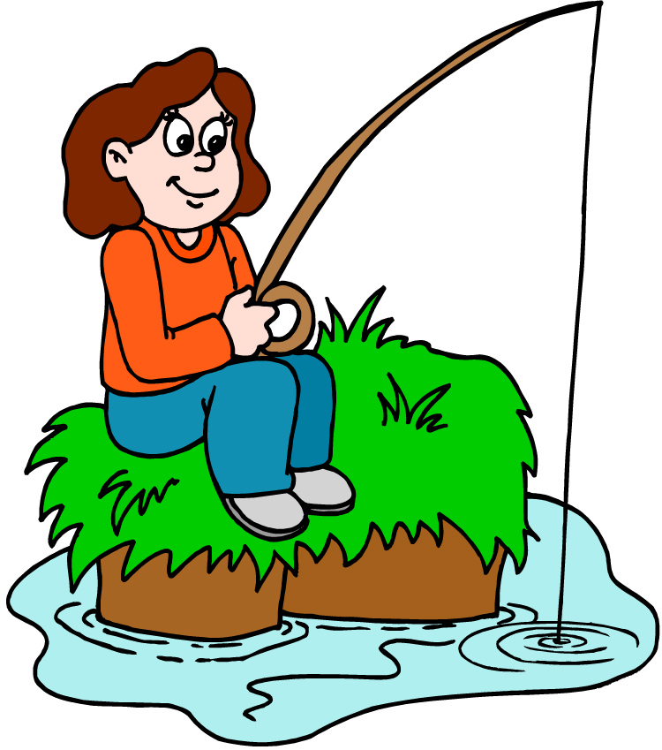
Graphic Organizer for Lesson 4

Thin
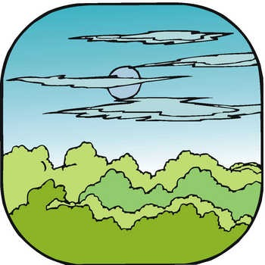
Thick
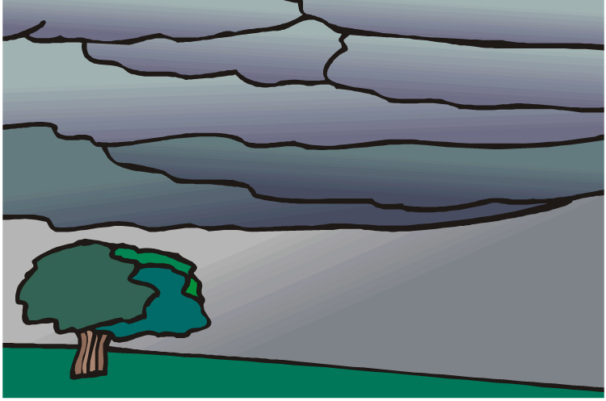
White

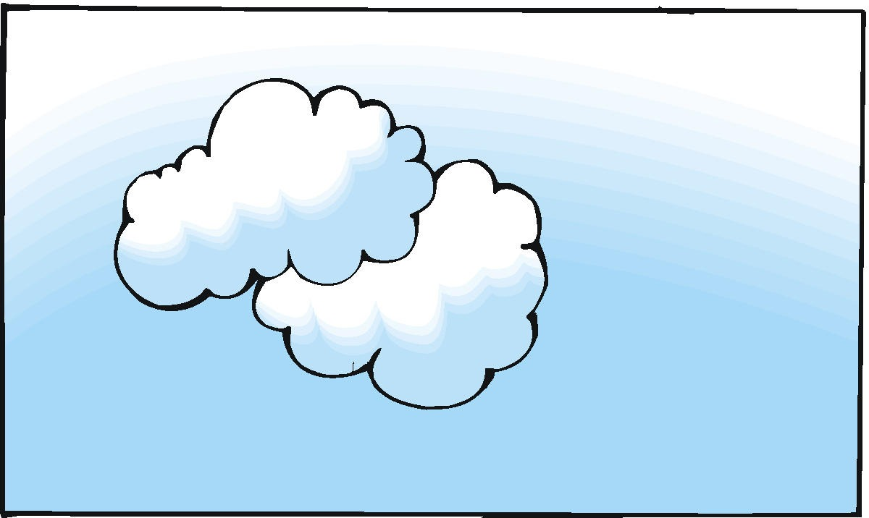
Gray
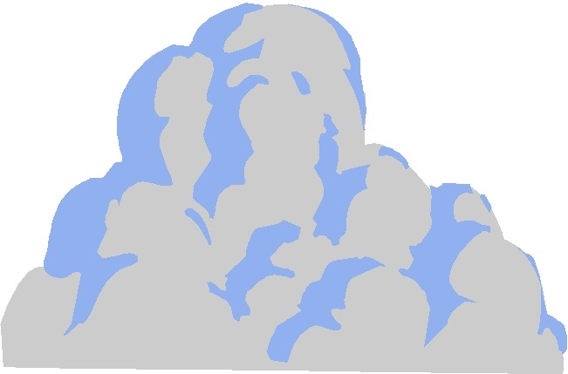
Clouds
Small
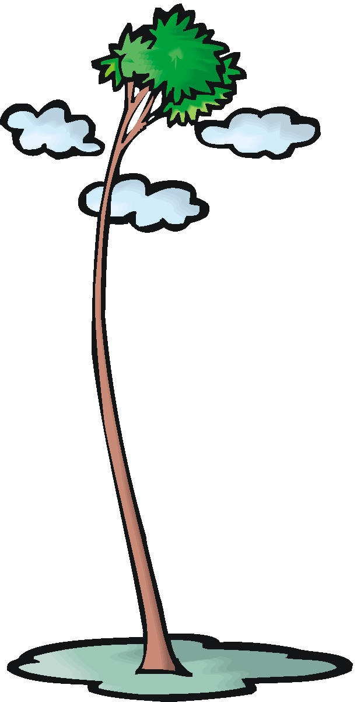

Big
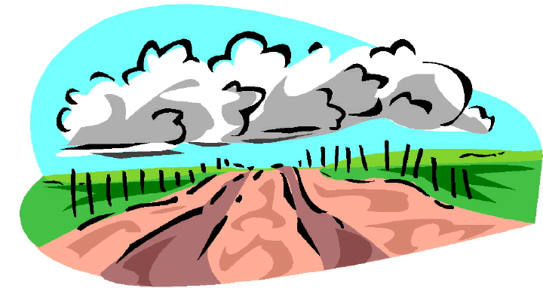
Graphic Organizer for Lesson 4

Cloud Cover

Cloudy
No Clouds
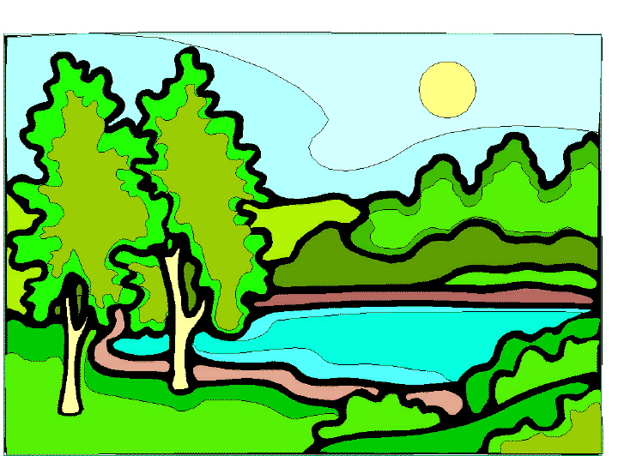
Partly Cloudy
Graphic Organizer for Lesson 6

Rain

Snow
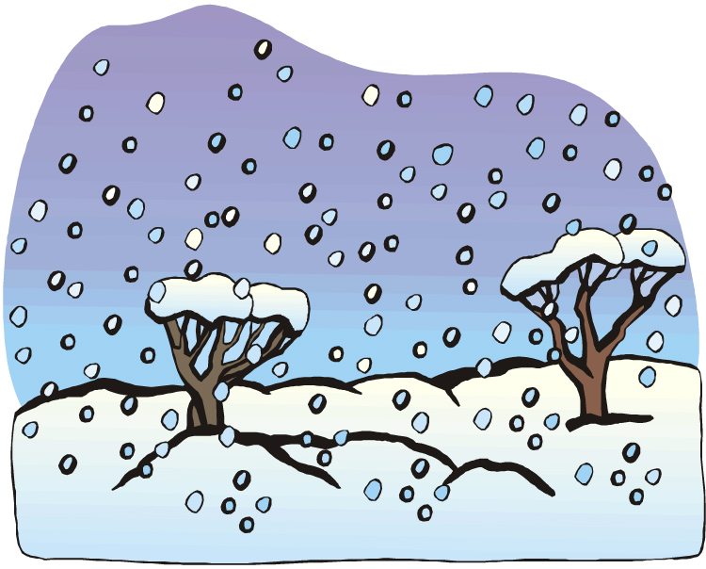
Hail
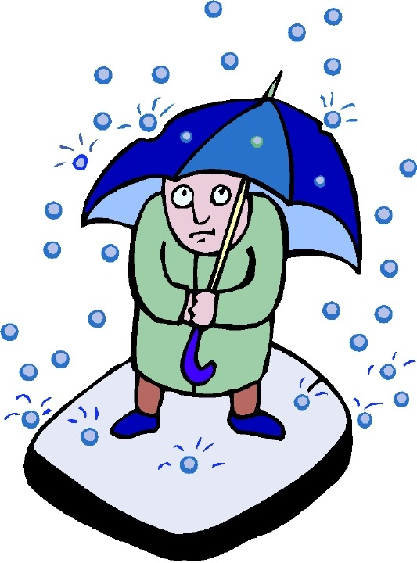
Sleet
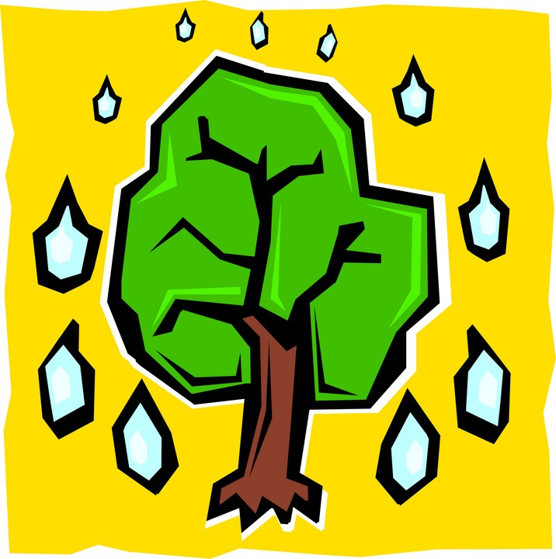

Precipitation

Graphic Organizer for Lesson 6

Thunderstorm

Blizzard
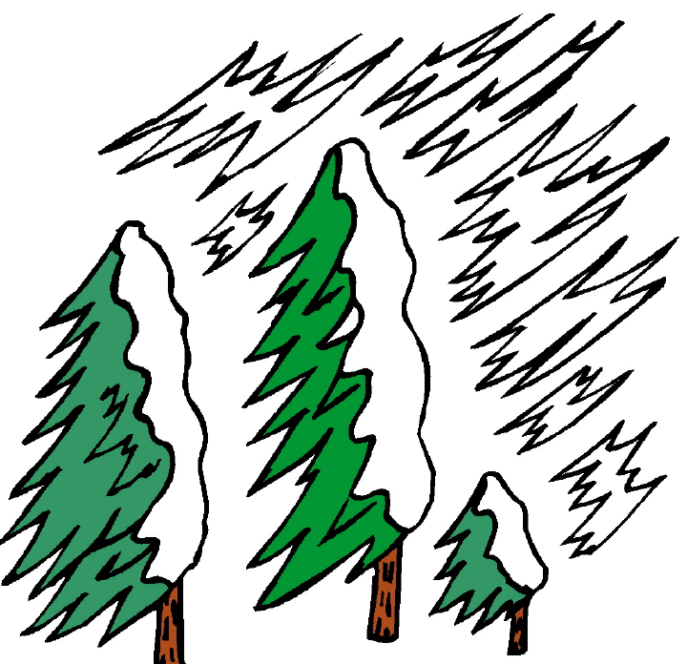
Flood
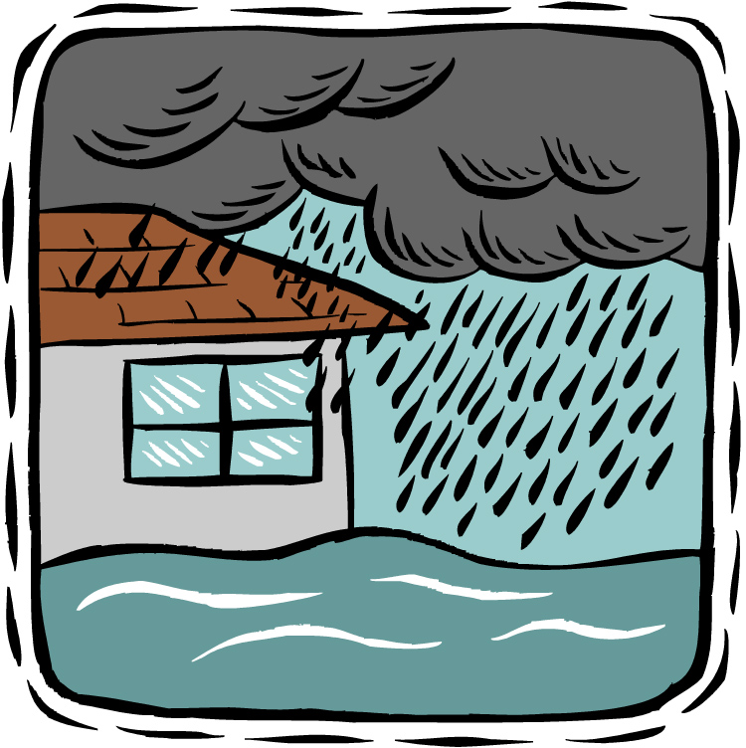
Tornado

Severe Weather

Graphic Organizer for Lesson 7

Rain

Light Rain
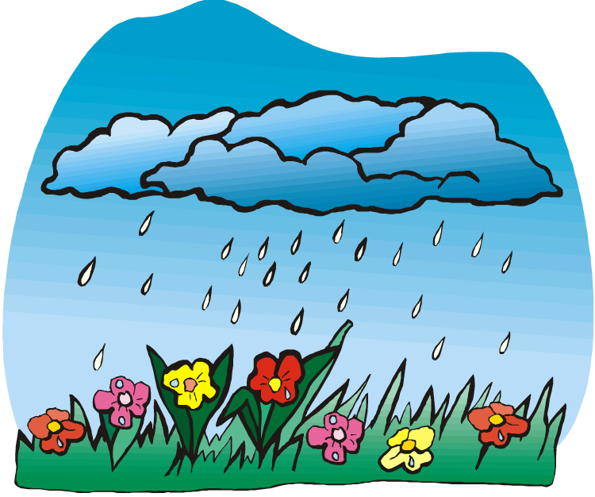

Downpour

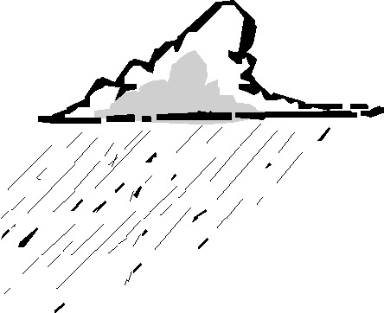

Graphic Organizer for Lesson 9

Violent Weather

Tornado
A strong wind in the shape of a funnel

Blizzard

A heavy snowstorm

Flood

An overflow of water
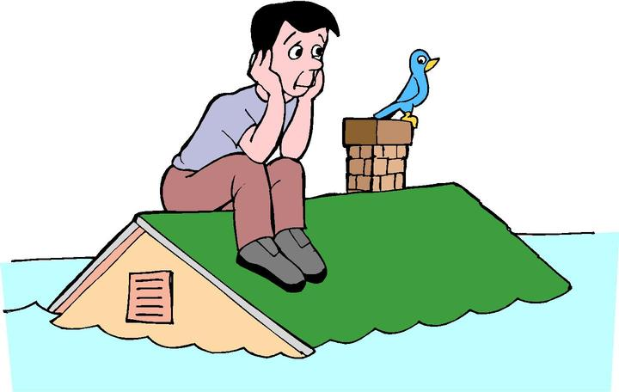

Lightning Storm
Storm with lightning
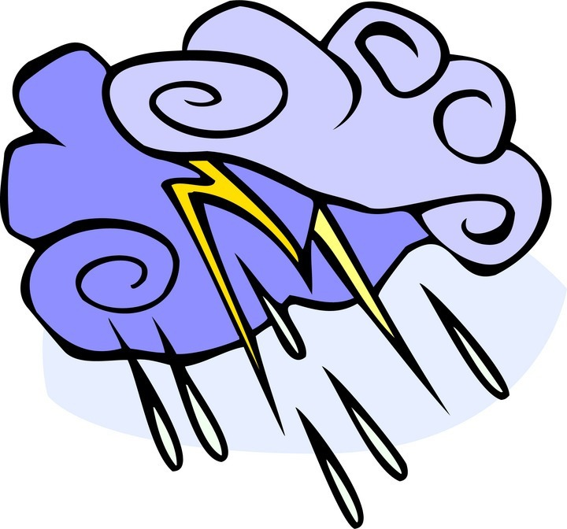
Graphic Organizer for Lesson 9

Seasons

Spring

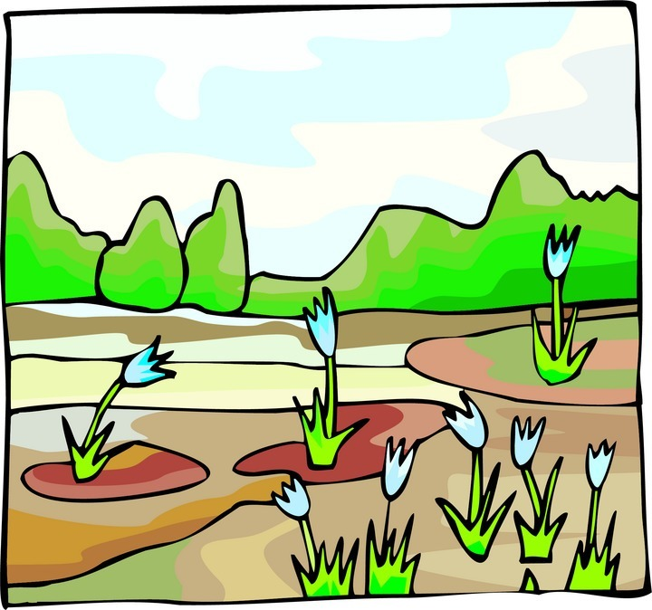

Winter
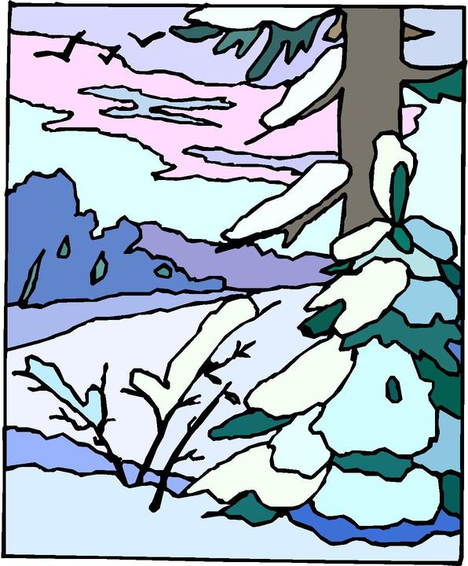

Fall

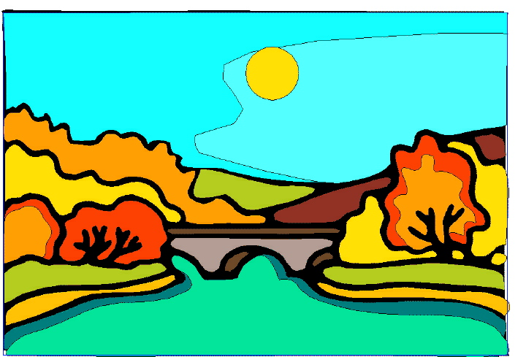

Summer

